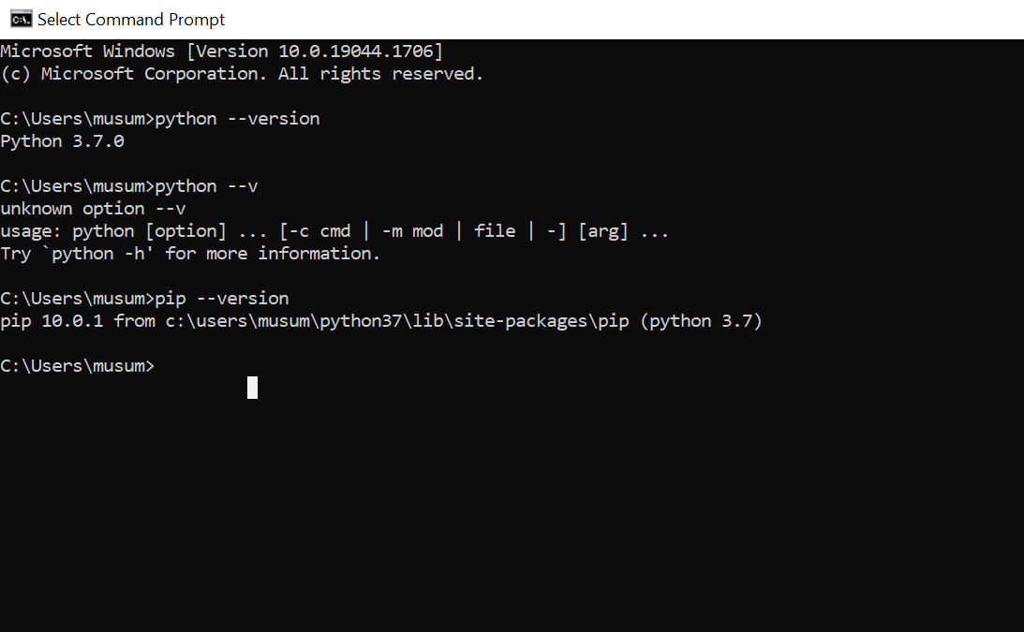

Pip –version

Pip is used to install any third-party modules

Most of the Unix system is having default python and pip

Some requirements are dependent on Linux like systems

So don’t disturb this python in this system

Sudo su –

Also be root to install python

Sudo yum install wget

Cd /opt/

Ls

Wget source of the tarball

Tar -XVZF python.gz

Yum insta

Cd phthon-3.7.0

. /configure /use/local/bin--🡪by default it will install hear

If you want a release build with all stable optimizations active (PGO,ETC),

Please run ./configure –enable-optimazations

Make-----🡪for compiling and then install

./configure –enable-optimizations

./configure—prefix=/opt--🡪it will install python on this location

Make alt install--🡪it will install a new version it won’t disturb the older version

ls -lrt /usr/local/bin

cd /usr/local/bin/

./python3.7 – version

Which python3.7

echo $path

cd /bin

ln -s python3.7 python3--🡪for creating soft link between this teo versions

if you are using this we can simple use this python3 from any where in the system

python3 –version

pip3.7 –version

ln -s pip3.7 pip3

pip3 –version

exit from root and you can run this command

python3 –version

pip3 –version

code editors for python:

idle-🡪integrated development environment

vi/vim---🡪

notepad/notepad++

pycharm

spyder

pydev

atom

sublime text etc

yum install vim--🡪for installing vim

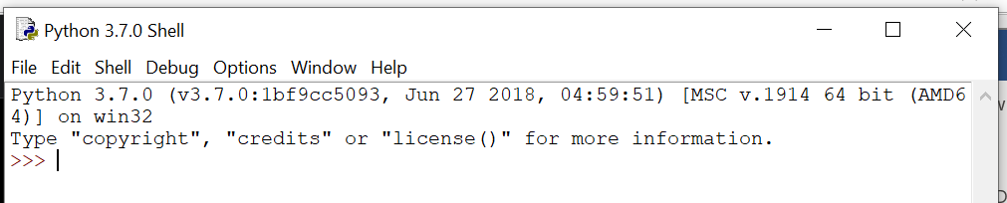

Above one is idle it will get install by default

Or else go to cmd and type python

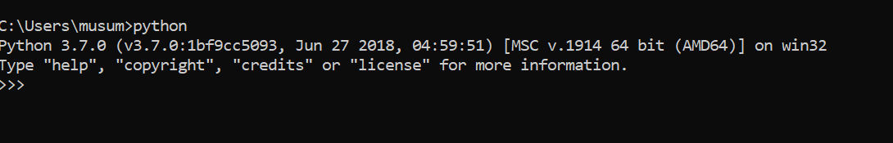

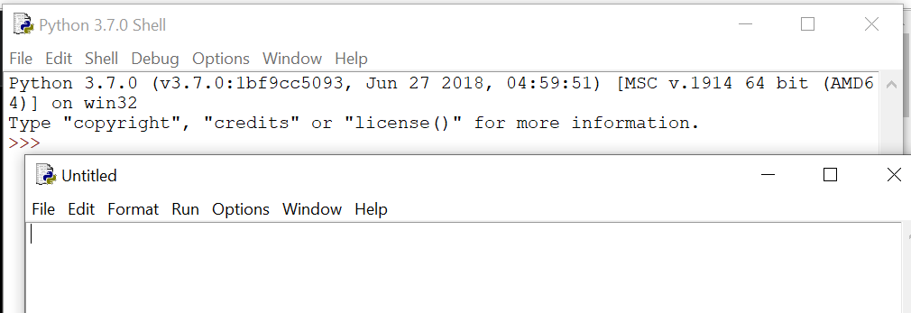

Click on file then new file will open editor we can write our code hear and we can save it

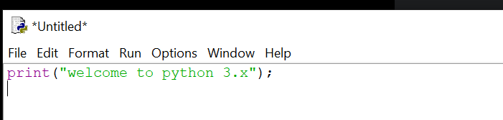

Ctrl+s to save the file

Run---run module f5

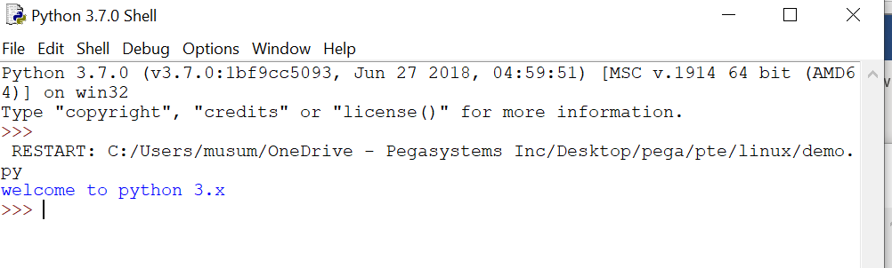

Out put printing the details

<https://www.freecodecamp.org/news/vim-windows-install-powershell/>

installing vim

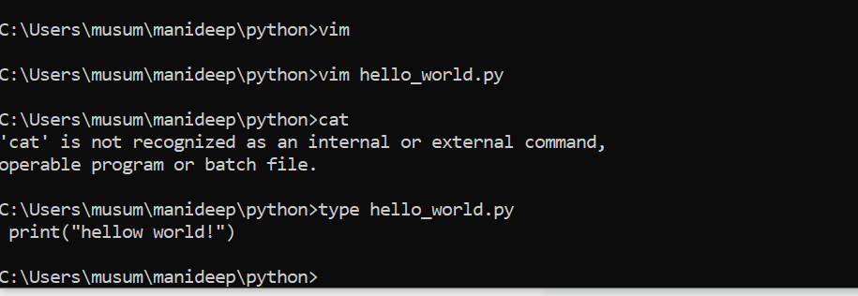

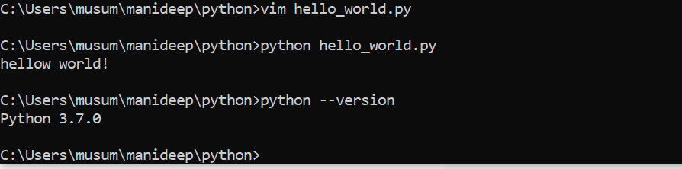

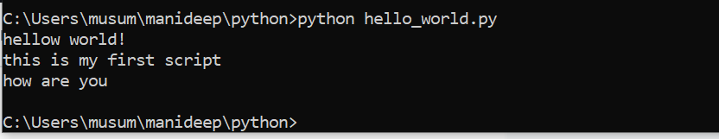

If you want to run the with the other versions of python, we can use the path where the python was installed c:\python27\python.exe hello_world.py

Indentation:

Indent---: space to represent a block of code

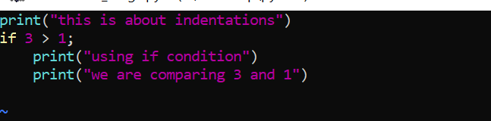

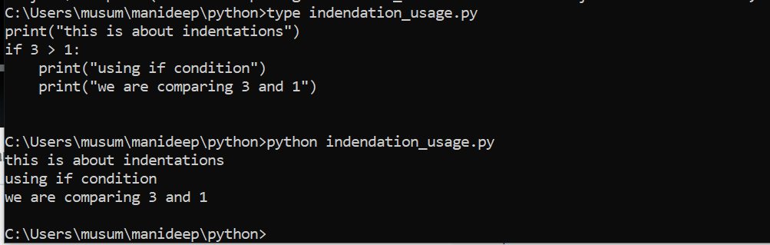

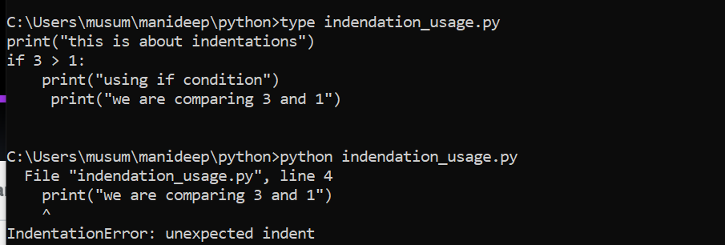

print("this is about indentations")

if 3 > 1:

print("using if condition")

print("we are comparing 3 and 1")

print(“this is manideep”)

if all the three printf statements are on the same same line and space is also given we can say it is a block of code if you are giving 3rd priftf statement on the different line and also its not matching the space provided with the above two then it wont comes to a block of code if the third printf is having a different statement above it it is again a new block of code

python comments:

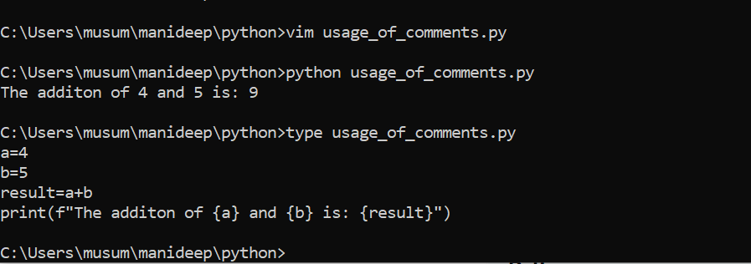

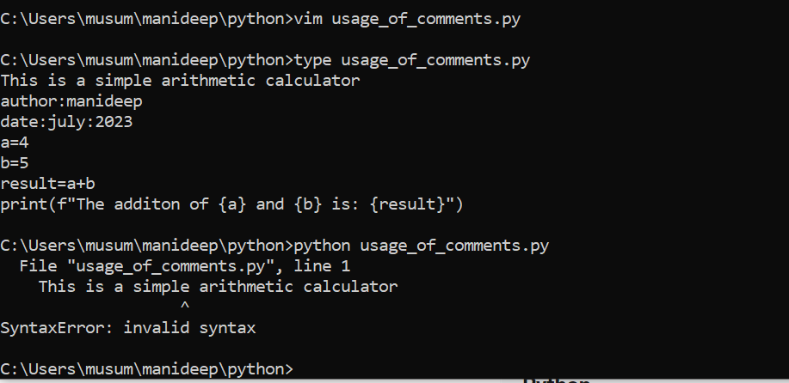

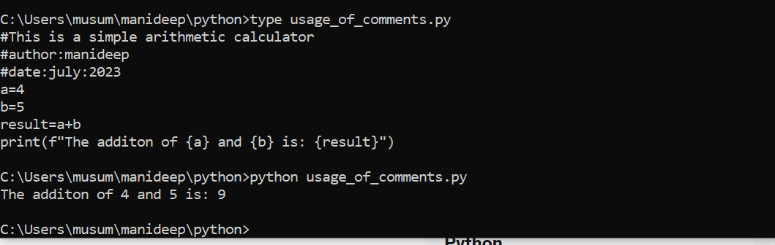

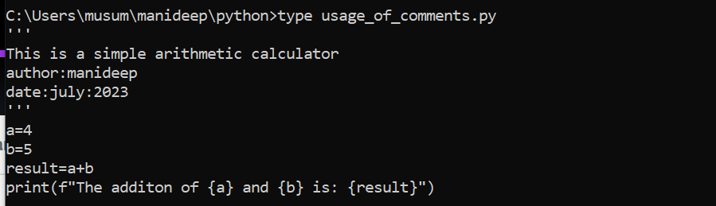

‘’’

‘’’

“””

“””

All the above are also used to uncomment the steps

Special character:

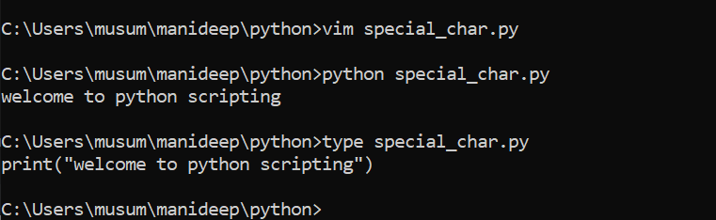

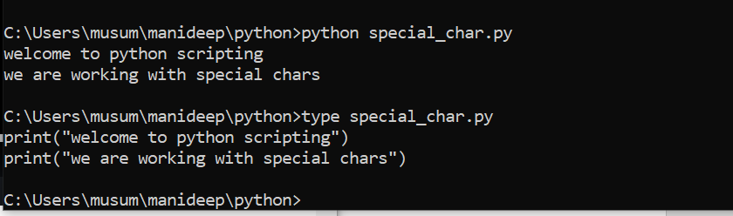

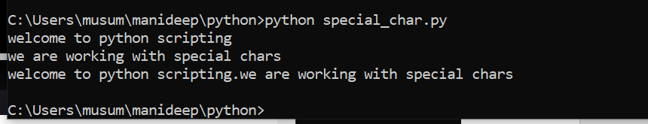

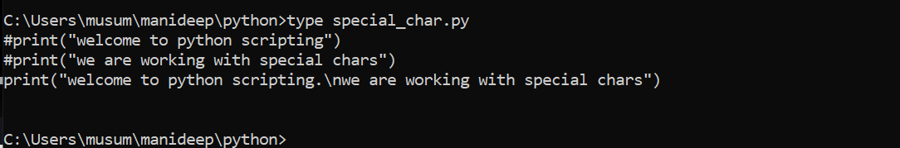

First two lines are commented.

\n will print the output in the new line

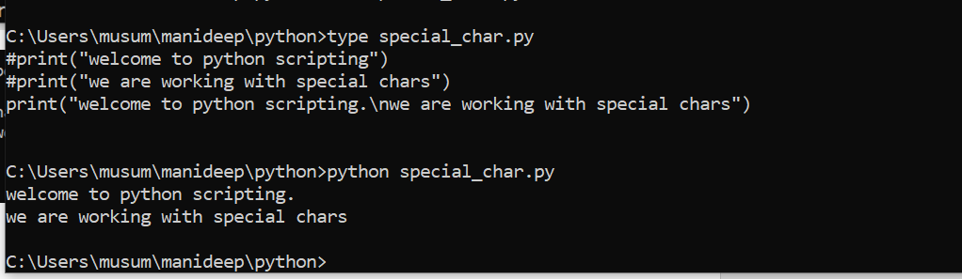

Write special chars only inside of quotes -🡪’’,””

\n new line--🡪new line

\b ---🡪back space

\t ---🡪tab

\---🡪escape symbol

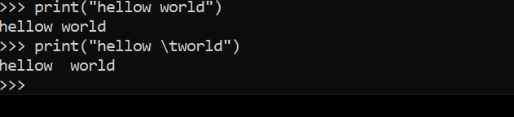

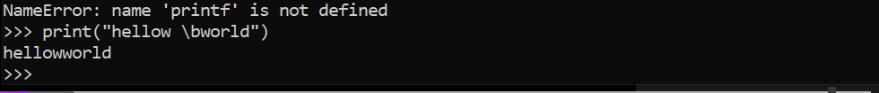

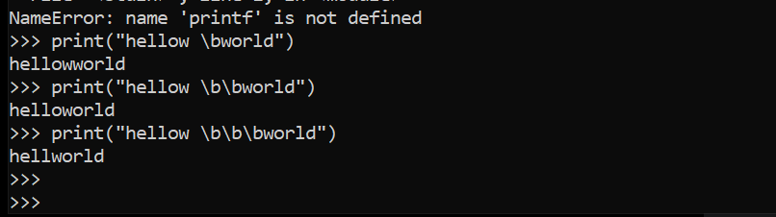

It will remove the spaces and also words based on the given number of \b



Tab will be used to give space

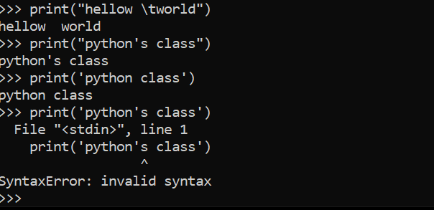

We can use singe quotes also but while doing it we will see error because python’s ‘s is considering as an end of the quotes

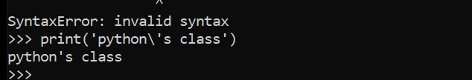

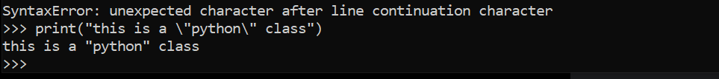

\”python\” class”)-----🡪for escaping the details

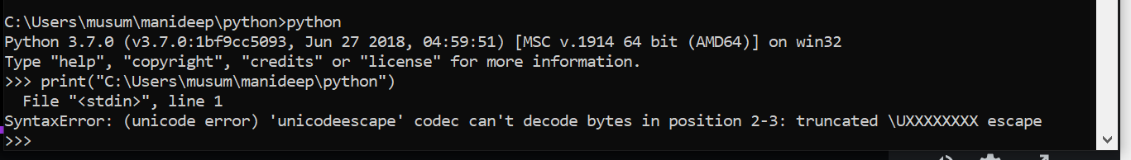



If its windows path we need to mention double slashes if its Linux we can go ahead with single paths.

In linux

Python –version

Python3 –version

Python hello_world.py

Which python3---🡪to check the location of python

/usr/local/bin/python3

On the top of the script use this path

#! /usr/local/bin/python3-----🡪shebank line (we are mentioning the interpreter to run the python script)

Chmod +x filename.py

./filename.py

Python hello_world.py

The below command is used to run the python which is in different location

/home/ec2-user/pythonscripts/hello_world.py

If you are having python on the same location run it from the location using

./hello_world.py

Working with variables:

Variables:

A reserved memory location to store values

No need to declare variable before using them

Dynamically programming language

A=10

Print(a)

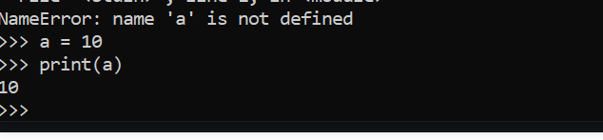

Done write quotes around the variable name

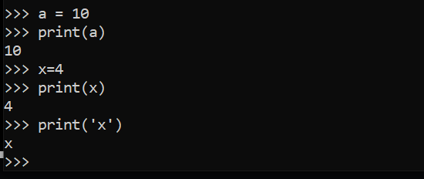

If you are placing words in the single quotes it will show the accatis values

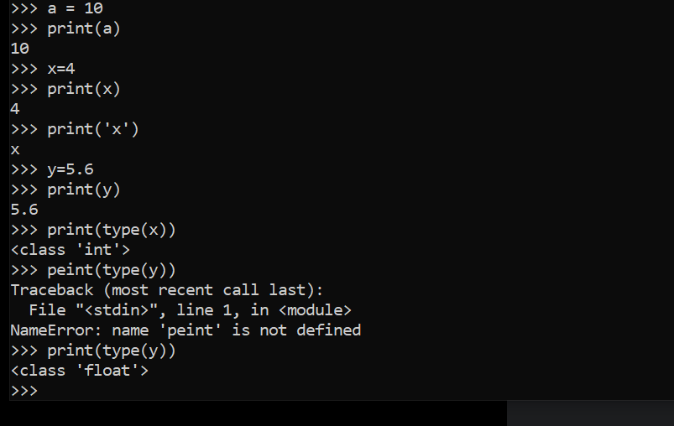

Redeclaring values

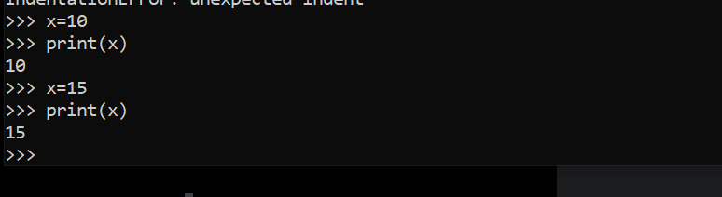

Changing a variable is mulcher easy it will execute from top to bottom if we are redeclaring the value it will take the new value

Deleting variables:

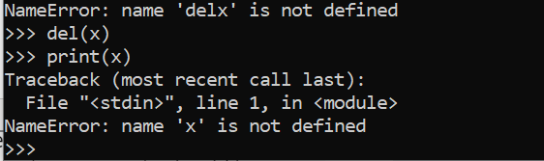

Rules to define a variable name.

It contains letters, numbers, and underscore.

Don’t take special char like $

Don’t take predefined words like if print

Can’t contain spaces

It should not start with a number

Case-sensitive

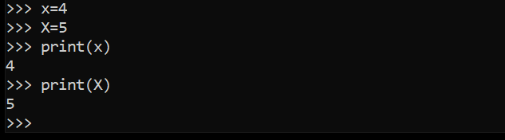

Datatypes in python (variable datatypes):

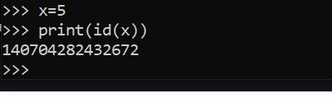

Print(id(x))

This will give the memory location of this variable.x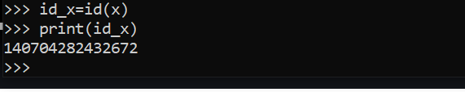

We are assigning id_x=id(x) and we are calling them hear

Every value in python has a data type

Since everything is an object in python programming, data types are actually classes and variables are instance(object) of these classes.

There are various data types in python.

Basic data types are:

1)Number (int, float and complex)

2)strings

3)Boolean

Note: type(variable_name) will give the type od data stored in variable

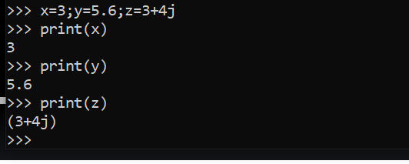

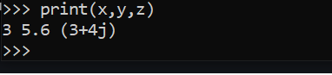

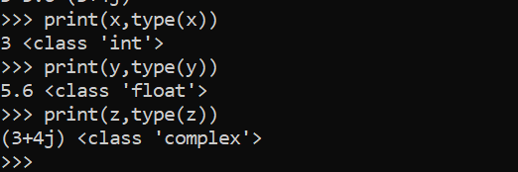

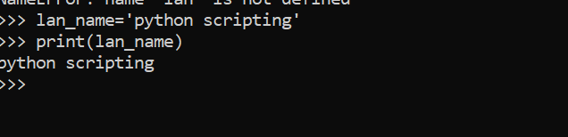

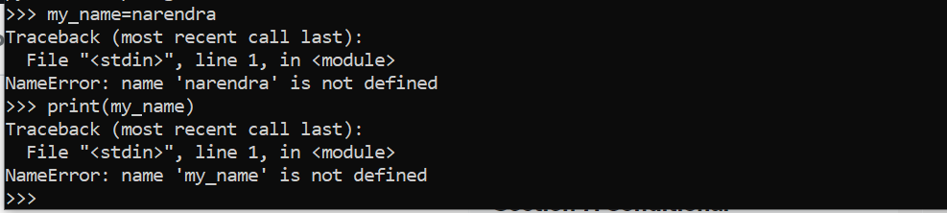

In the above screen shot name is not defined so it is showing that my_name is not defined

And also if we are doing it in a variable kind of thing

X=2

Y=x

Print(y)

Above will print x value because we are defining the variable.

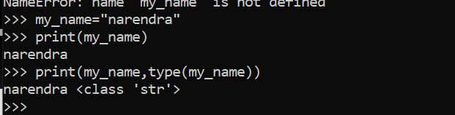

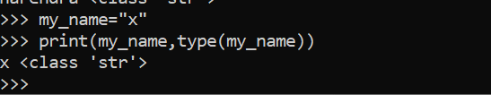

We can take single value also a string

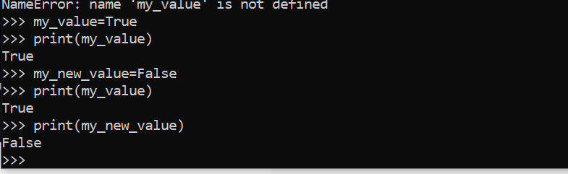



If the above is Boolean like true or false no need to specify in quotes and also True,False first letters should be caps

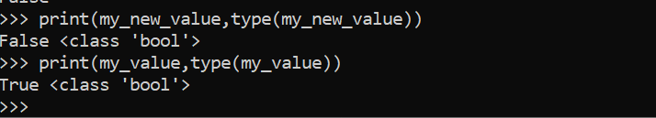

My_value=”TRUE”---🡪this will consider as a Boolean value

Typecasting: or type conversion:

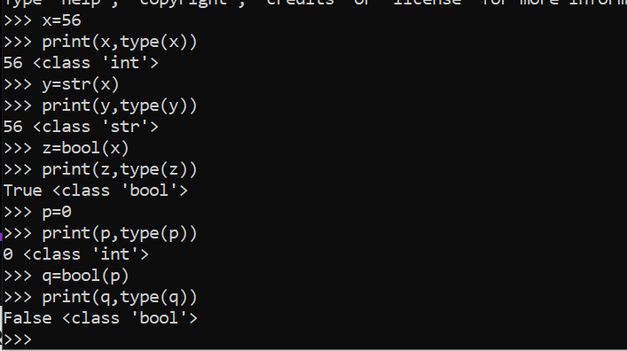

Converting values from one value to another value bool to int int to numeric etc

Int,float,complex

Str

Boolean

Note:any data type can be converted into Boolean

Bool(any_data_type)=true or false

Bool(empty)=false-🡪bool(0),bool(none),bool([]),bool(()),bool({})

Bool(non-empty) =True

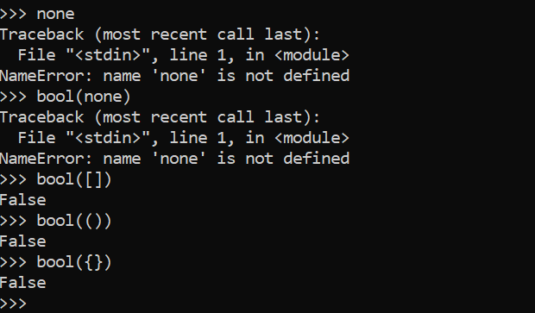

Any data type can be converted into a string but reverse is not always true.

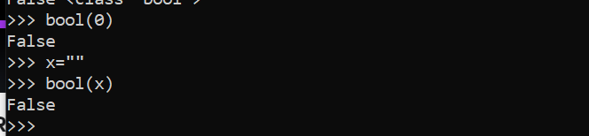

Always define versions as a string not number

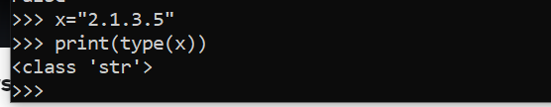

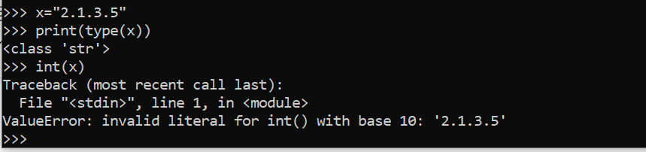

In the above screenshot we can see 2.1.3.5 can’t be changed as a number because this version is not a standard number so we always consider it as a string

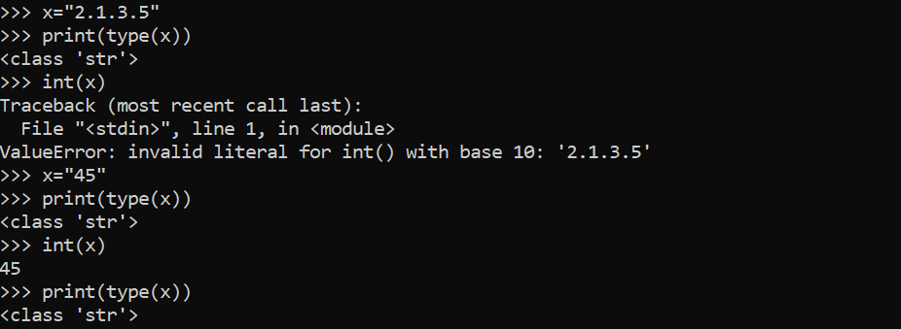

bool(100)=true

bool(0)=false

print with variables(s) and string(s):

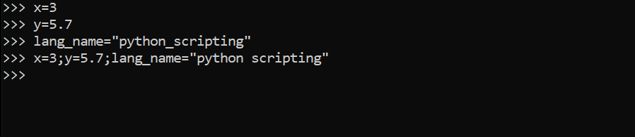

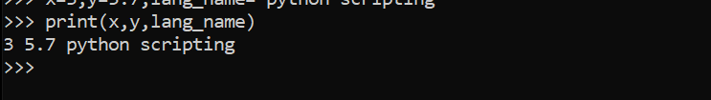

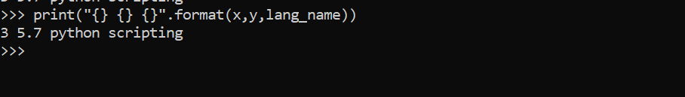

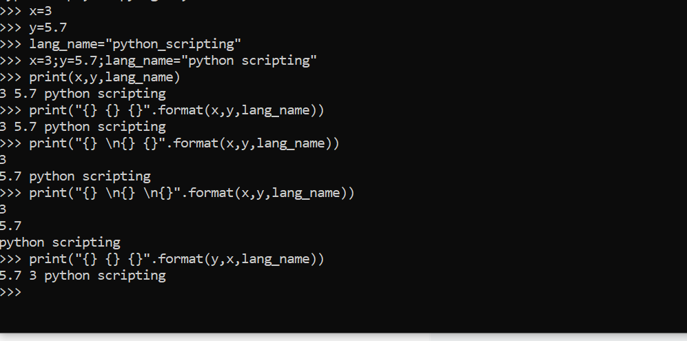

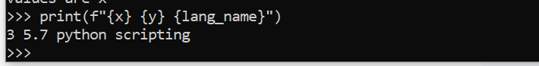

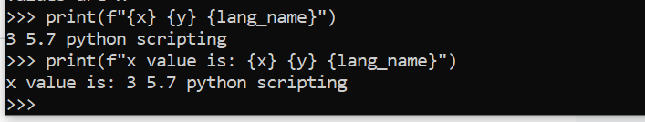

Value is --🡪 this is consider as a string

{x}---🡪 values inside the brackets are considered as variable and it will print the variable



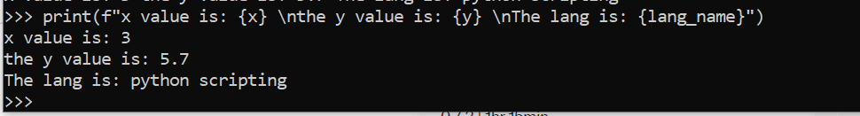

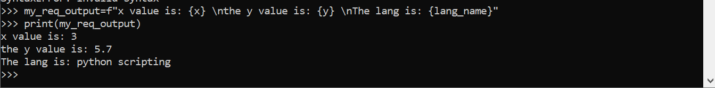

Input and output statement of python and using of eval function:

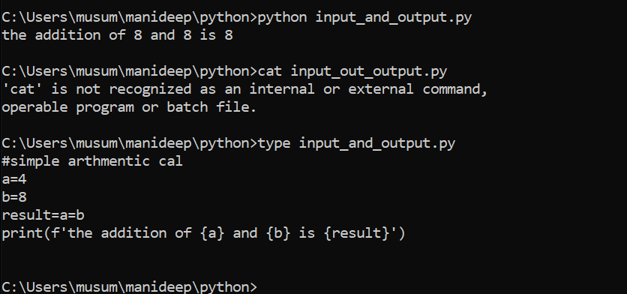

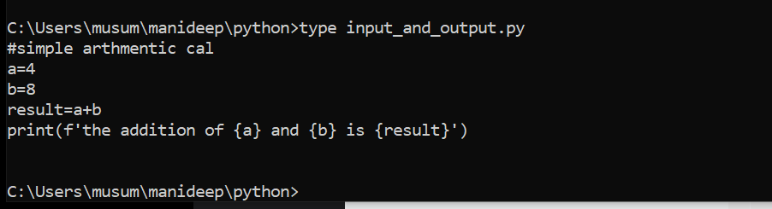

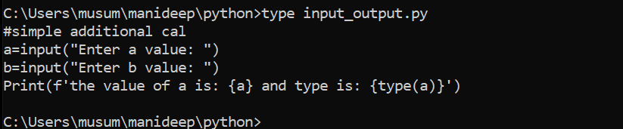

Instead of giving the value we can read the value from the command line to pass it and once fetched we can get the result.

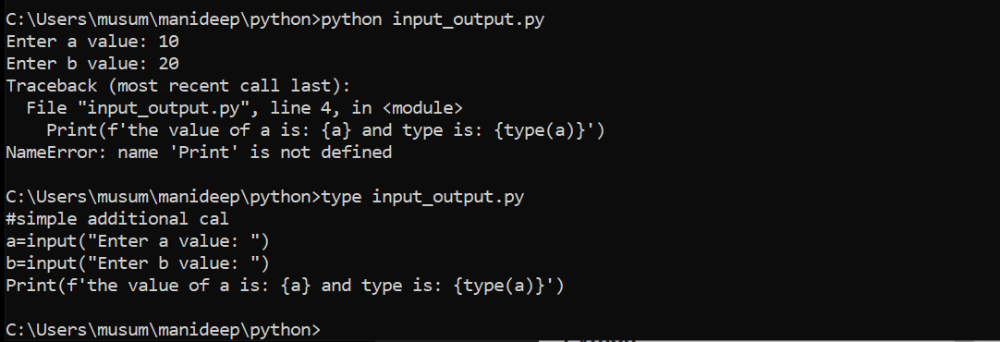

It will execute It top to bottom

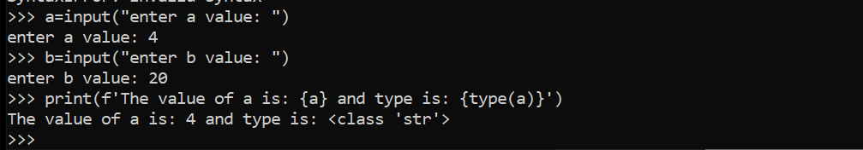

It is taking the values from given input from cmd and giving printing the result.

Only from python 3 we has this facility of print f

If you are reading your value with the help of input then always it is a string in python 3

In python 3 we has

Input to read numbers and raw_input to read string

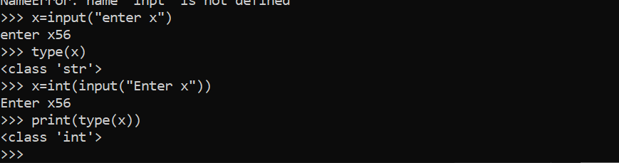

String is converting into integer.

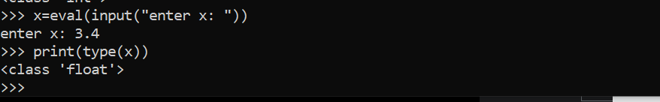

Eval function will automatically convert it into

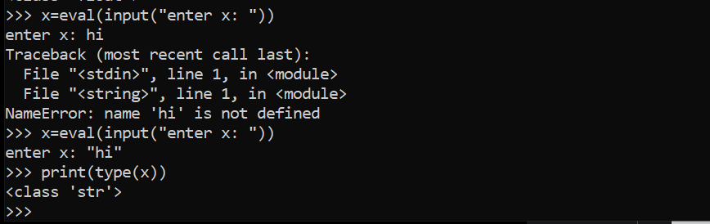

When ever you are using eval function give your string values in double quotes

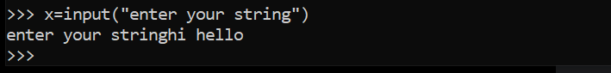

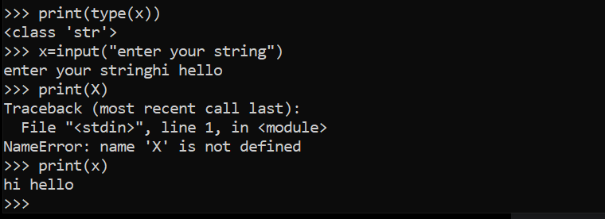

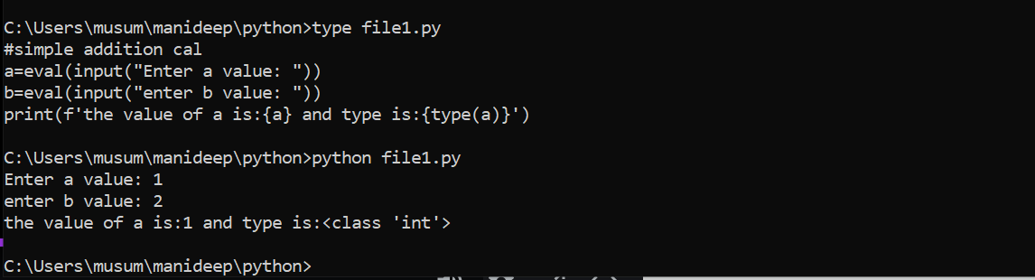

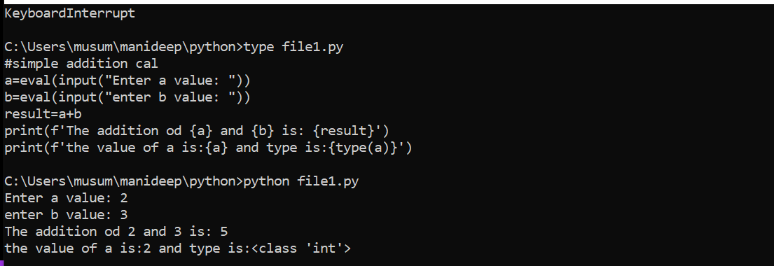

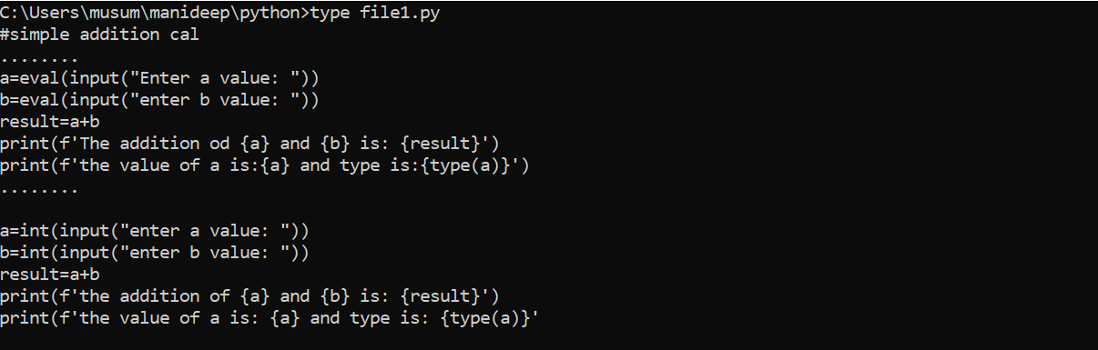

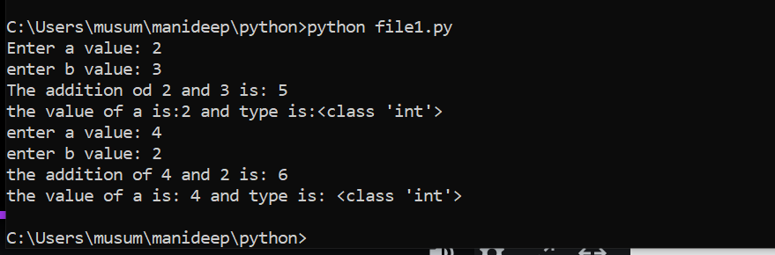

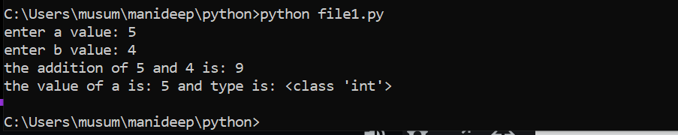

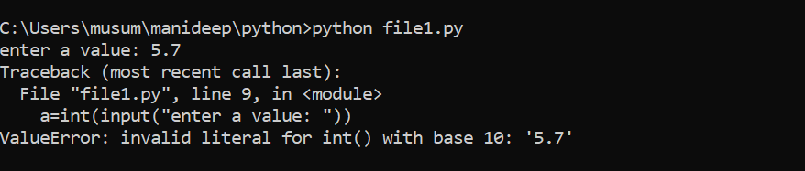

If we are giving 5.7 it is not taking because we are seeing it is floating point and we have mentioned as integer value

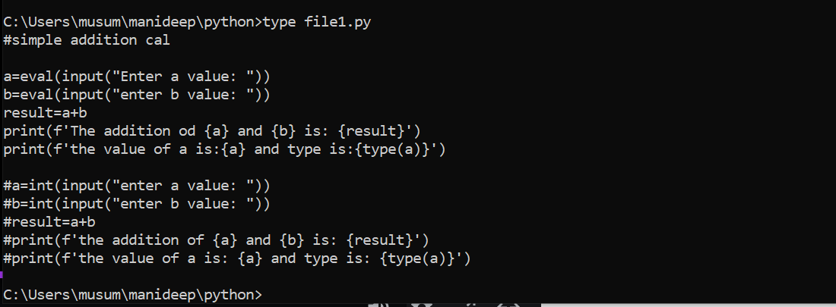

If you are taking eval automatically values will be converted and then it will display the result automatically.

Basic operations on strings:

String-🡪 a sequence of characters

A character is a simply a symbol. For example, the English language has 26 characters.

Computer do not deal with characters,they deal with numbers(binary).even though you may see characters on your screen, internally it is stored and manipulates as a combination of 0’s and 1’s

The conversion of character to a number is called encoding,and the reverse process is decoding.acii and Unicode are some of the popular encoding used

In python string is a sequence of Unicode character. Unicode was introduced to include every character in all languages and bring uniformity in encoding.

How to create a string in python:

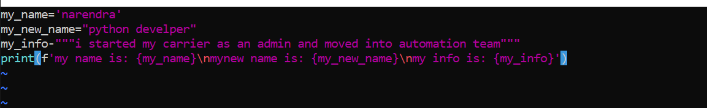

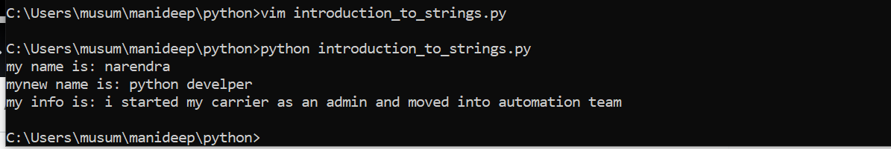

In the above we have used single quote double quote and triple quote, but the output is same

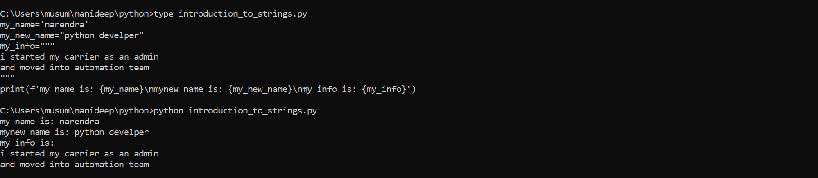

If you are mentioning the long script in between these two columns like mentioned above

Python then consider it as a single line

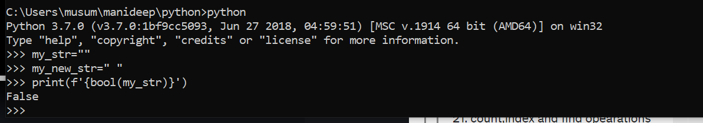

In the above screenshot we are seeing empty space in between the double quotes are also

Consider as a value and also if we can printing it with bool it will check and give the output if

It is true or false

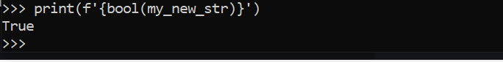

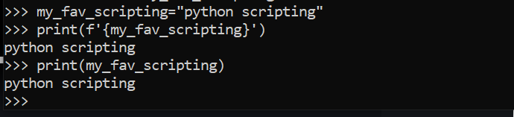

Index values:

My=python

012345

P [0]y[1]t[2]h[3]o[4]n[5]

-6-5-4-3-2-1

Starting index value is always zero and keep on counting

And negative index value is always -1 and it is the end of block

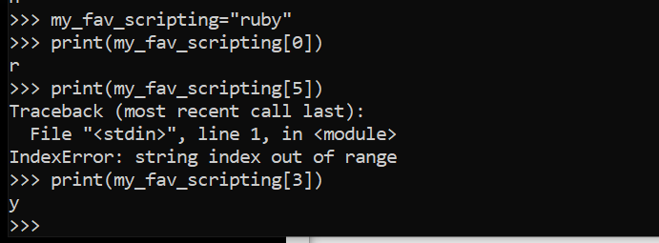

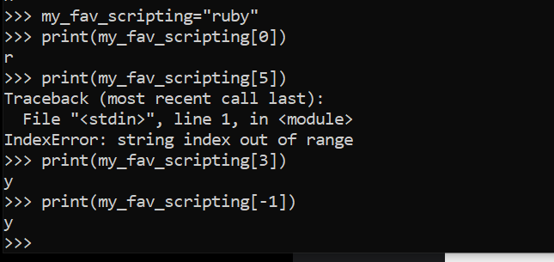

-1 is giving the last value

This value -1 is is giving the last value of the string what ever it maybe it will be giving the last value of the string

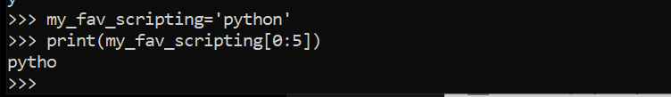

The above screen shot is showing the 5 values starting from 0 to 5 so we need to get 5 values 5 values are pytho

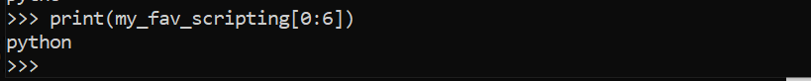

The above screen shot is showing the 6 values starting from 0 to 6 so we need to get 6 values are python

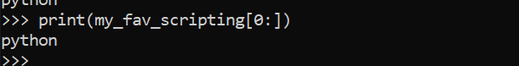

It will print all the index values like from 0 to n last value

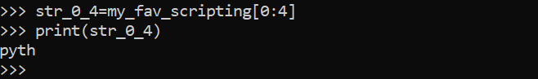

In the above screen shot we have defined from 0:4

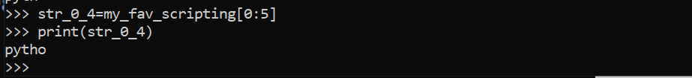

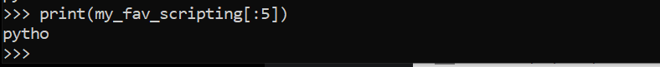

How to change or delete the string

Strings are immutable. This means that elements of a string cannot be changed once it has been assigned. We can simply reassign different strings to the same name.

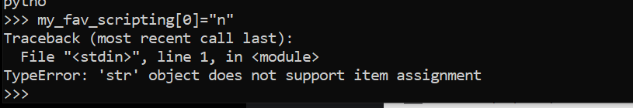

We can’t change the new value to the string values once assigned cant be changed

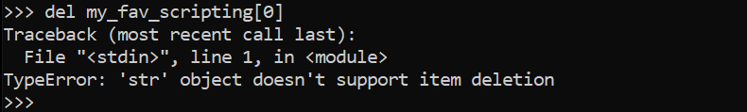

We can’t even delete the part of the string we can only delete the entire string

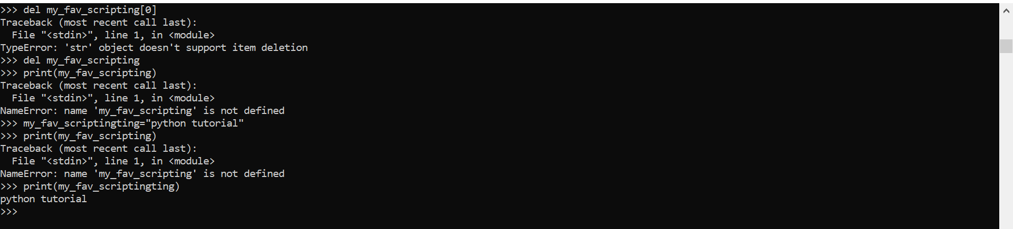

In the above screenshot we have deleted the entire string

Del my_fav_scripting

So while printing it is showing an error.

How to find the length of a string:

Pre-defined function called Len

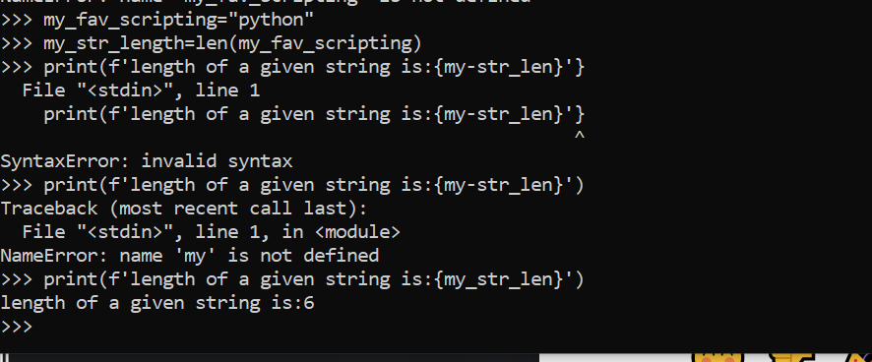

It will show the length of the string



Length means how many length in a given string

If string is having 16 values then string length is from 0 to 15

Negative index values are -1 to -16

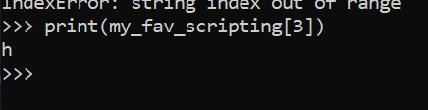

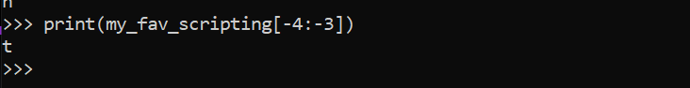

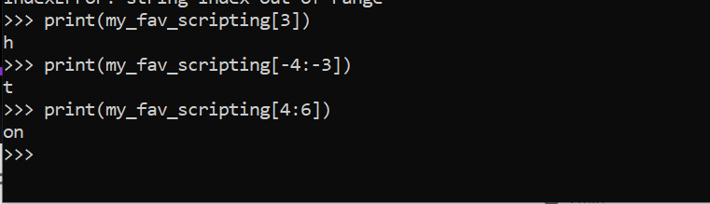

How to add/concatenate two strings:

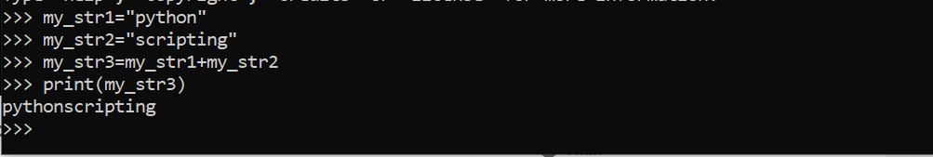

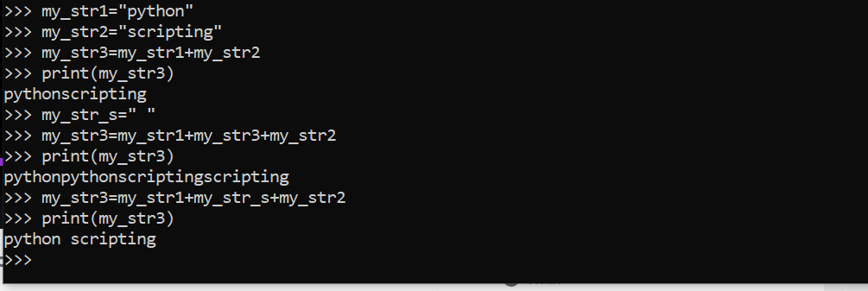

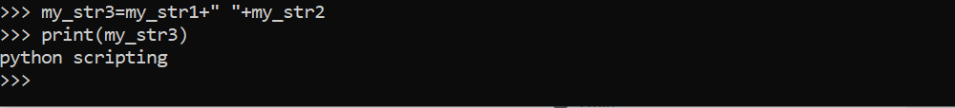

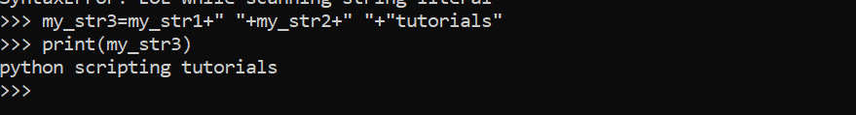

Case conversion operations on strings:

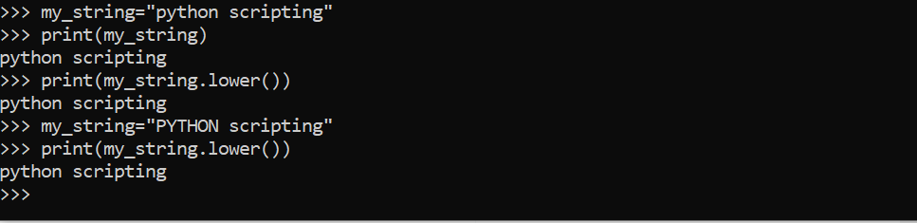

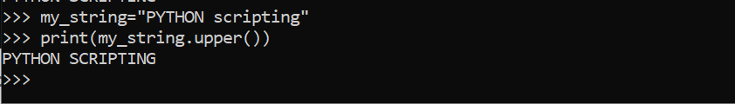

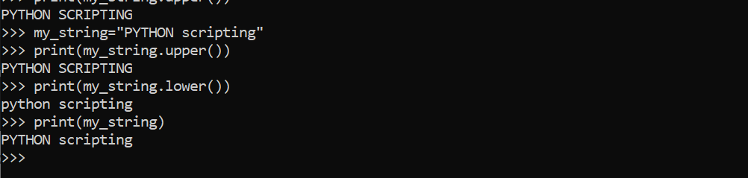

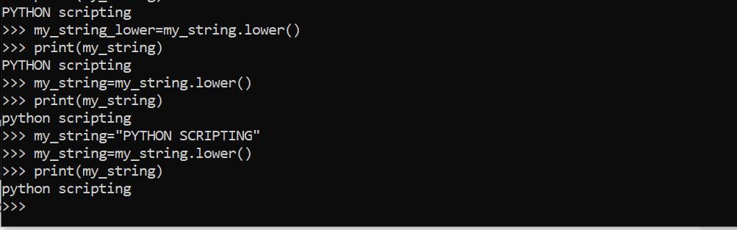

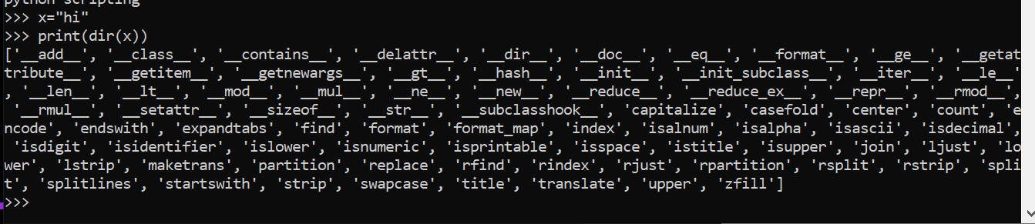

Available operations on the given string

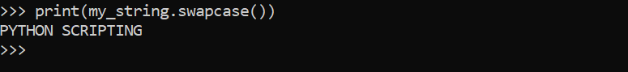

When ever you are printing the details in print f after the. operation it won’t disturb the original string it will only make changes in the. Operation.

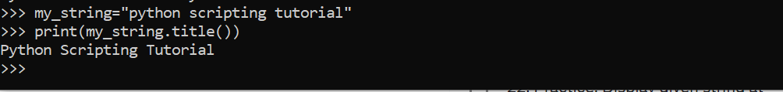

Python scripting tutorial all the first words are in capital as we are using title format hear .

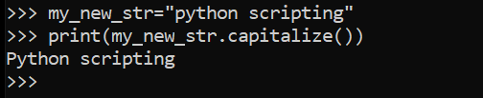

Capitalize is used to mention the first letter of the string in capital.



These above details will show all the possible values of mentioning the string values.

Like changing the values

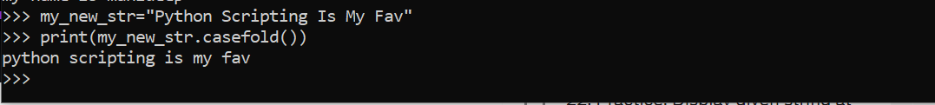

Changing all the values to lower case

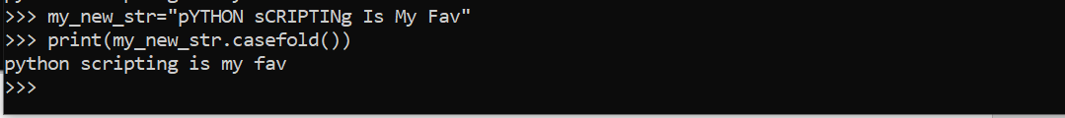

Instead of lower operation we can use case fold

Boolean result operations on string:



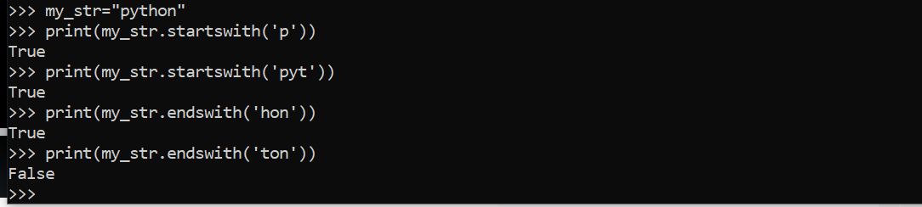

If the string does not exist with ton it will throw the result as false. Because it does not exist.

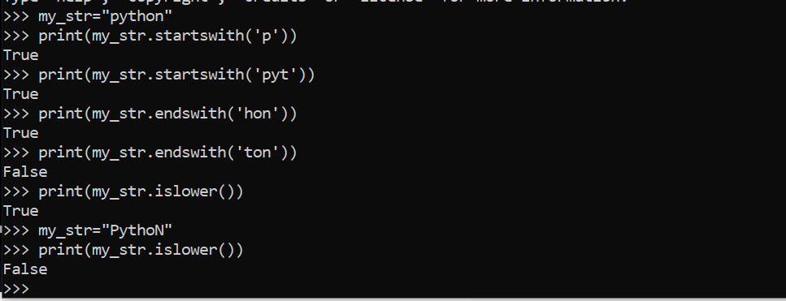

Is lower())

Hear the values are having higher value P-🡪caps and also N-🡪caps so it is showing as false.



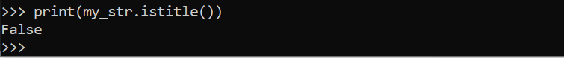

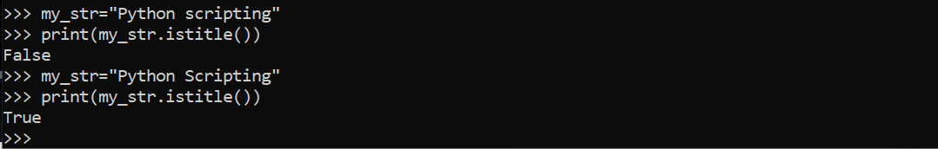

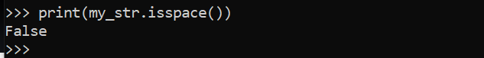

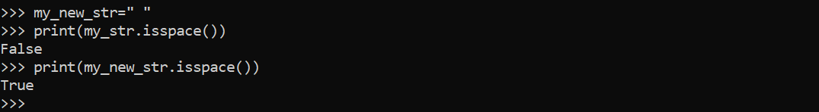

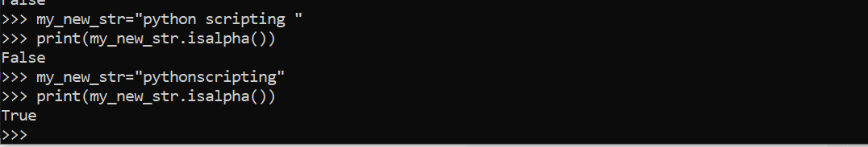

If we are having spaces between string, it will give result as false and if we are not having any spaces between string it will give the output as true

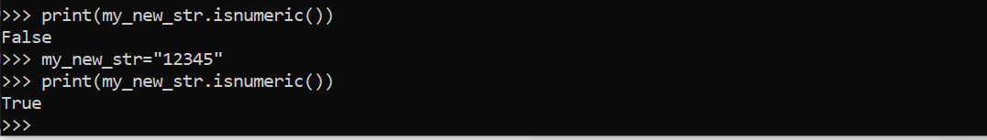

Is numeric will give result as true if the string is having the numeric value.

Help(str)=🡺 it will show all the operations,

Join, center and zfill string operations:

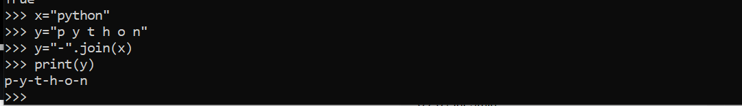

If we are defining the above value python like P-Y-T-H-O-N hen by using this y=”-“.join(x) this will be useful it will automatically prints the value like P_Y_T_H_O_N

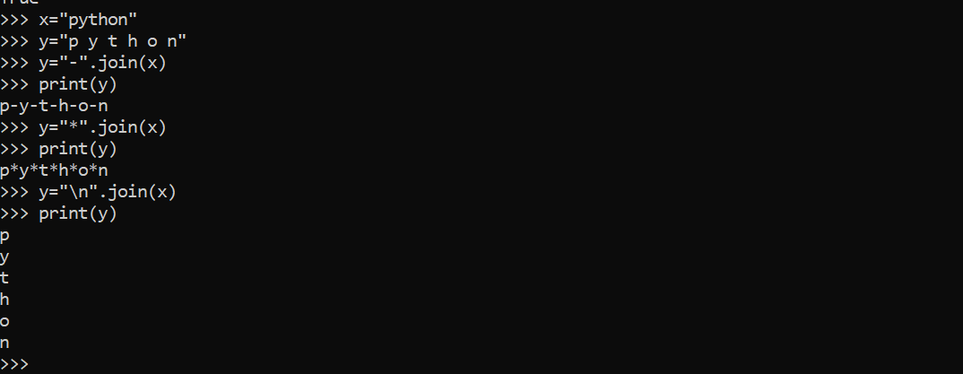



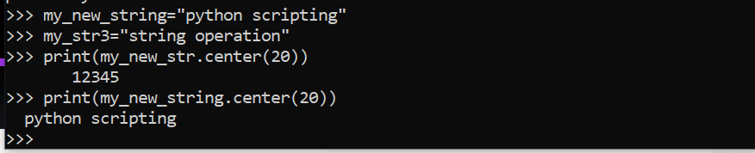

It will print the values with the gap making it centre

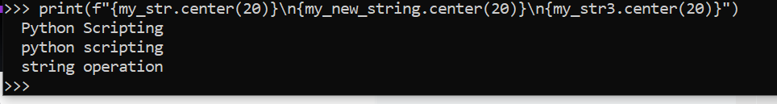

It will print all the things in an order. From the middle taking 20 length and equal distance from both the sides

Padding:

Filling the values with zeros or required values in before the string

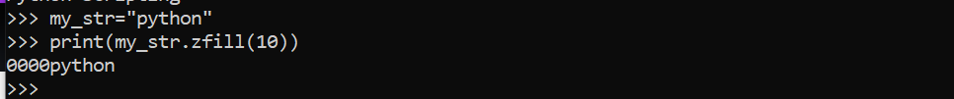

Values before the string are padded with zeros

Strip and split operations on strings:

Strip: it is used to remove space towards left or towards right of the string starting or ending

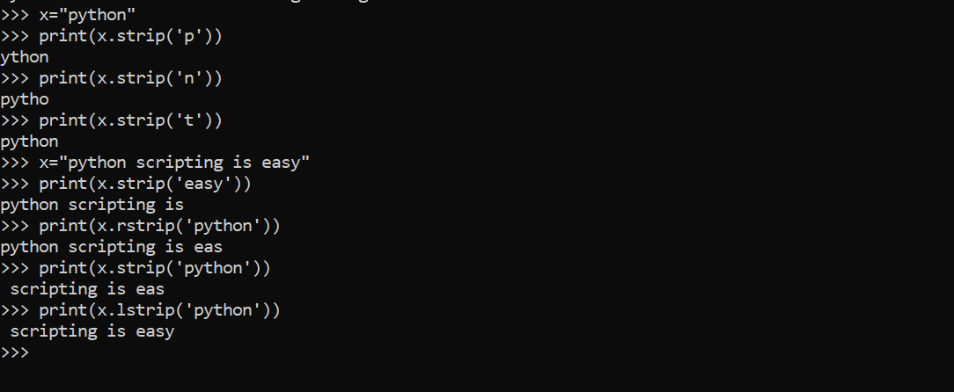

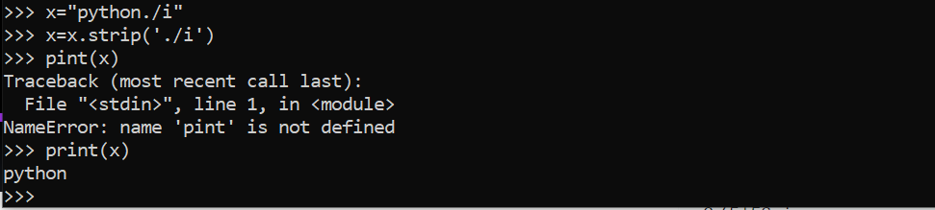

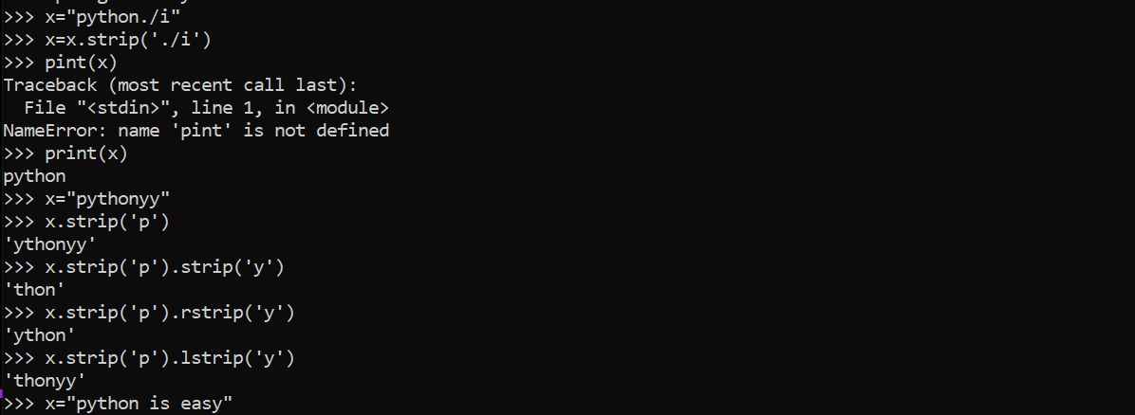

Split:



It will split the single value into multiple values

It will split into multiple values

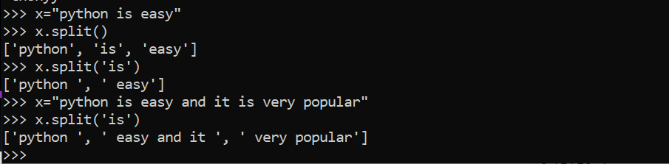

It will split the values based on the mentioned values.in split functionality

Count, index and find operations on strings:

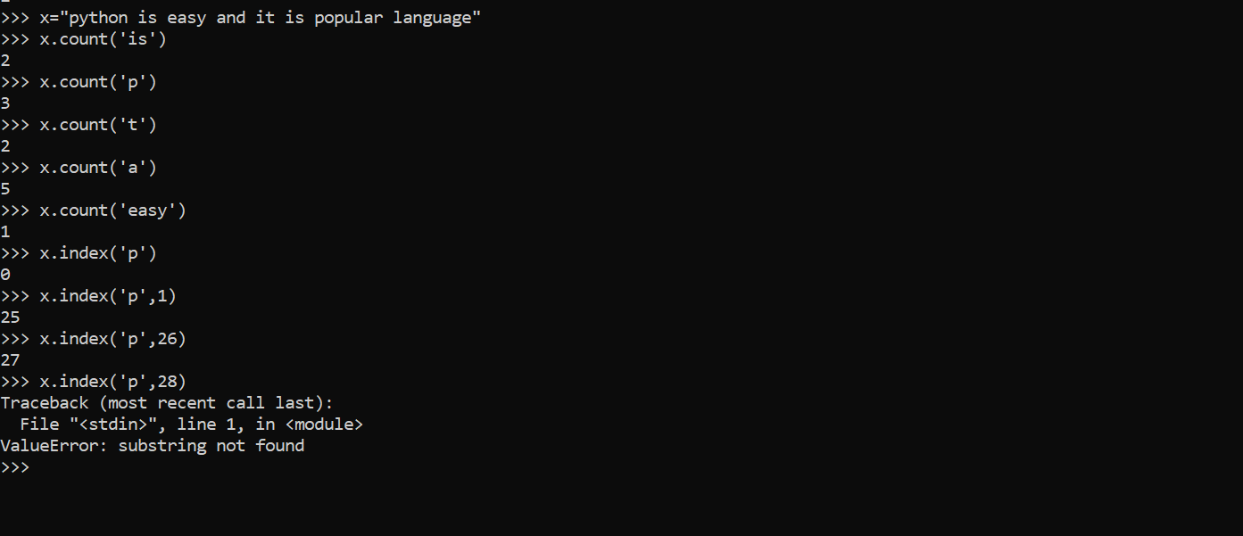

In the above screen shot it is giving the value count of string values and also it is searching the index values searching from left to right and it will consider the first value x.index(“p,1”) it will start from

Left to right but it will skip the 0 value and start from 1

And after 28 we are not having a word called p so it is giving an error

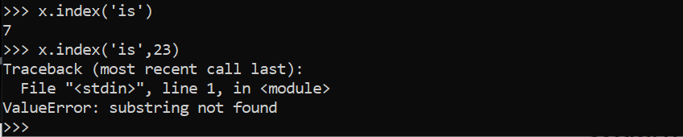

After 23 is not there and not mentioned.

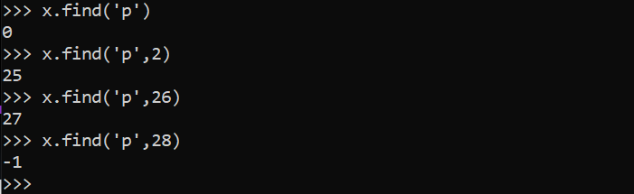

After 28 we are not having any p letter, so it is giving output as -1



It is not having any values which represents z so it is giving the value as -1

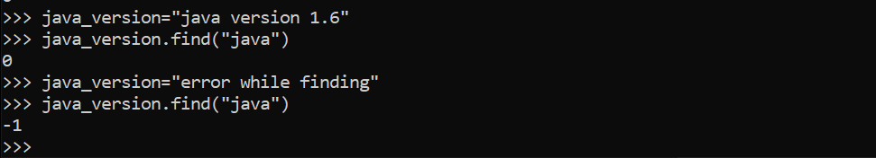

The first value is defining there is a value

But the second is defining there is no value

Practice with string operations:------------

Display given string at right/left/centre of a line in tittle format:------------

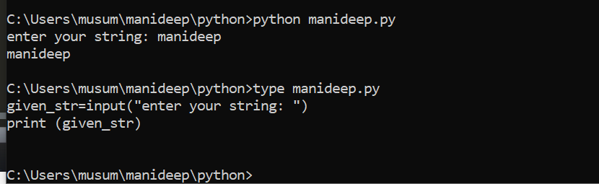

Reading the given input: in the above screen shot

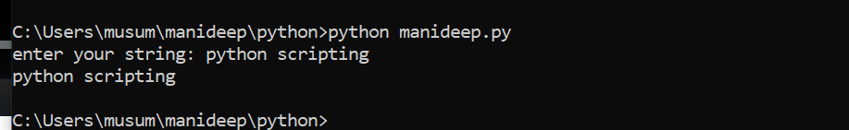

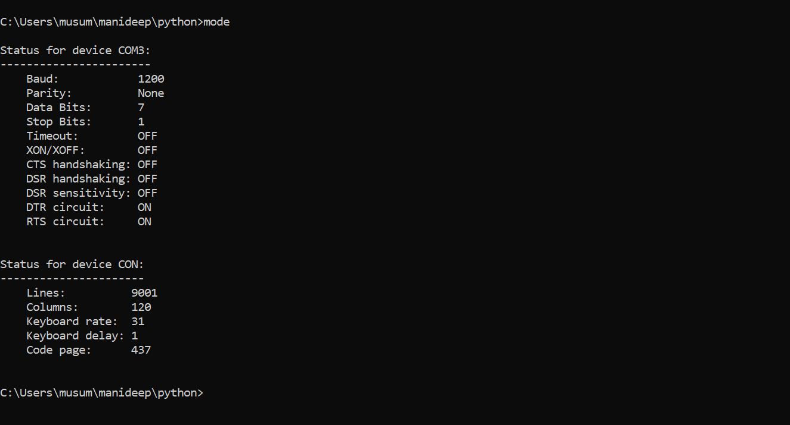

In the above screen shot there are 122 columns as width mode will give all such details

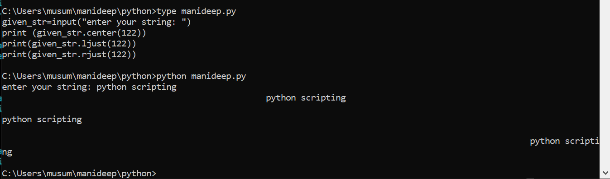

This is used to move the values to centre to left to right and to centre.

Tput cols:

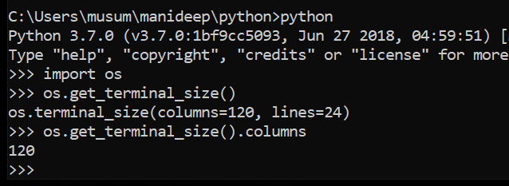

To get the column details

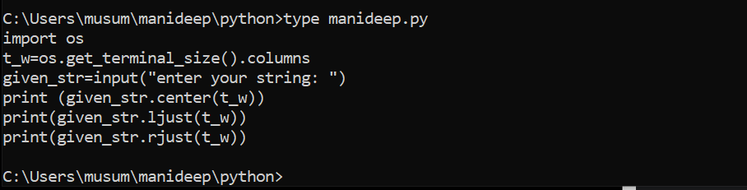

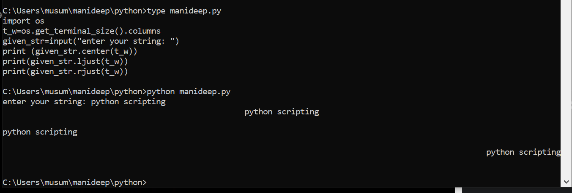

This will get the string details automatically and print the output line by line with the correct details.

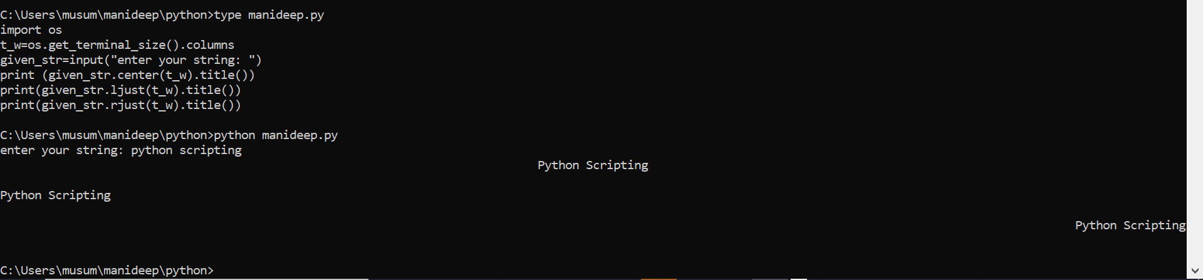

It will print all the values in title format P____>cap and s_____>cap

Data structures of python:

Data structure variable holds multiple values

Normal value holds only single value

Print(x)

5

My_values=[3,4,5,’python’,’devops’,5.6]

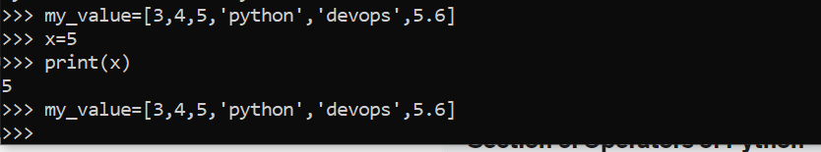

My_value is storing multiple values

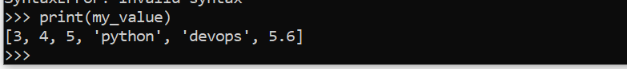

Data structures are used to store a collection of data

There are four built-in-data structures.

They are :

List--🡪[]

Tuple--🡪()

Dictionary---🡪{} with key value pair

Set--🡪{}

List data structure of python:

My_list=[]

My_list1= [3,2,4,” python”,5.6]

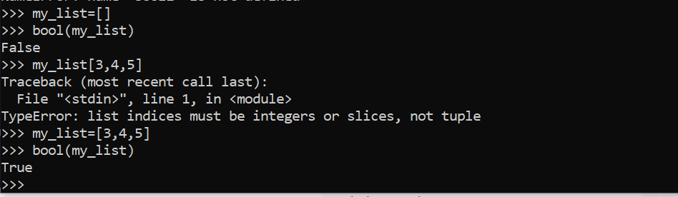

Bool(empty_list)🡺 False

Bool (non-empty list) ==🡺True

Hello--🡪0,1,2,3,4(negative=-5-4-3-2-1)

My_list1=[3,2,4,” python”,5.6]

Iv 0,1,2,3,45

Positive index:(0=3,2=1,4=2, python=3,5.6=4)

Negative index:(0=-5,2=-4,4=-3, python=-2,5.6=-1)



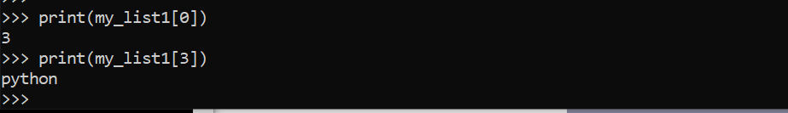

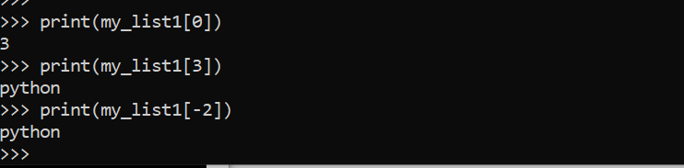

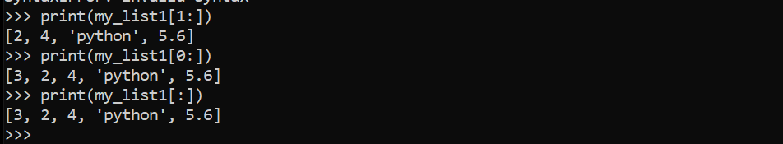

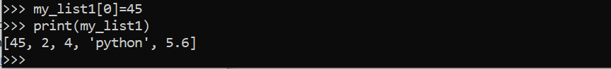

We are modifying the 0th value to 45

Lists are mutable we can change the values at any time

Strings are immutable. We can’t change the values in strings once they are assigned

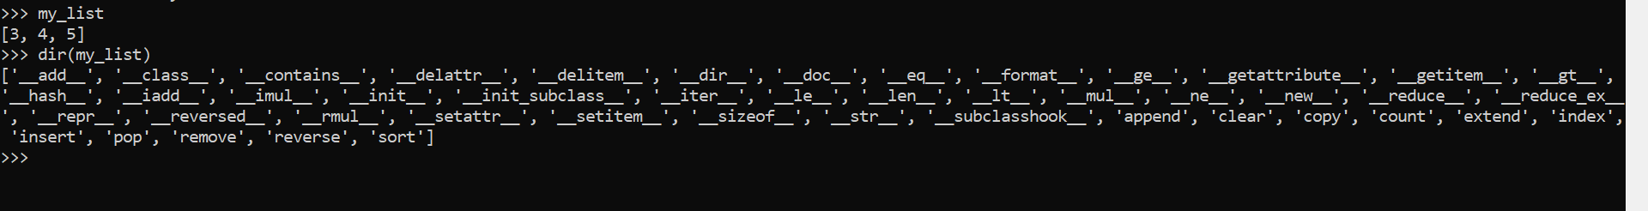

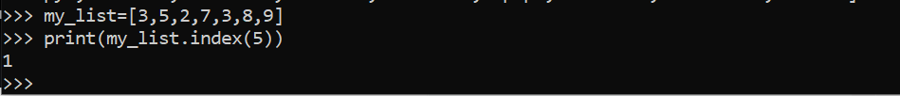

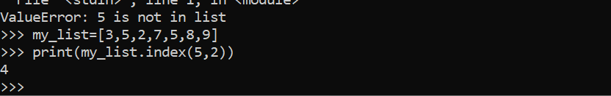

If there are multiple values we can

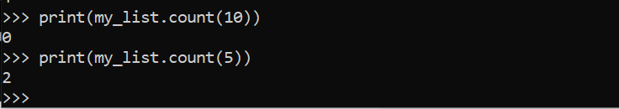 this will give the details of how many times it is listed

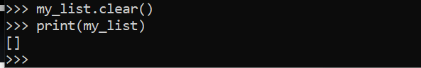

If you are modifying the things use them directly like my_list. Clear () done use it with print statements

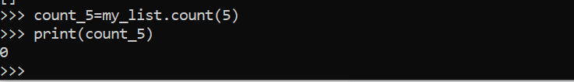

We are storing the variable in to other values and from there we are printing the data

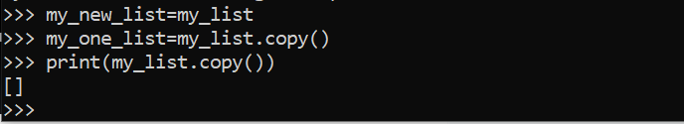

When every we are using the first step like my_new_list=my_list

In this memory location will be same for all the two values

My_one_list= my_list.copy()

When we are using the second one new address location will be assigned instead of the old one

Append: whenever you are modifying the list don’t do with print

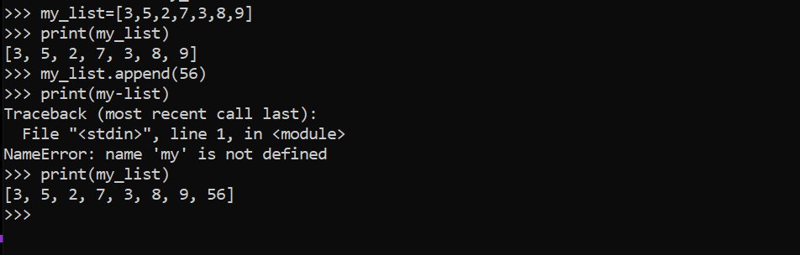

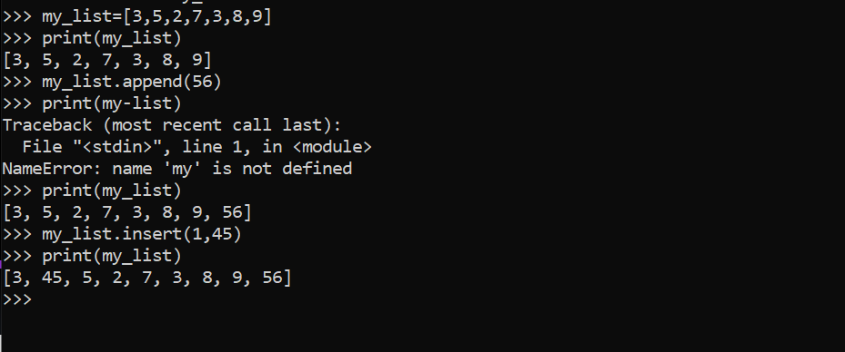

Append is used to add date at last but insert is used to insert data based on the reference index

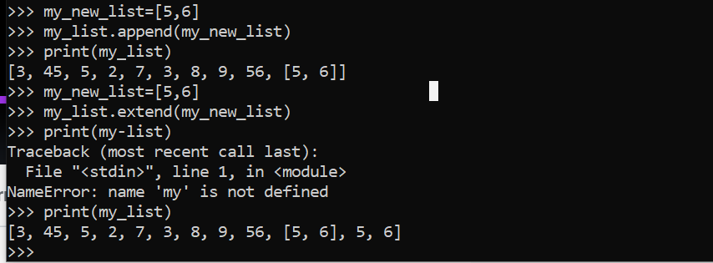

Extend: it is used to add the data as same as the string

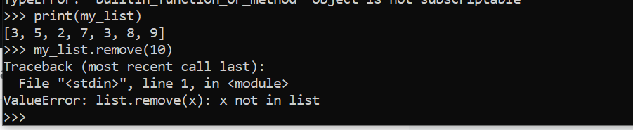

10 does not exists

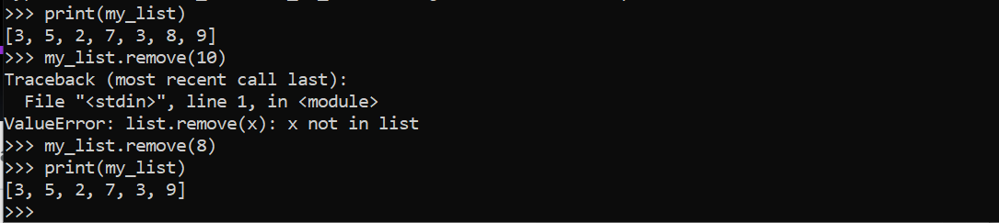

Now we are removing 8. number 8 is removed

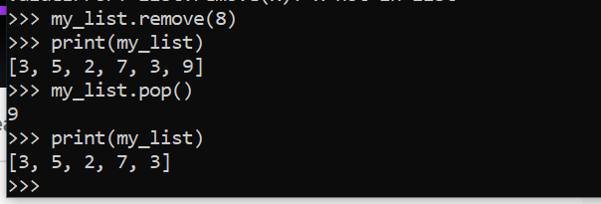

Pop will remove the last value

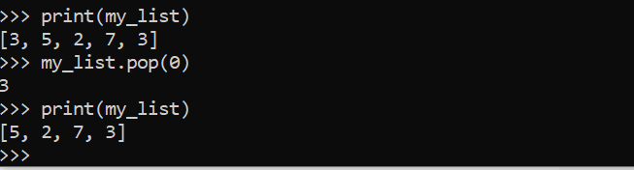

If you are mentioning the index value, we can remove the value mentioned in the index.

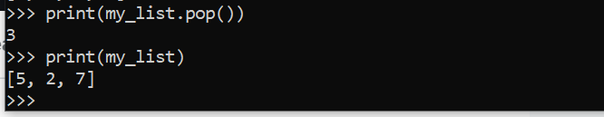

It will show which data has been removed print(my_list.pop())

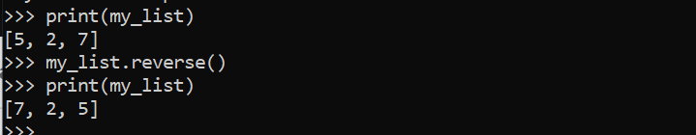

This will print the values in the reverse order

Mirror image of the data

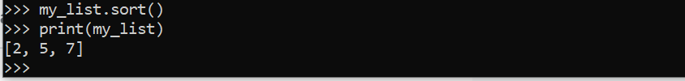

The above one will print the data in ascending order

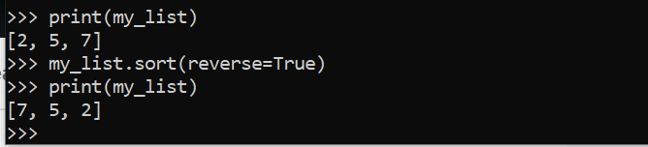

The above one will print the data in the reverse order.

Tuples:

Tuple data structure of python:

Define a tuple:

My_tuple=(3,4,5)

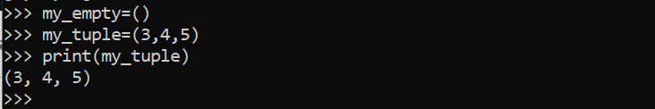

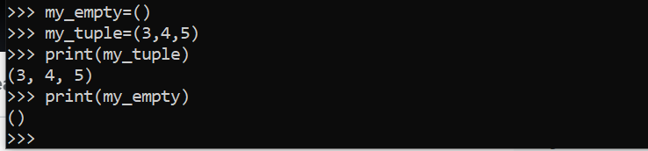

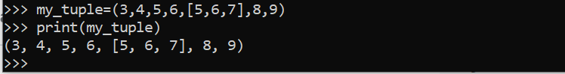

We can print string in between tuple

Indexing in tuple:

(3,4,5,6, [5,6,7],8,9)--🡪in the given statement 3=index0

4=index1,5=index2,6=index3, [5,6,7]=index4,8=index5,9=index6

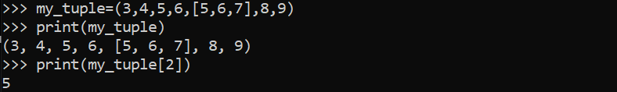

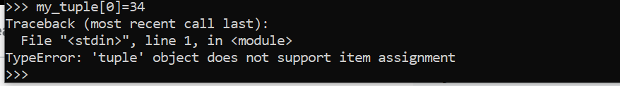

Tuple once assigned can’t be changed. They can be changed.

Modifying the part of the tuple is not possible.

Tuple and strings are immutable.

There are not much operation on tuple.



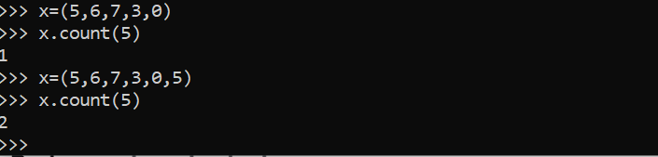

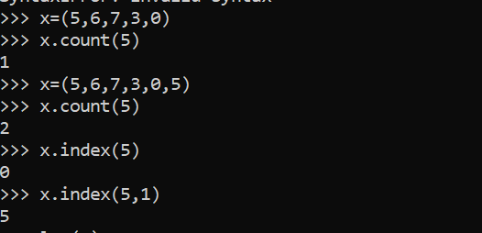

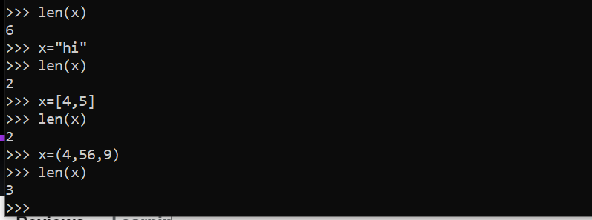

String,list,tuple length can be calculated by the above way

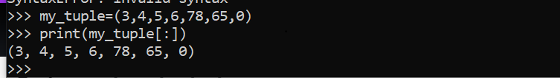

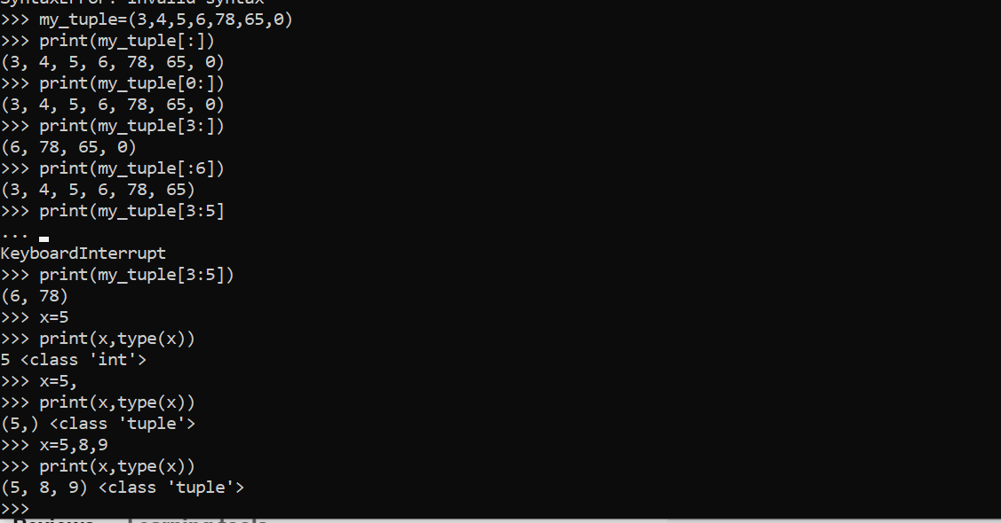

Lists are mutable tuples are immutable

Dictionary data structure of python:

Dictionary’s are represented with curly braces,

My_dict={}

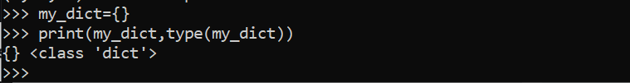

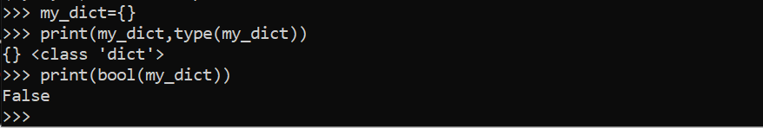

If you are writing the things as a key value pair and they are strings we need to mention them in quotations.





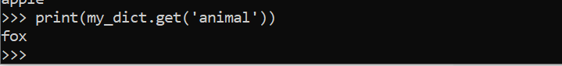

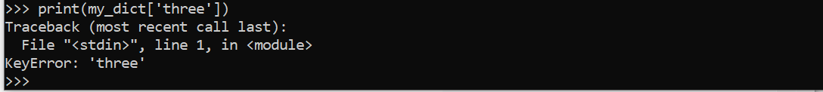

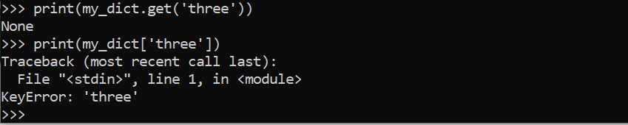

Operations which can be performed on directory:

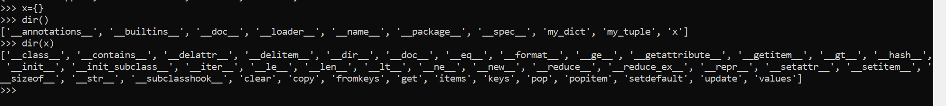

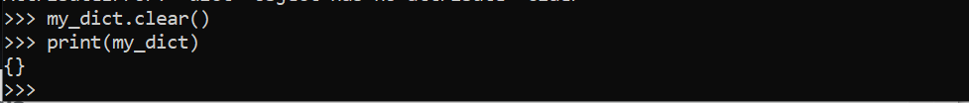

Clear() operation will clear the complete operations from the dictionary

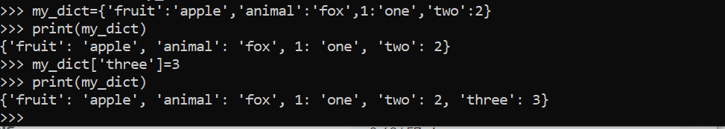

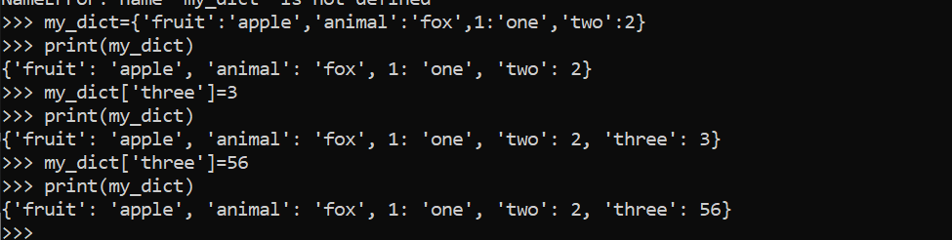

There is no key value called three=3 so new value is getting assigned.

If key is already there the whole value is getting modified.

Print(my_dict.keys())

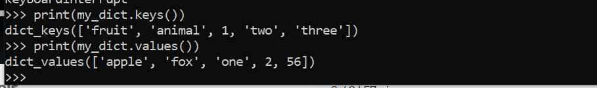



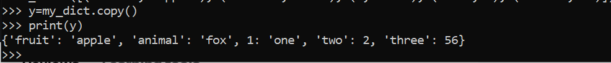

It will assign a new index value instead of old one it will copy the data to a new memory variable

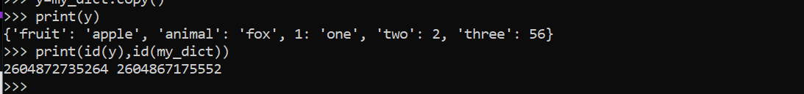

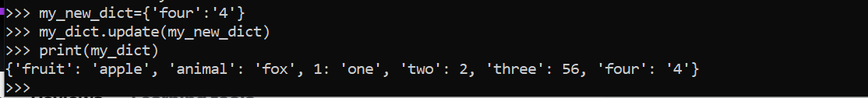

If you want to add one dictionary to other dictionary you need to use update dictionary

Pop: it is used to delete or remove the key value pair



We are giving only key it will delete both key and value pair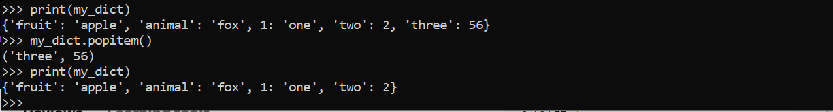

We need to remove random values by using popitem()

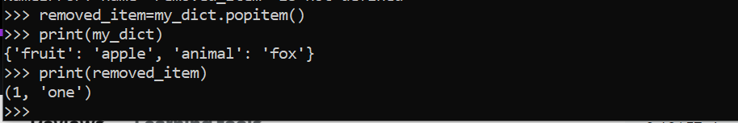

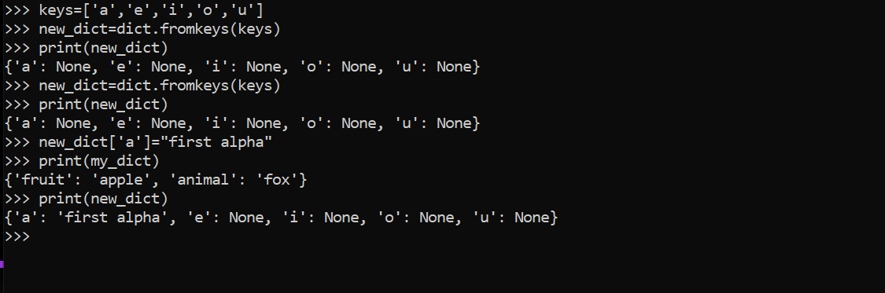

We can update the values as required.

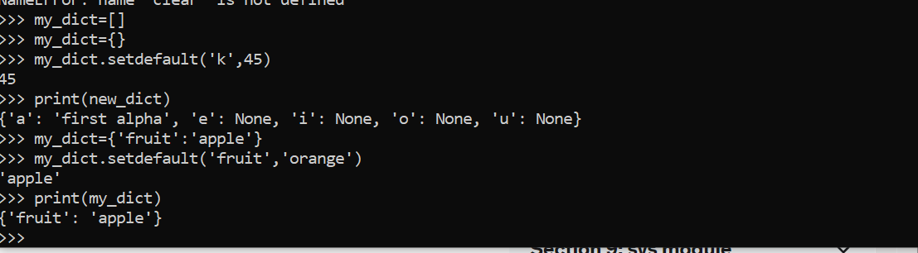

If we are setting this default value automatically if you are not providing the value for the key then

By default, it will consider the set default value

If key is specific, it won’t disturb if key is not defined it will assign the new value

Python(3.0) will print the values in the same order like how you defined

Before 3.7 there is no dictionary ordered collection of data in 3.7 and after 3.7 we are having ordered collection of data (dictionary)

Sets: data structure (default data structure)

Set is a unordered collection of data and if you give data multiple times

Duplicate data will get removed.

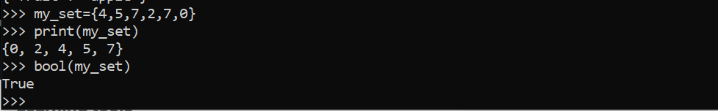

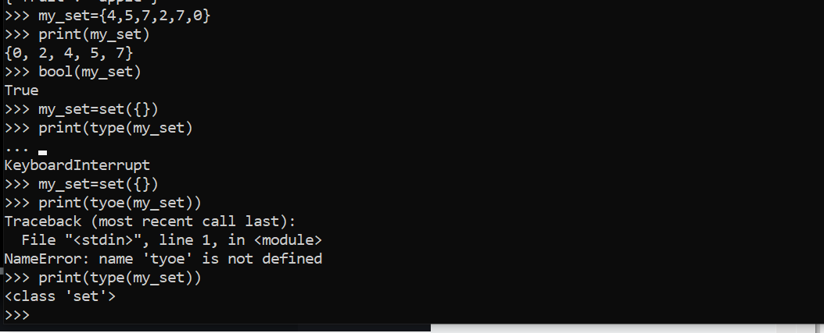

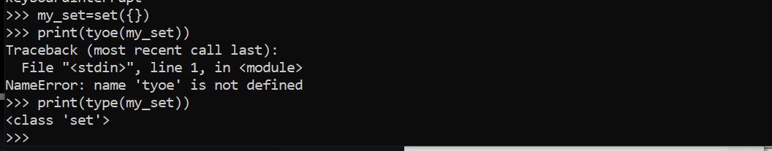





If we are given set it will only print the primitive values eliminating the main values

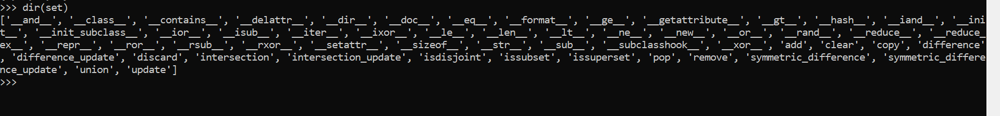

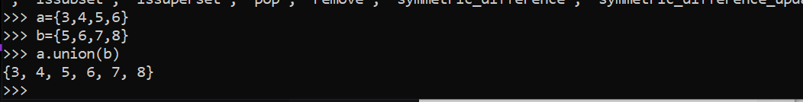

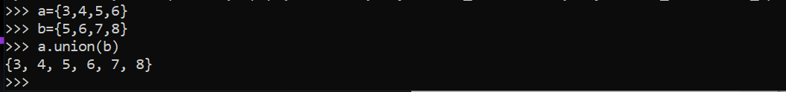

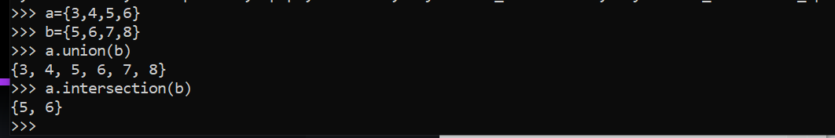

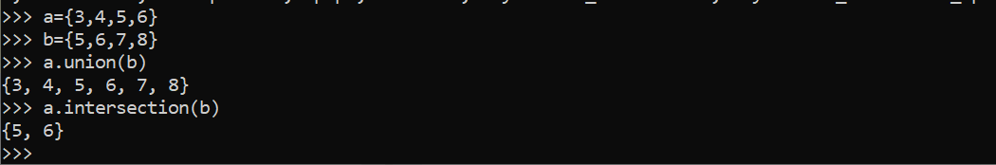

Operators of python:

Operators are the pillars for any language

The operator can be defined as a symbol which is responsible for a particular operation between two operands.

X=2,y=3 result=x+y 2+3=5

(+=)--🡪 this two are operands.

Example ‘+’ is an operators, to perform addition operation on operands.

Operands may be values or variables or combination of values and variables.

Python provides a variety of operators described as follows.

1.arthmetic operators

2.assignment operators

3.comparison operator

4.identity operators

5.membership operators

6.logical operators

7.bitwise operators

Arithmetic operators, assignment operators--🡪takes values as inputs, perform its operation on input values and gives values as output.

Comparison,identity,membership operators---🡪takes values as input,performs its operation on input values and gives output as either true or false

Logical operators-🡪take true or false as inputs, performs operation on these inputs and give output as either true or false

Bitwise operators--🡪takes values as input, performs operations on its binary representation and gives output as value

Arithmetic and assignment operators:

Addition +

Subtraction –

Multiplication *

Division /

Modulo %

Floor division //

Exponential **

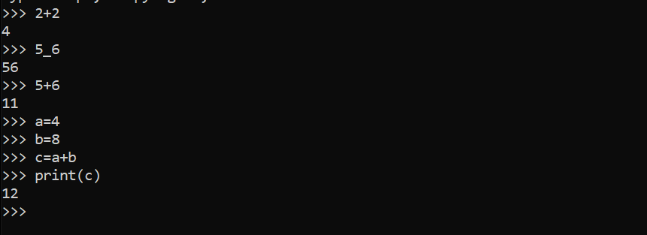

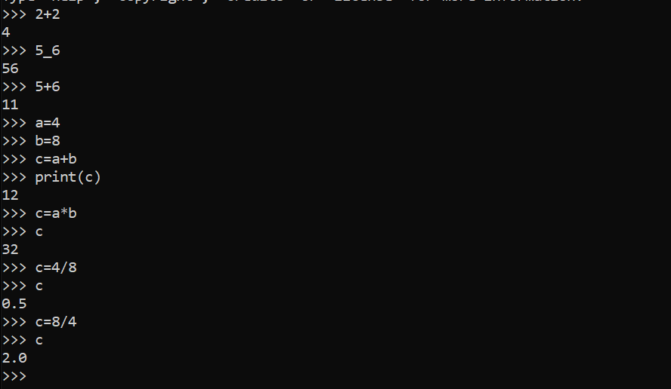

In python 3 if the result is in 2.0 then it will consider as float but when we are doing it in python 2 if any of the value is in float in first then then only the result will display as float.



To clear the screen we can use the above values.

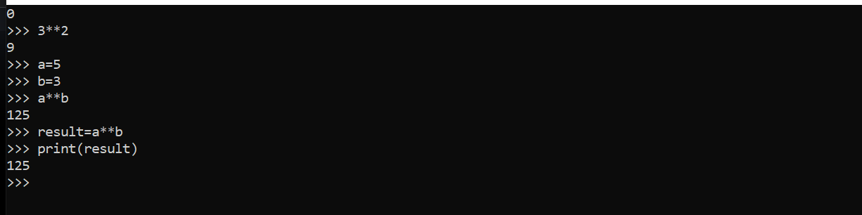

Modulo 3**2

A=5

B=3

A**B

Result=A**B

Print(result)

Float division:

7%2

1

8%2

0

8//2

4

7//2

3

7/2

3.5

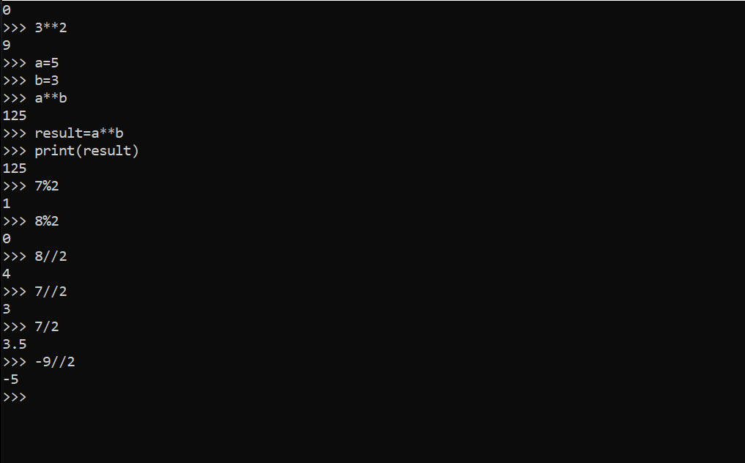-9//2=4.5 lowest round off value is -5 so it is giving that result

Assignment operators:

X=3x+2

=🡪 is an assignment operator

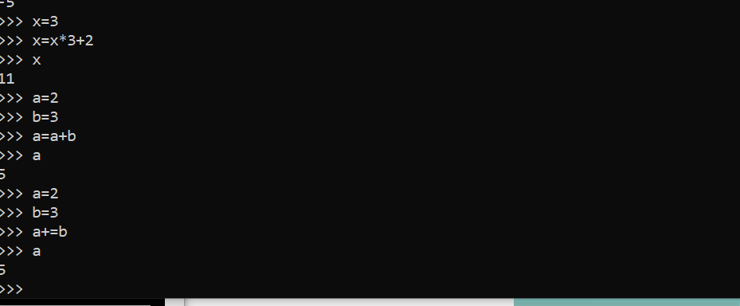

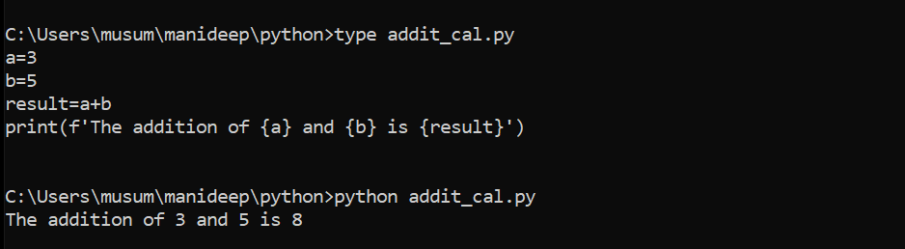

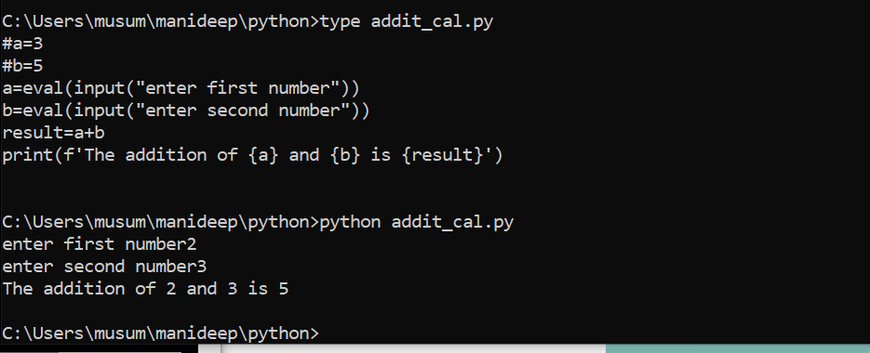

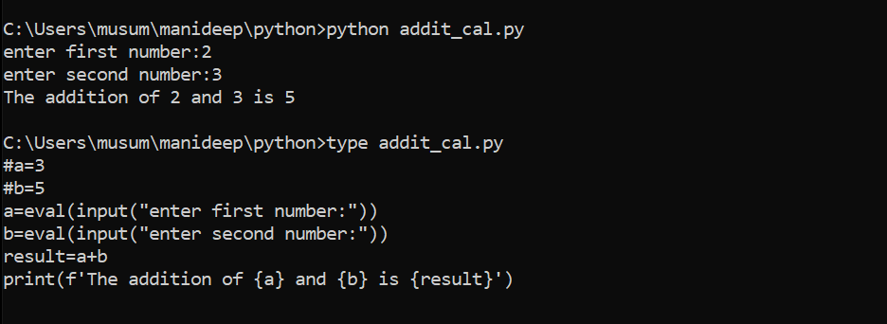

**Operator example same as**

**= a=b a=b**

**+= a+=b a=a+b**

**-= a-=b a=a-b**

**\*= a*=b a=a*b**

**/= a/=b a=a/b**

**%= a%=b a=a%b**

**Comparison operators of python:**

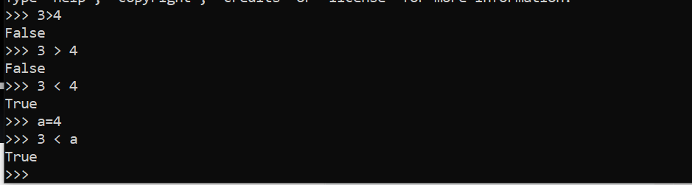

**>grater that-true if left operand is grater than the right**

**< less that-true if left operand is less than the right x<y**

**>grater that-true if left operand is grater than the right x>y**

**==equal to -true if both operands are equal x==y**

**!= not equal to -true if operands are not equal x!=y**

**>= grater than or equal to-true if left operand is grater than or equal to right x>=y**

**<=less than or equal to-true if left operands are less than or equal to right x<=y**

**ord(‘a’)->this will give the ascii code for this function.**

**Identity operators:**

**Identity operators are used to find type of: class/type/object.**

**There are two types of identity operators:**

**Is**

**Is not**

**Membership operators:**

**Membership operators are used to validate the membership of a value**

**X=[4,5,7,7]**

**6 in x**

**True**

**Membership operators:**

**In**

**Not in**

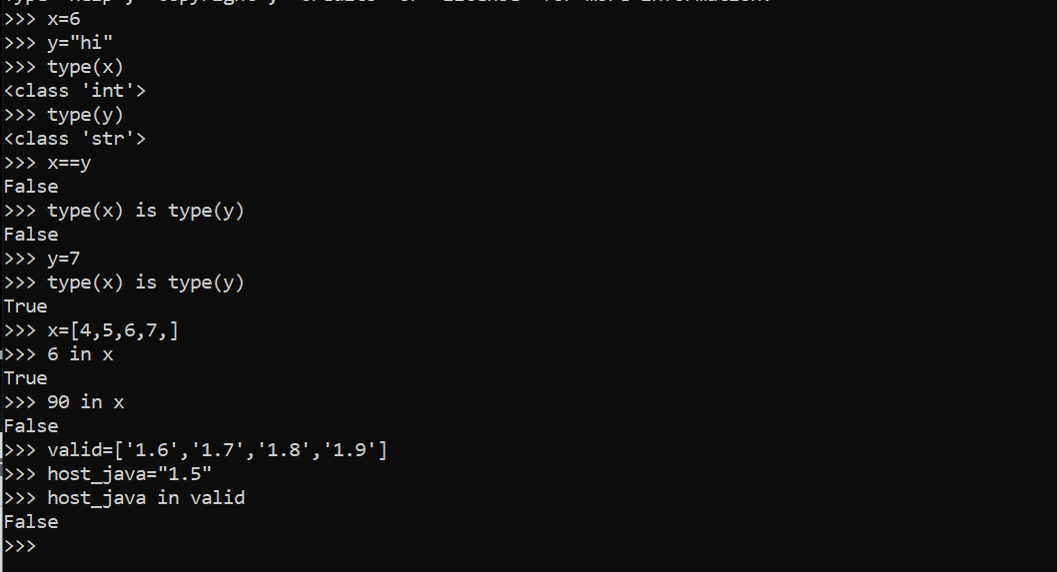

**Membership: it is nothing, but some thing is there in a given group of values or not**

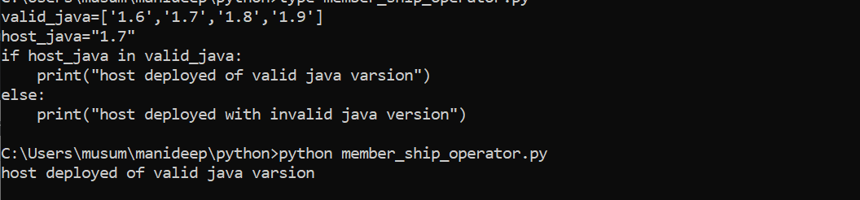

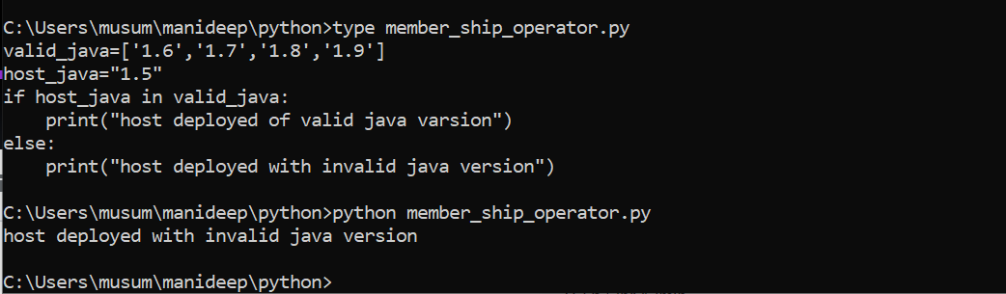

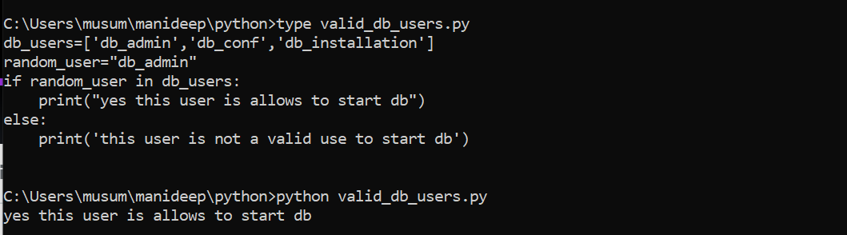

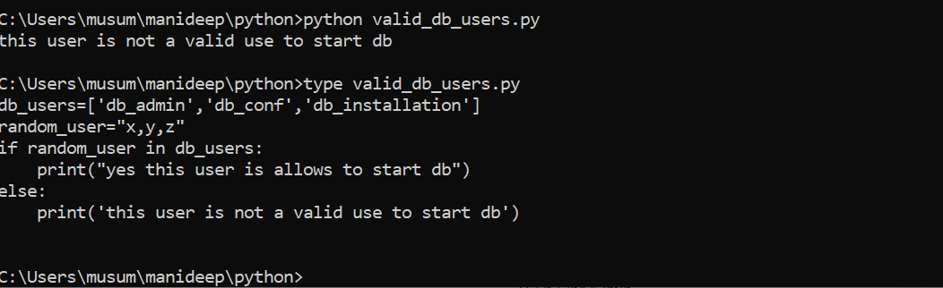

**Logical operators of python:**

**Logical operators are useful to combine multiple conditions:**

**To combine multiple things, we are using logical operators**

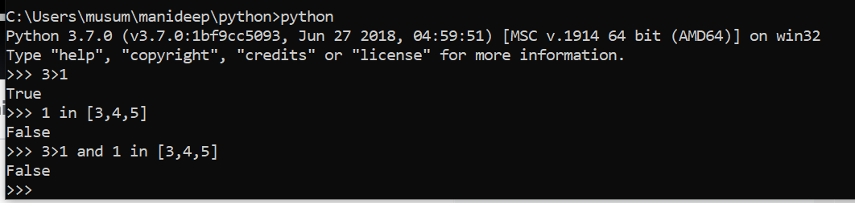

**They are:**

**And**

**Or**

**Not**

**For and operator-if return TRUE if both the operands (right side and left side) are true**

**And is an operand logical and to compare two values or functions we use and**

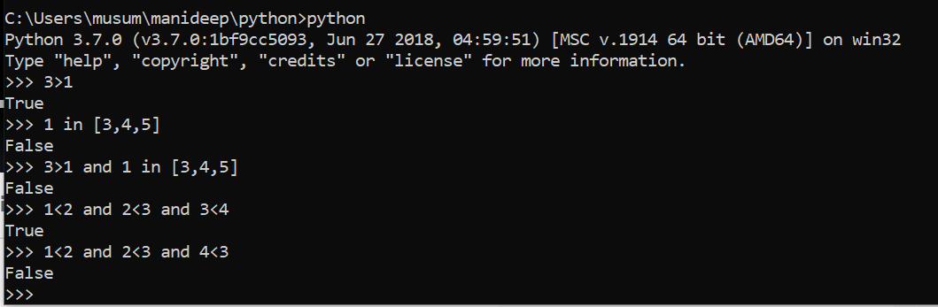

**We are using and comparing all the values and also if all the values are true output is also true**

**If all the values are true and one value is false, then final output is also false**

**For and operator – it returns true if both the operands (right side and left side)are true**

**For or operator-it returns true if either of the operand (right side or left side is true)**

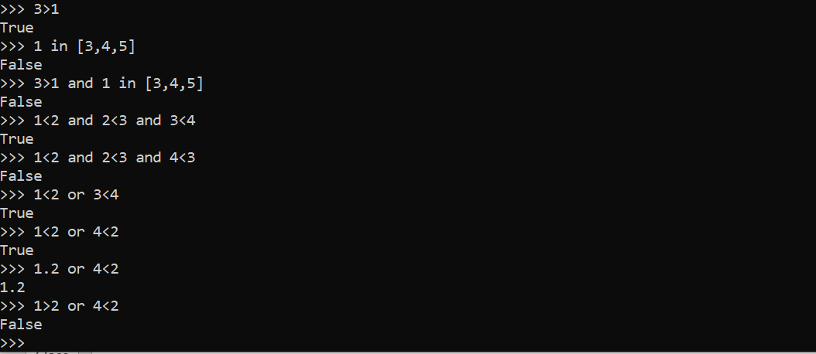

**And--🡪 if any one of the conditions is false then result is also false**

**Or---🡪if any one of the conditions is true then result is also true**

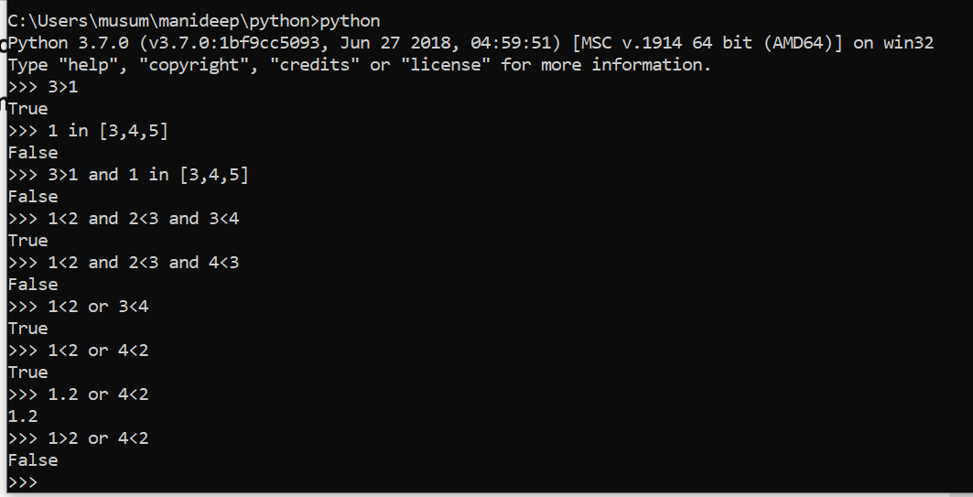

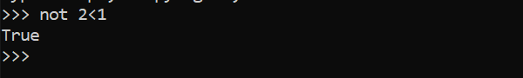

**False we are converting in to true**

**Not --🡪 not ture--🡪false,not false=🡺true**

**Reverse the result**

**2<3 and 4<5 and 5<6 and 7<10---🡪4 conditions then we need 4-1 and/or logical operators**

**All([2<3,4<5,5<6,7<10]) all==and**

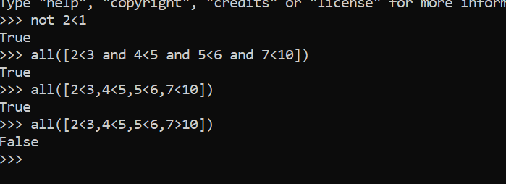

**If you are applying and on all the conditions all the conditions are true then the result is true**

**If any of the condition is false then all the condition final result is false**

**Any--🡪or**

**Any([2<3,4<5,7>10])**

**If any of the condition is true then the result is also true**

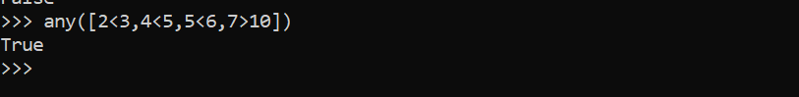

**On the final result of and,or we can also apply not**

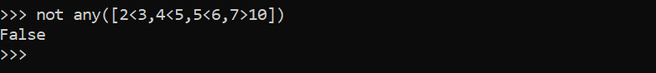

**Logical operators:(output is always true or false)**

**For not operator returns true if operand is false**

**If there are many conditions, then we will use any or all based on your requirements**

**Conditional statements: simple if condition**

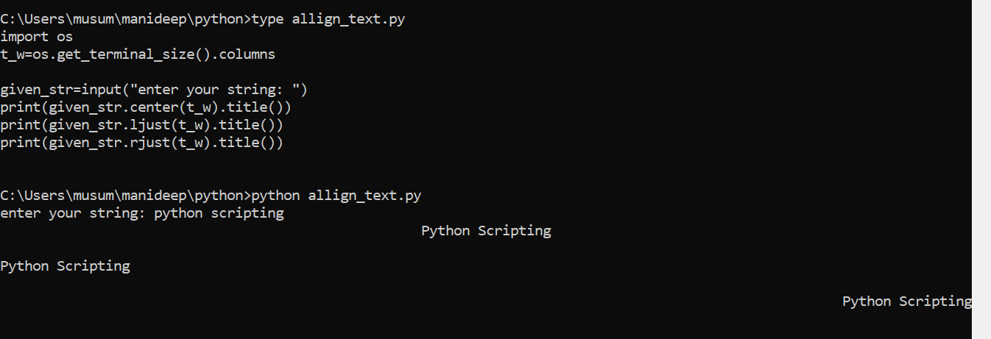

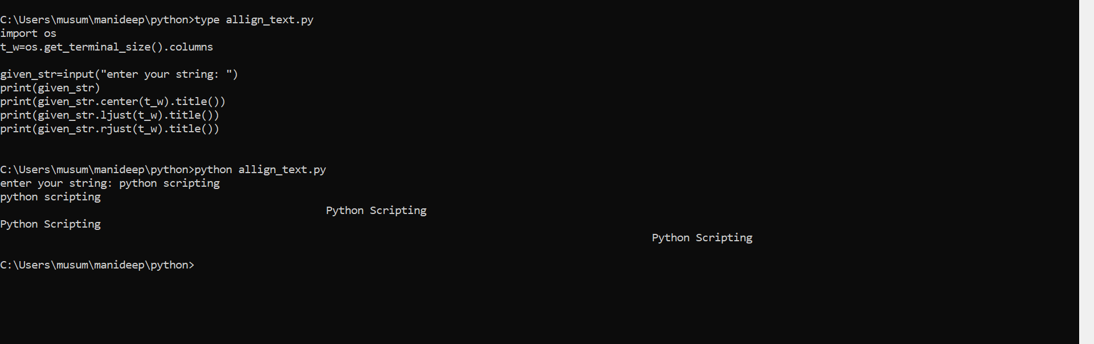

**In the above statement we are executing all the statements and we need to control them then if comes in to picture we can control the program like below**

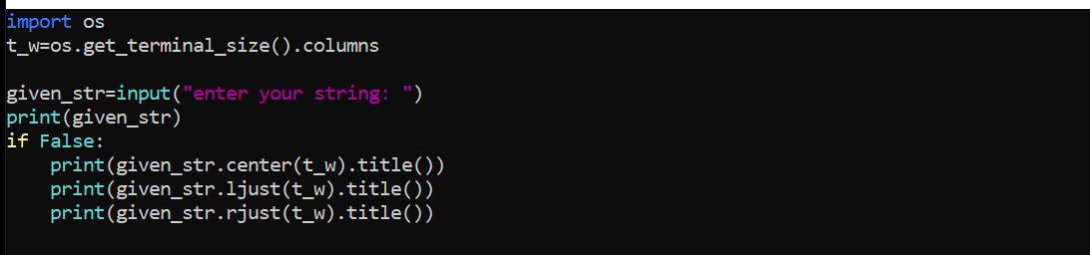

**If we are using if false: then it won’t execute the remaining statements it will break hear and stop the execution.**

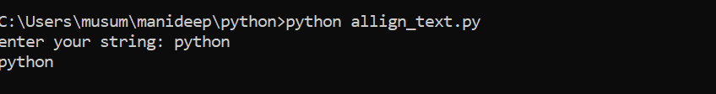

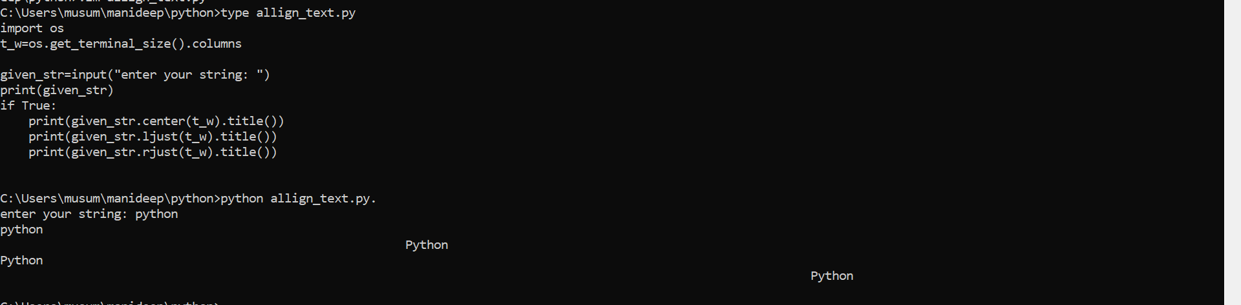

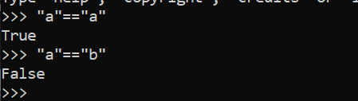

**If “a”==”a” true this same condition will apply in the program logic also**

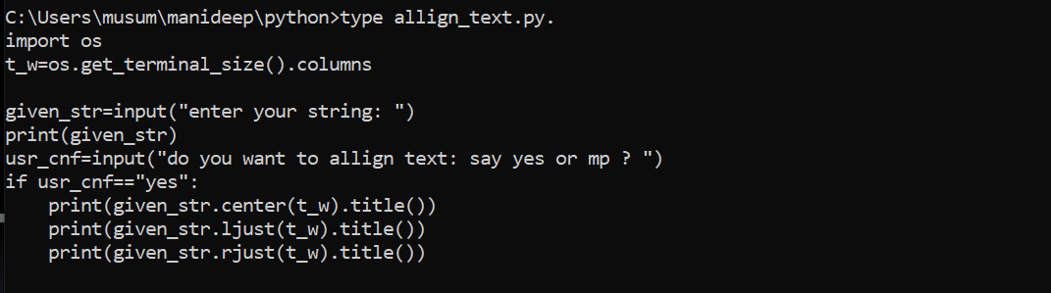

**In the above code also If it is satisfying the given condition usr_cnf==”yes ” then it will execute the remaining statements.**



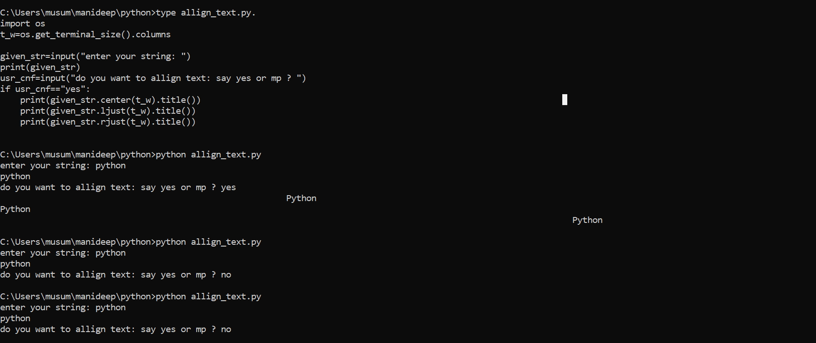

**In the above screenshot we are seeing the condition satisfies usr_cnf==”yes” then it will go further and execute it or else if usr_cnf==”no”then no==no it will not go further and it will stop the execution**

**If is called simple condition statement.**

**Used to control the execution of set of lines or block of code or one line.**

**If expression:**

**Statement1**

**Statement2**

**Comparison operators**

**Identity operators and logical operators final result is true or false**

**To get the result either true or false we can use this below operator**

**Comparison operators**

**Identity**

**Membership**

**Logical operators**

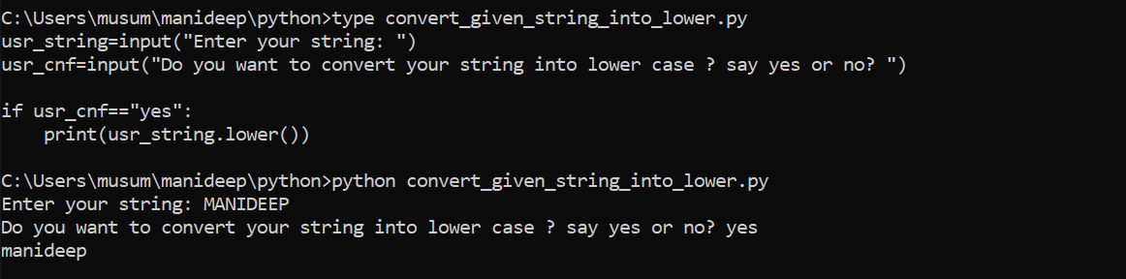

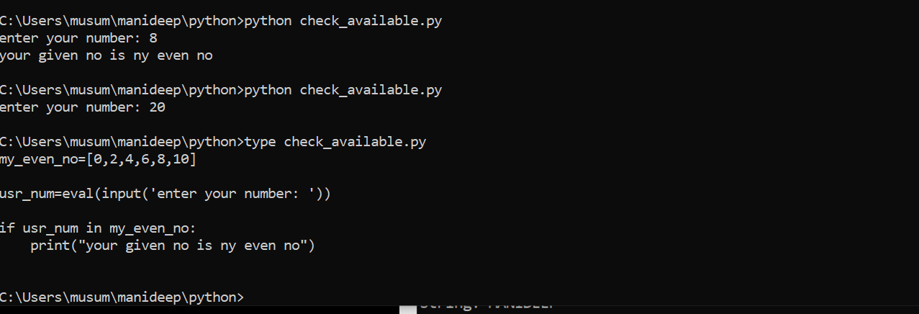

**If else conditional statement:**

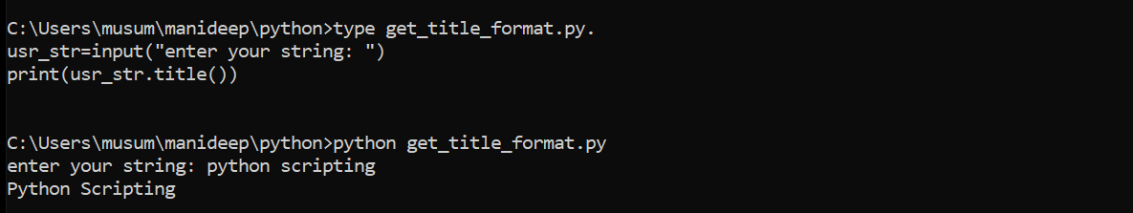

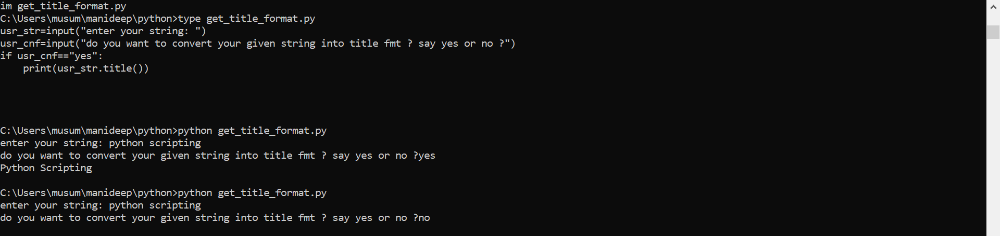

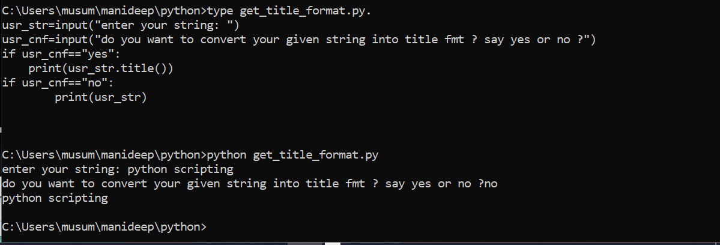

**Instead of writing two if conditions we can write else: you can go through the below example**

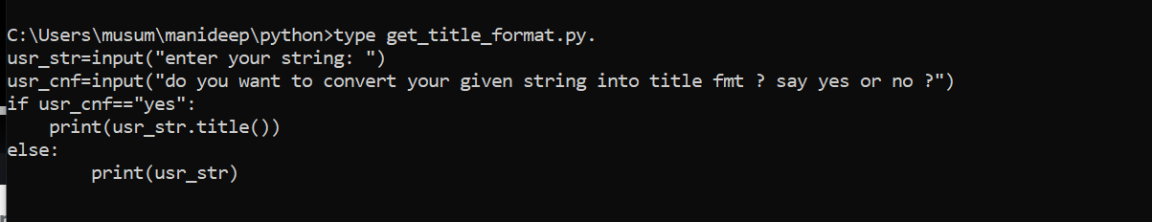

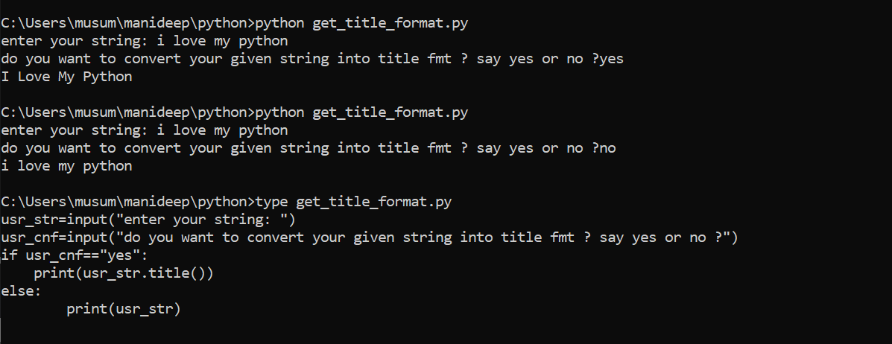

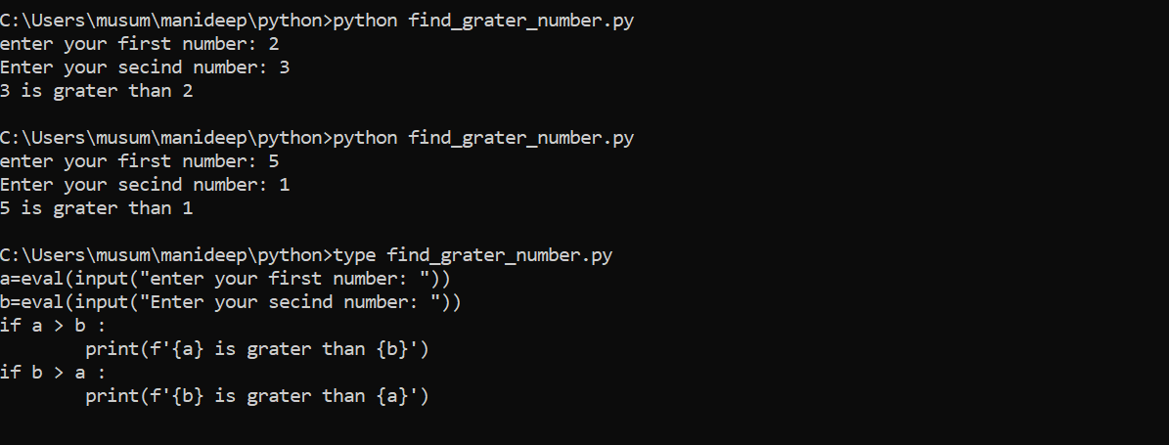

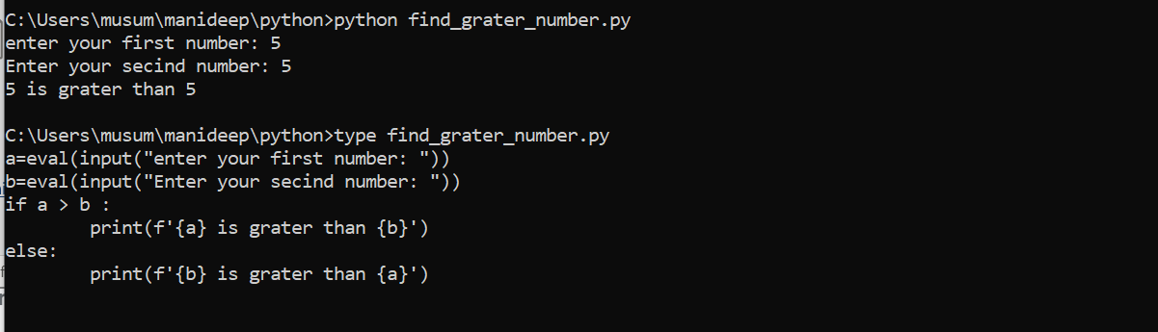

**If there are three possibilities, then we cannot take if an else block**

**If there are two possibilities, then only we can take if and else block**

**Elif🡪 we can use this if we are using multiple conditions**

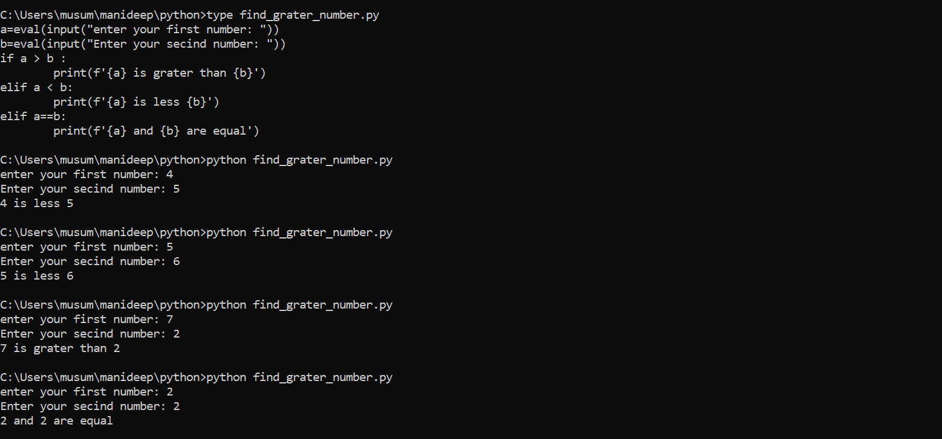

**If first and second value is false then print the third one no need to heck the condition agin**

**Else:**

**Print(‘f{a} and {b} are equal’)**

**If a > b:**

**Elif a < b:**

**Else prinf(‘f{a} and {b} are equal’)**

**If all the above if and elif are false, then the last block else will execute**

**Practice with conditional statement read a number between 1-10 and display it in words**

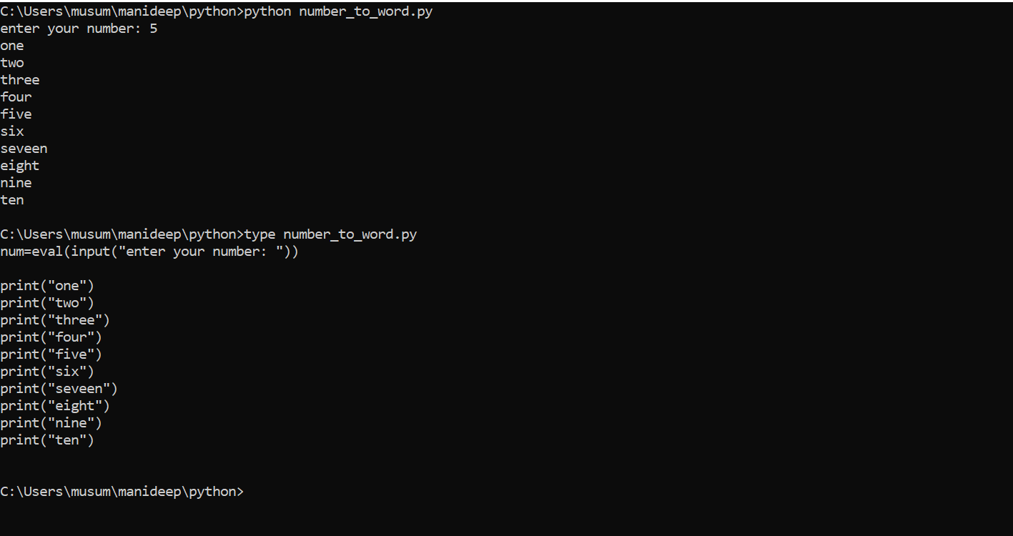

**This above program will print the entire details. Which is given as a part of print statement.**

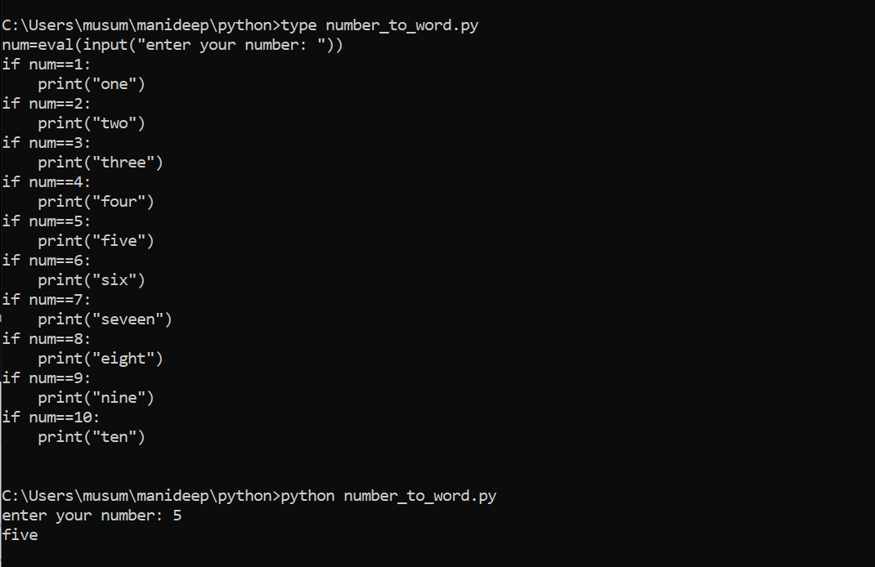

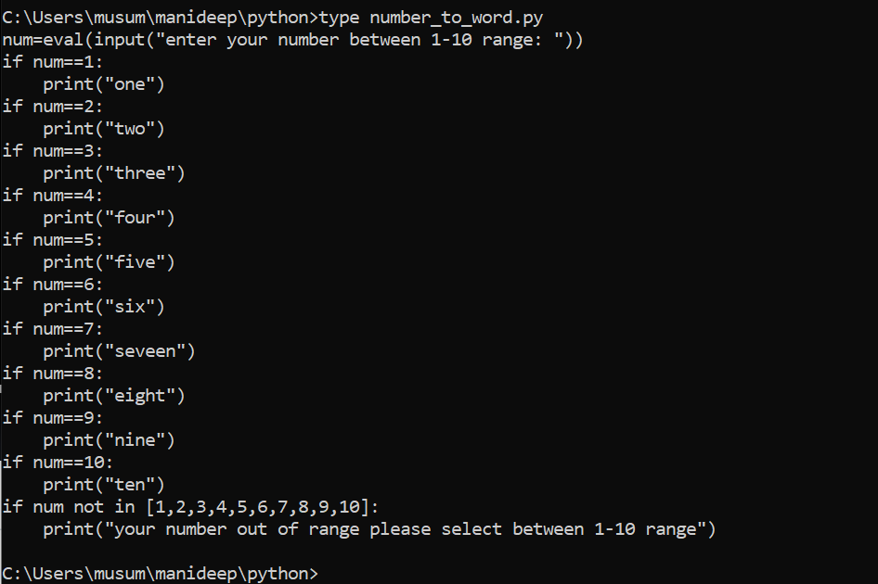

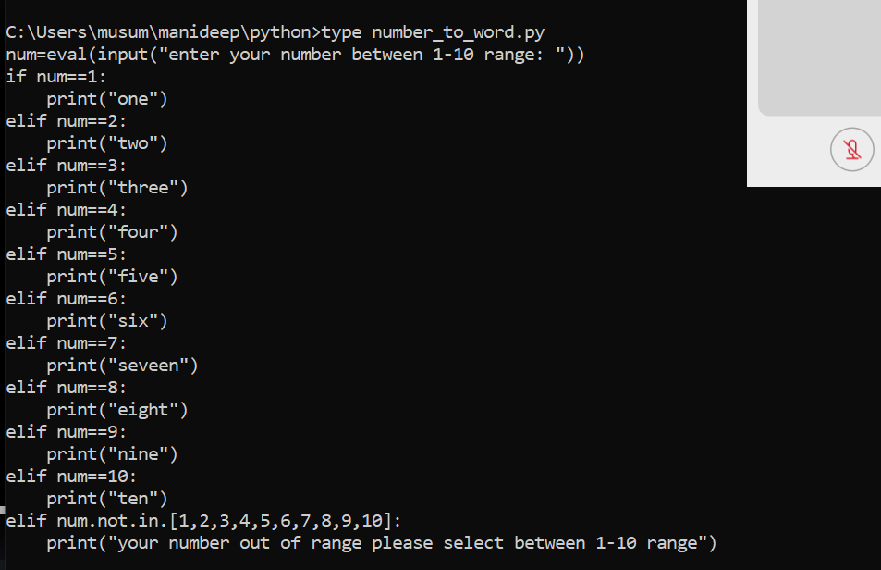

**Entire statements are considered as a single if condition**

**If num==1**

**Then it will stop executing the remaining statements. First condition if self is satisfying so execution time also. will be less because it is waiting lot of time**

**If the first occurring condition is true it will stop checking other conditions.**

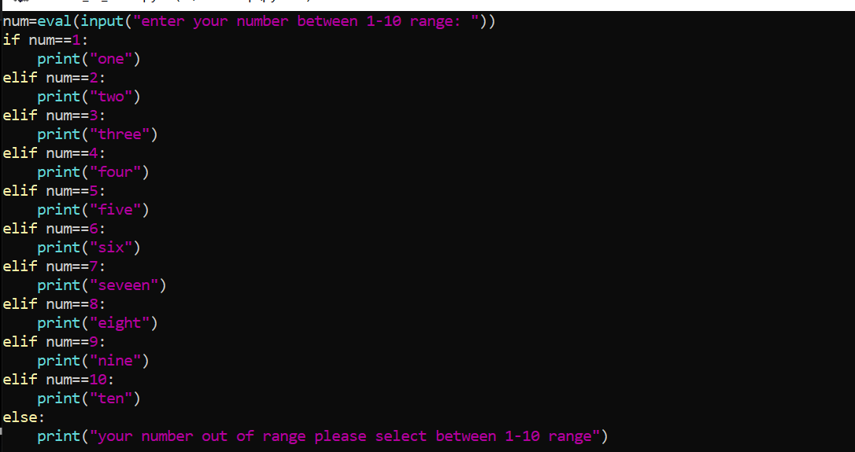

**No need to check the condition again. When all the above values are not satisfying it will**

**Automatically go to the last statement.**

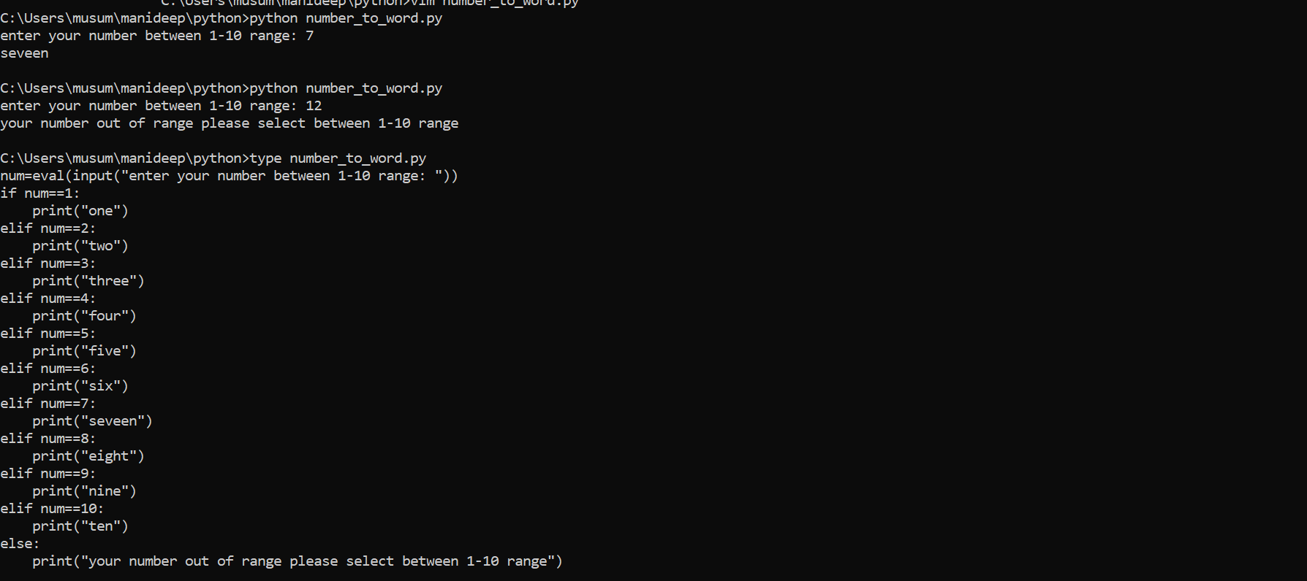

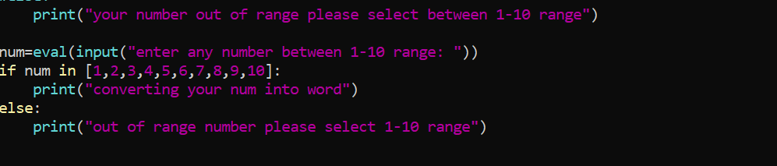

**Previously we are checking all the numbers and in the final step we are deciding the number does not exist. But in the above step we are deciding the number is not valid in two steps we are saving execution time.**

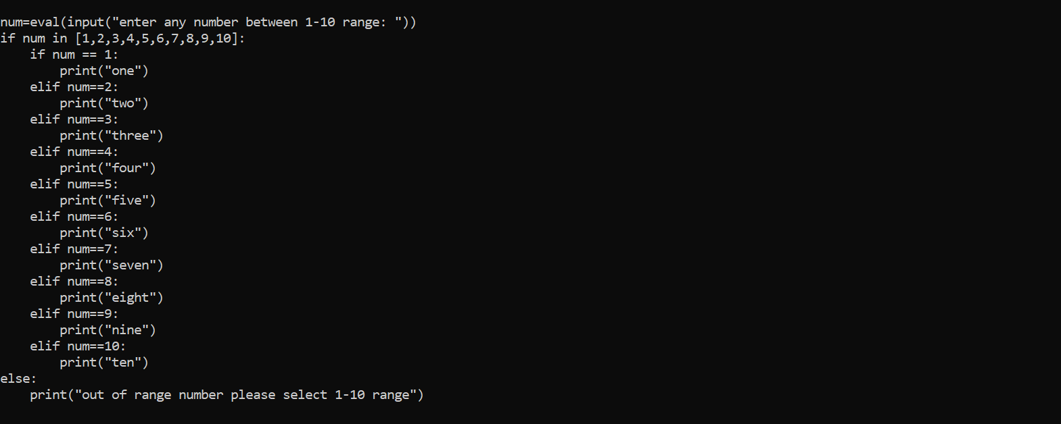

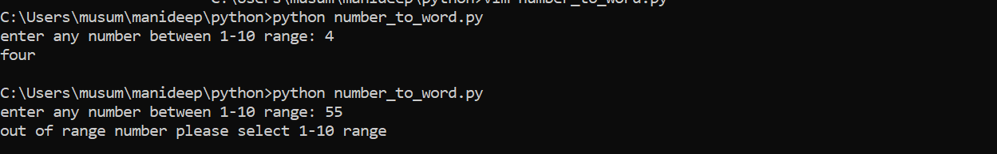

**Instead of writing this 10-line code we can write it in a dictionary. {key:value}**

**Key as number value as number in words.**

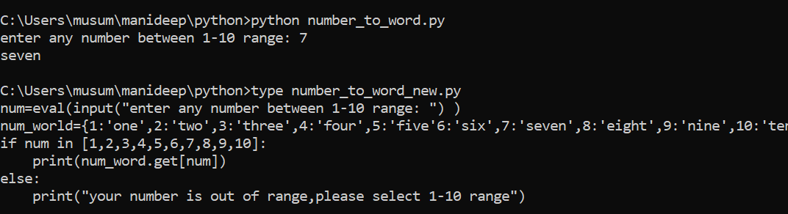

**Dictionaries are used to define the key value pair instead of writing a lot if if and if else statements we can use a simple dictionary to define key value pair.**

**Working with python modules:**

**A module is a file containing python definitions and statements. That means, module containing python functions, classes, and variables.**

**What is the use of module?**

**Reusability**

**Note: if script name is mymodule.py then module name is my module**

**Types of python module:**

**Default modules**

**Third party modules**

**Import either default or third party modules before using them**

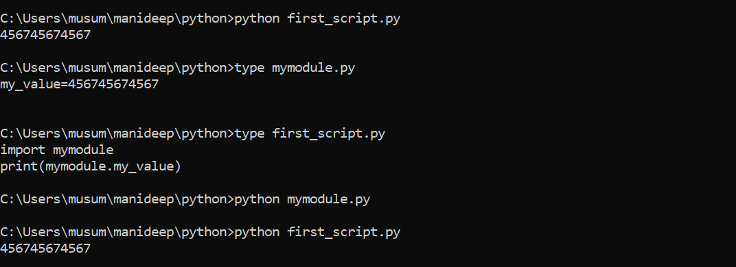

**We have defined my_value in my module we are using the same value of my_value in first_script.py we are importing import my module in the first script we can reuse the values defined in one script in n number of scripts.**

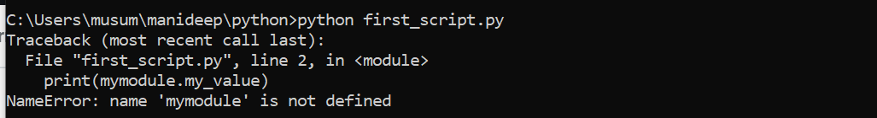

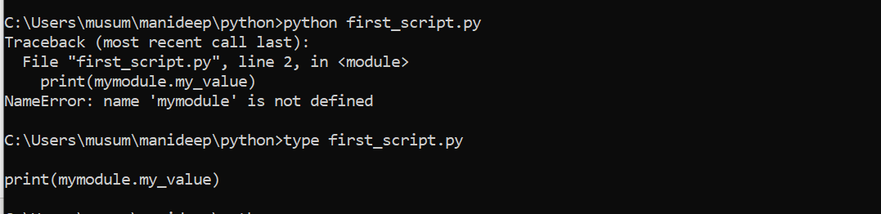

**If we are not defining the values, it will throw the error like module not defined.**

**Math default module**

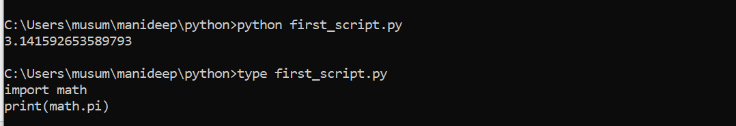

**Math is a default module.**

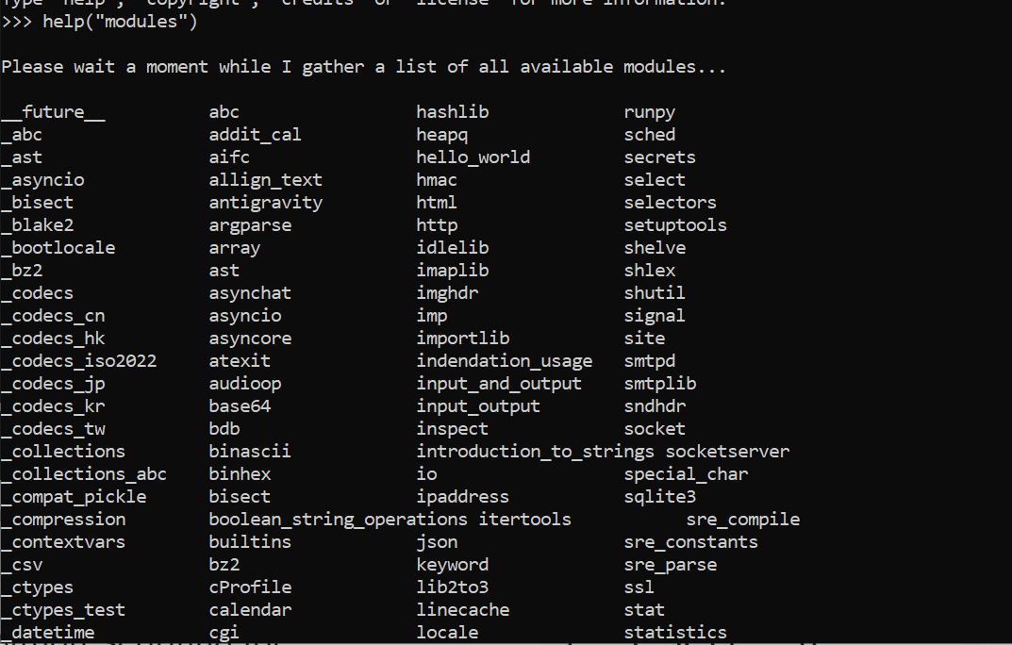

**For getting available modules in python.**

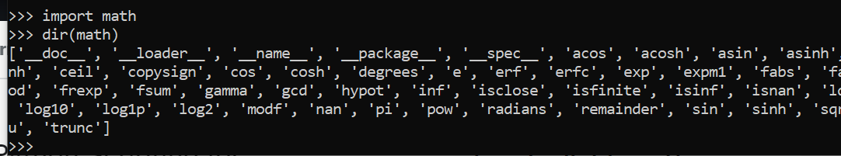

**Dir(math)--🡪 this will give the math related functionality’s. ignore __doc__ this are for documentation so we can ignore this we can use names like gmma gcd etc.**

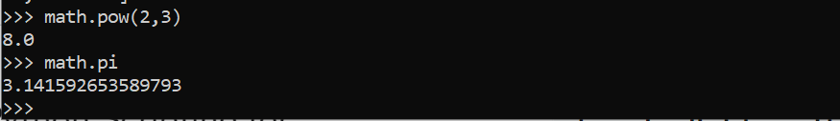

**Pi -🡪 is variable if it is a value, it is a variable.**

**Pow--🡪function any operation with parenthesis is a function.**

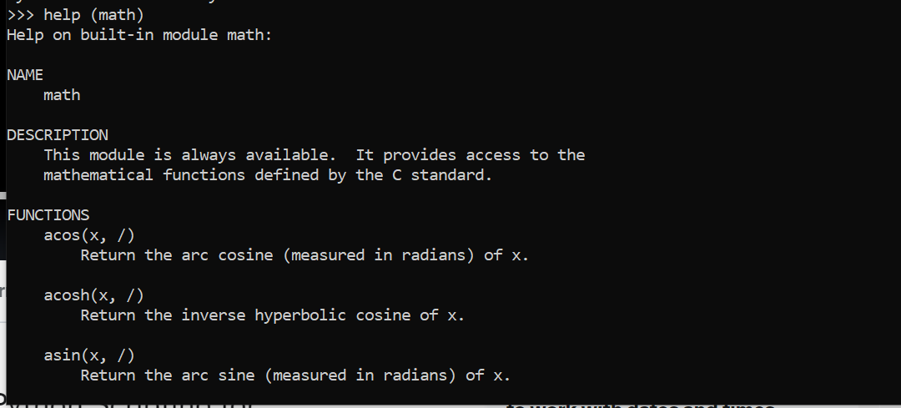

**This help(math)🡪 this will give the complete values on math function like how to run and how to do it.**

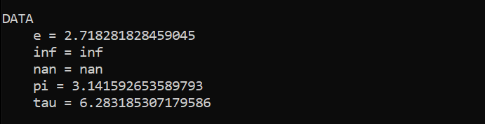

**Above are not function. They are data values.**

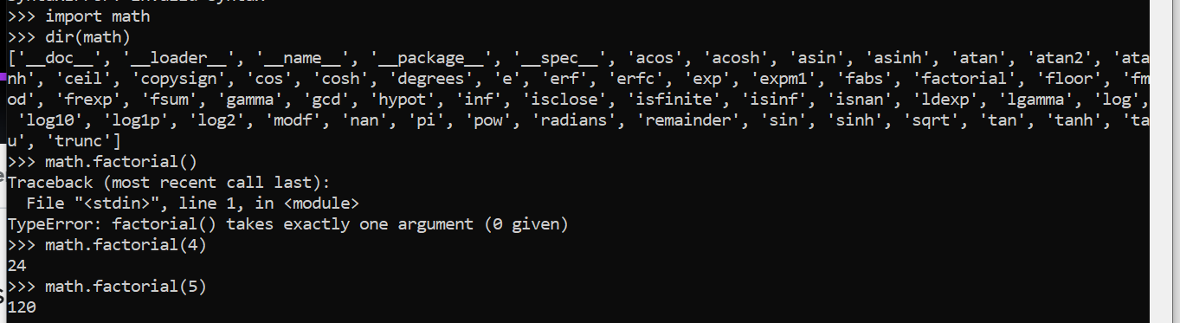

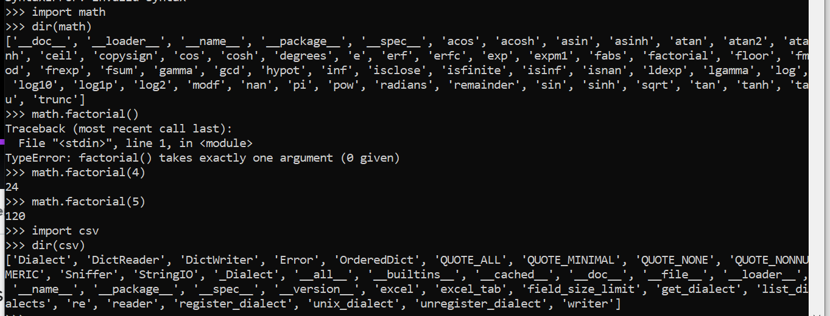

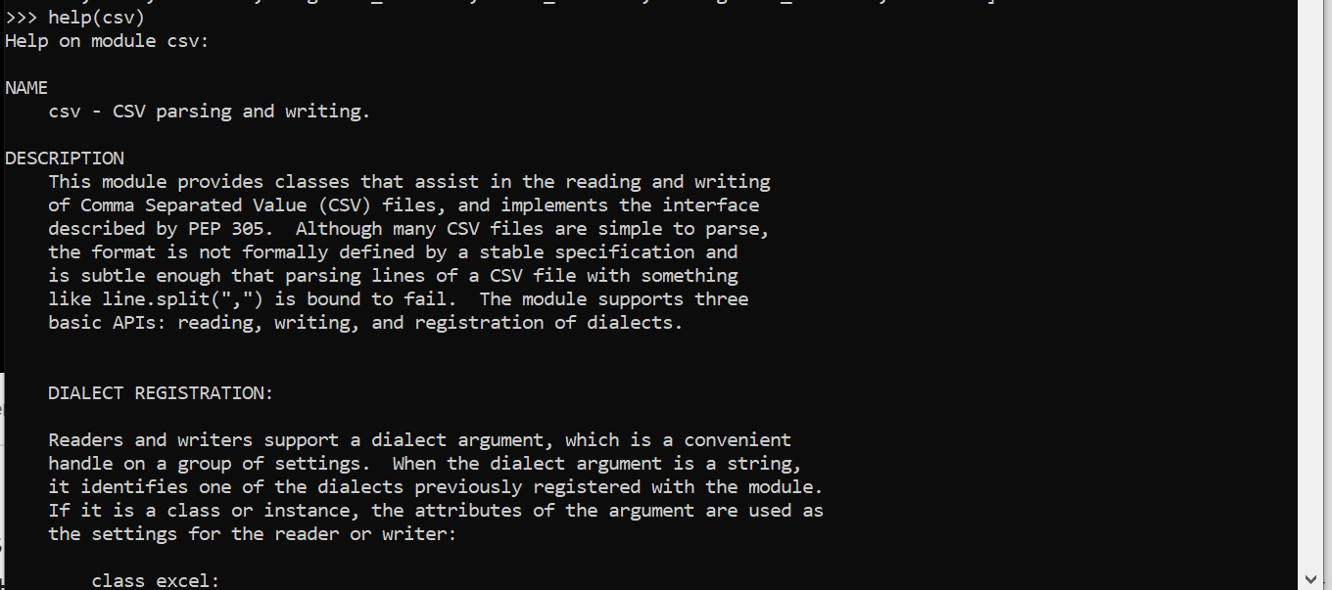

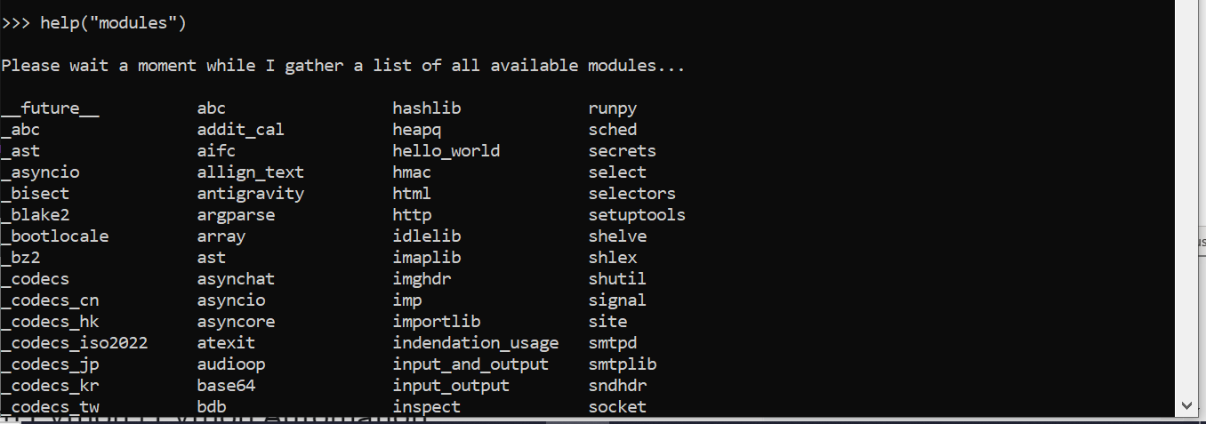

**Help(“modules”)--🡪it will show all the installed modules.**

**For installing new modules which are not there in python.**



**To work with excel we need python, so we are installing excel module using xlwt**

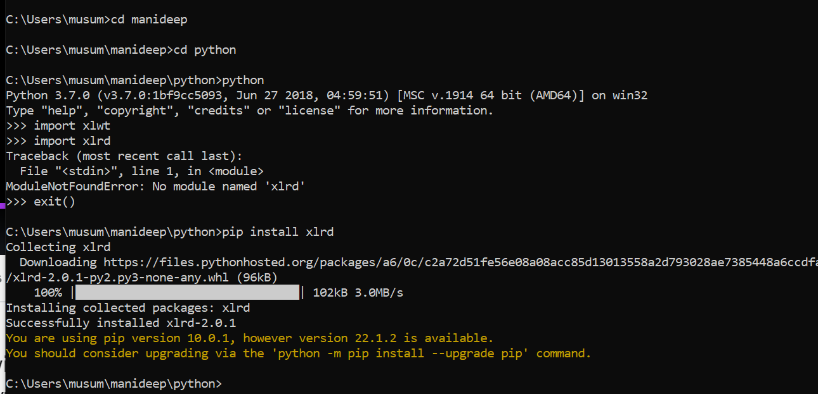

**The above will install xlrd then from there we can import it.**

**If you want to work with some remote servers you need module called paramiko so we need to install paramaiko.**

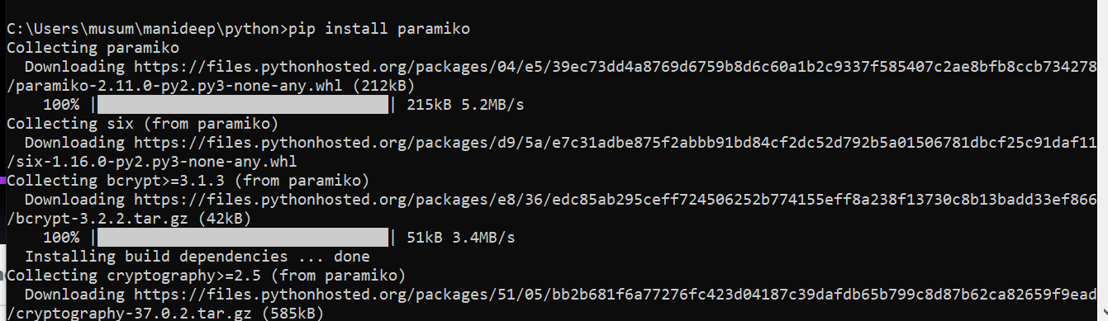

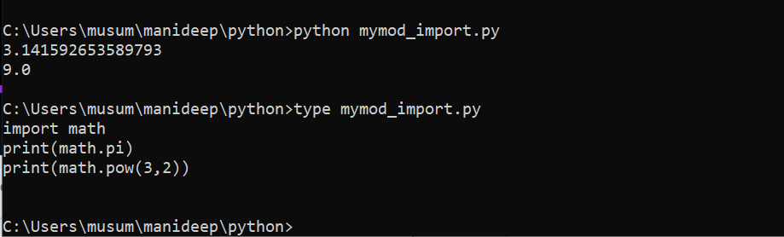

**Different ways to import module:**

**Using import math**

**Using form:**

**From math import\***

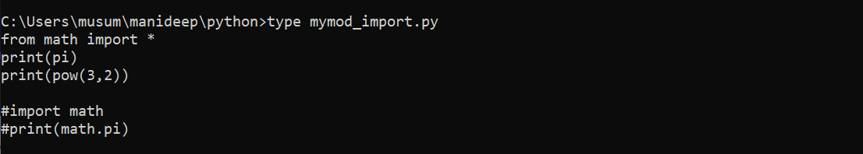

**Instead of writing print(math.pi) we can directly write print(pi) if we are importing the complete module from math import\***

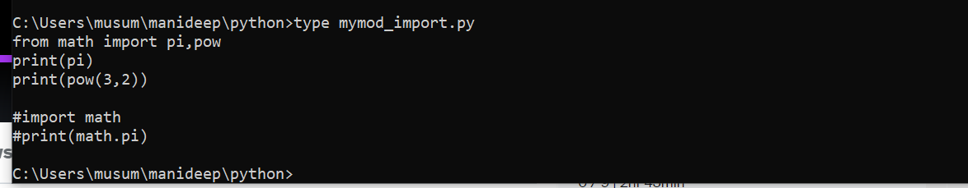

**Another way of importing data from math import pi,pow**

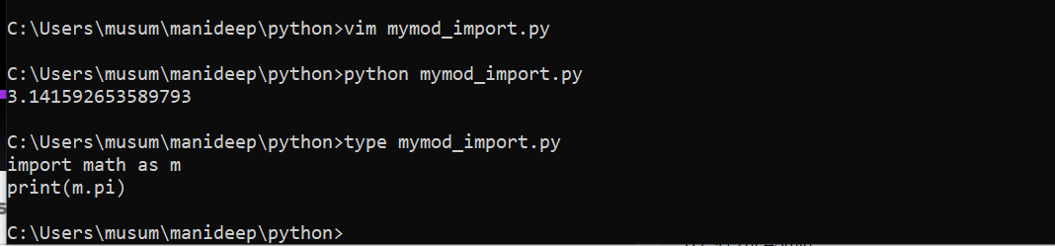



**We have imported the module but naming as m print(m.pi) while fetching the result we will use**

**Print(m.pi) instead of print(math.pi).if module names are too lengther we can use alias name for them**

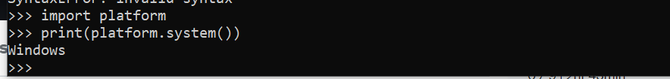

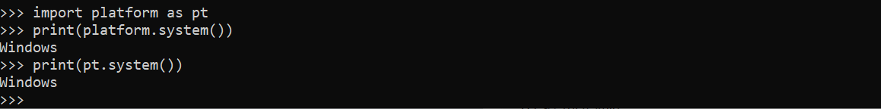

**Method1:**

**Import math**

**Print(math.pi)**

**Print(math.pow(3,2))**

**Method2:**

**Import math as m**

**Print(m.pi)**

**Print(m.pow(2,3))**

**Method3:**

**From math import \***

**Print(pi)**

**Print((4,2))**

**Method4:**

**From math import pi,pow**

**Print(pi)**

**Print(pow(4,2))**

**How to import multiple modules:**

**Import platform**

**Import math**

**Import sys**

**Import os**

**Import subprocess-------🡪above all are good practice.**

**Or**

**Import platform,math,sys,os,subprocess--🡪 this is not a good practice.**

**Platform Module:**

**The platform module is used to access the underlying platforms data such as hardware operating system and interpreter version info)**

**How to use platform module in a script?:**

**First import platform module using below syntax:**

**Import platform**

**Or**

**Import platform as pt**

**Or from platform import \***

**Or**

**From platform import system, platform.**

**How to list all functions and variables of a platform module?**

**There is a built-in function to list all the function names(or variable names) in a module and that is dir() function.**

**Then use dir() function as:**

**Print(dir(platform))**

**How to get help of a platform module?**

**From script: print(help(platform))**

**From python command line: help(platform)**

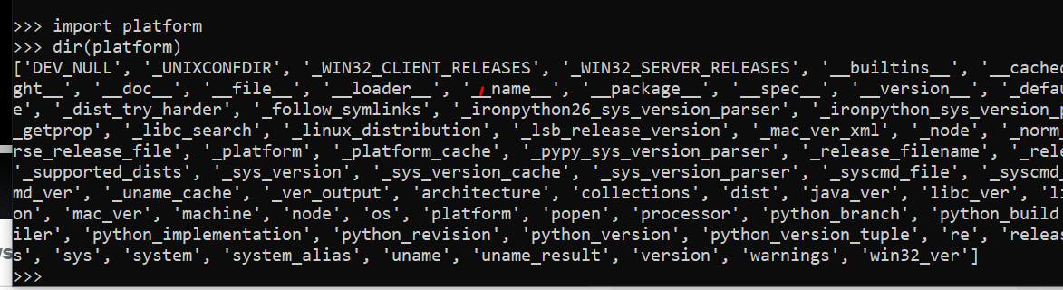



**72 operations different values have different operations.**

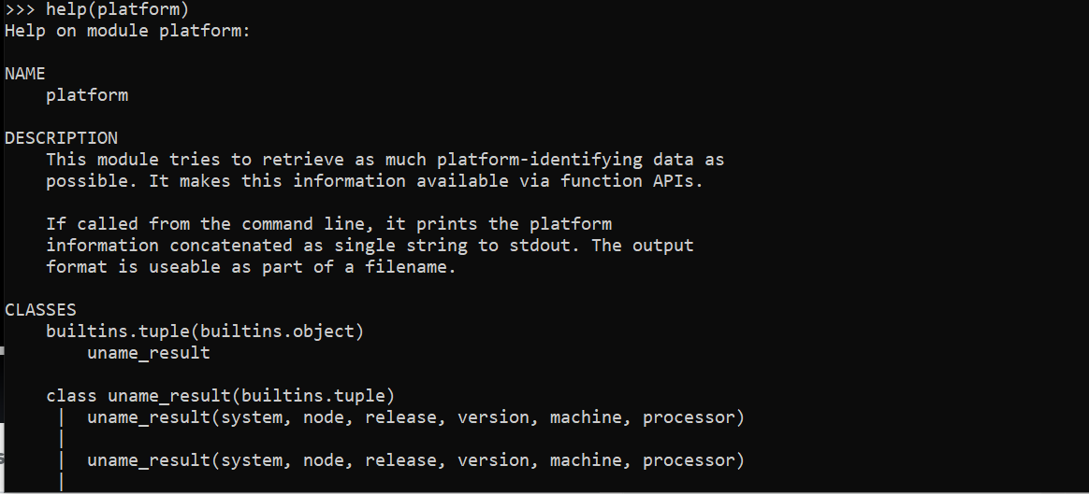

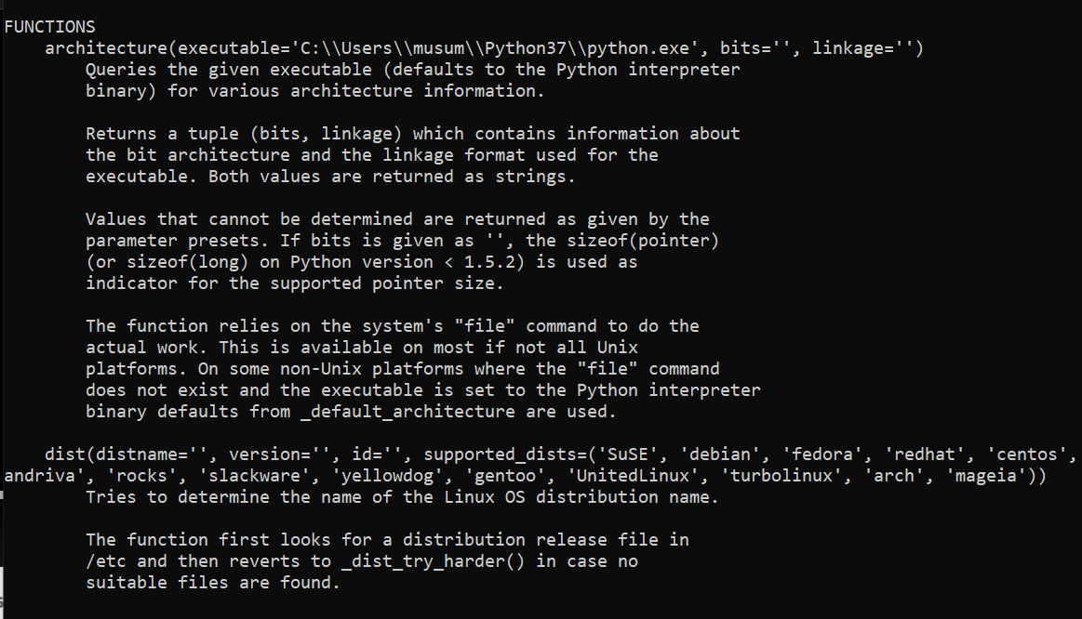

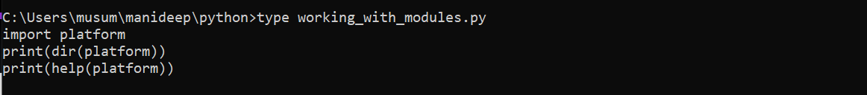

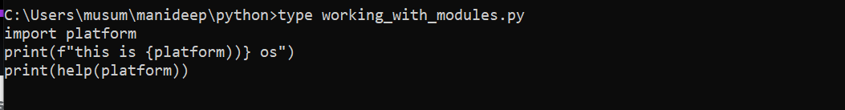

**{platform}-🡪 this is curly braces.**

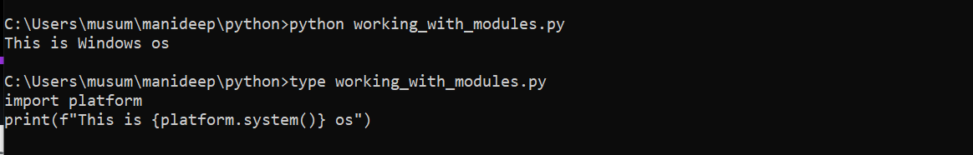

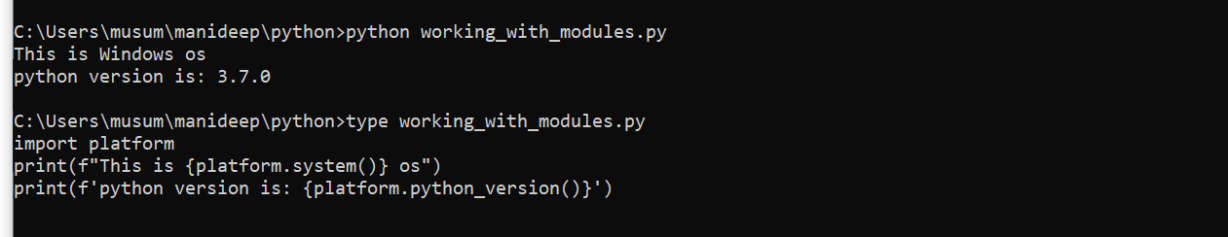

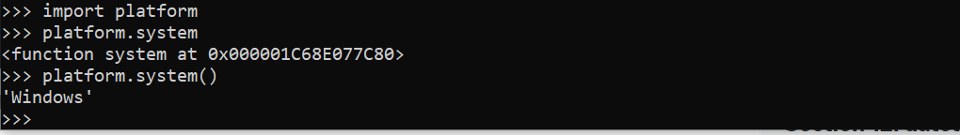

**The above one is mentioning about platform platform. System it is a function.**

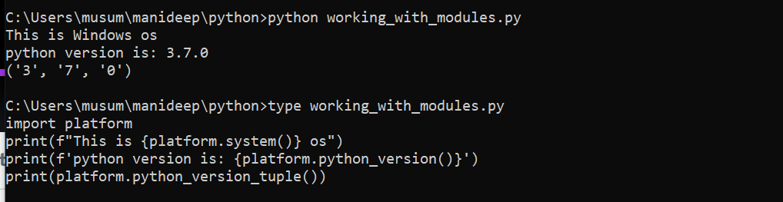

**In the above output tuple is giving values like major and minor versions.**

**Print(platform.python_version_tuple()).**

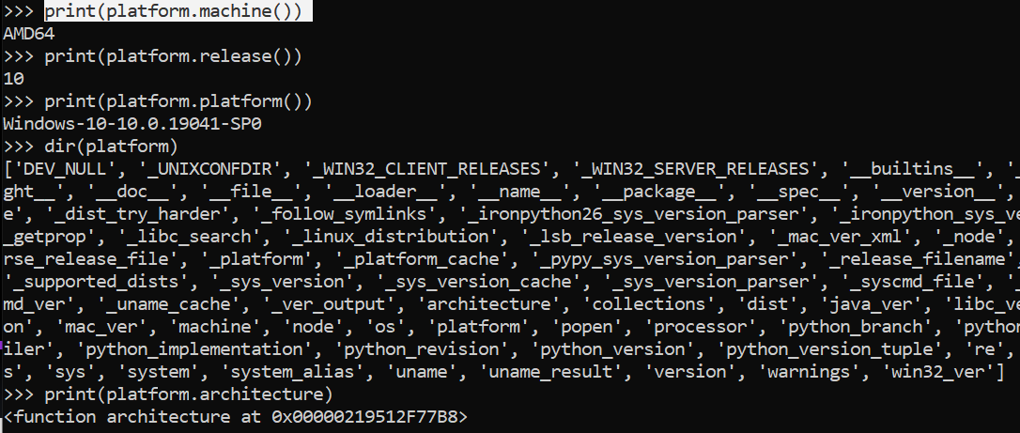

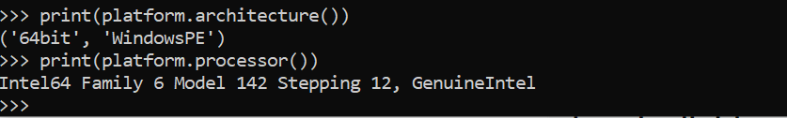





**Getpass module:getpass() and getuser()):**



**Getpass() prompts the user for a password without echoing.the getpass module provides a secure way to handle the password prompts where program interact with the users via the terminal.**

**Getuser() function displays the login name of the user.this function checks the environment variables logname,user,lname and username in order and returns the value of the first non-empty string**

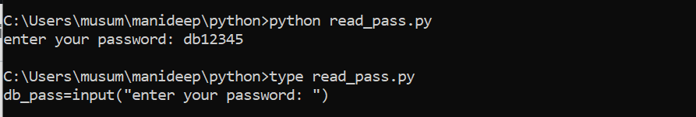

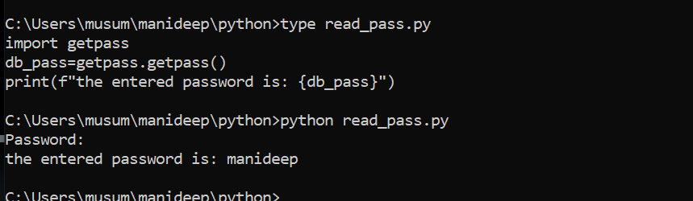

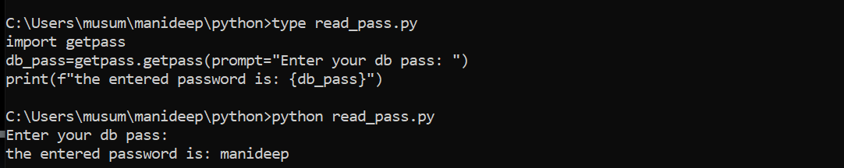

**In linux we need to use our system like this #!/usr/local/bin/python3 shebang**

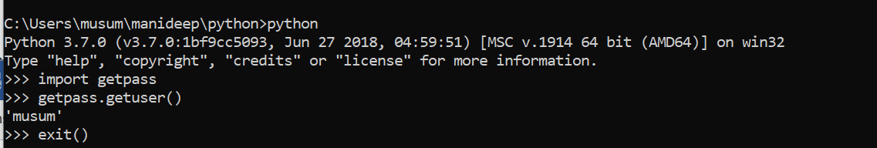

**When you are running a command like getpass.getuser() it will try to get the details from logs like log name user from logs and it will print the output automatically with the user who logged in.**

**SYS Module:**

**The sys module is used to work with python runtime environment.**

**Introduction to sys module:**

**The sys module provides function and variables used to manipulate different parts of the python runtime environment.**

**How to use sys module?**

**Import sys**

**How to get help on sys module?**

**Dir(sys), help(sys)**

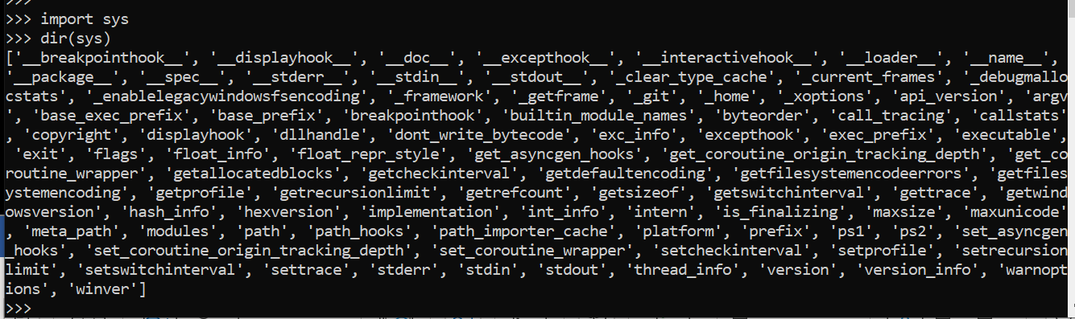

**Help(sys)=---🡪 to get help on how to work and proceed further.**



**Win32 this is a python version which is installed on this system as a 32-bit software.**



**This will show the system version.**

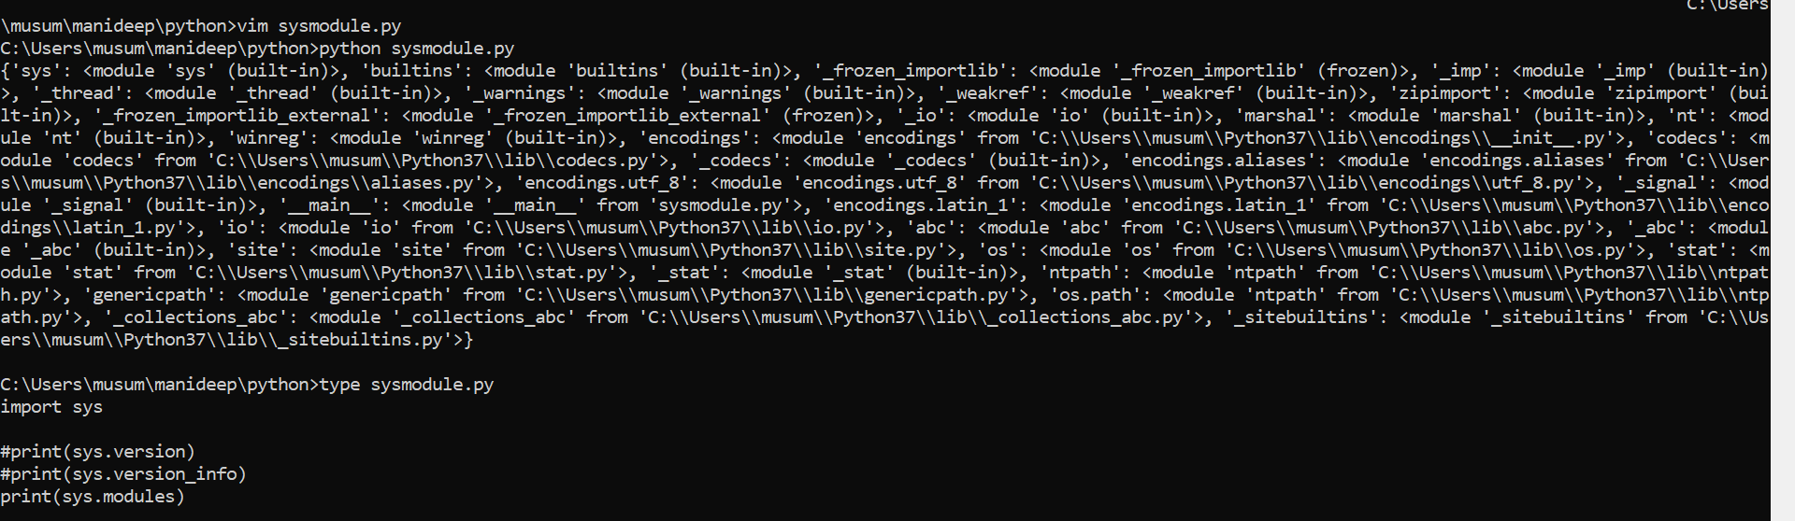

**Above will give the complete functions with modules.**



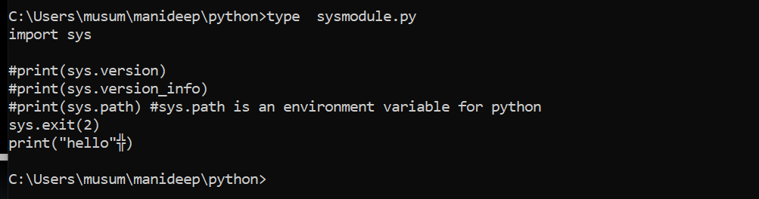

**Sys.argv of sys modules:**

**(sys.argv returns a list of command line arguments passed to a python script.)**

**Sys.argv | working with command line arguments with an example:**

**Sys,argv returns a list of command line arguments passed to a python script.**

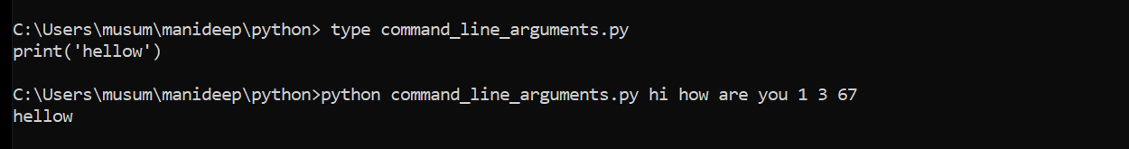

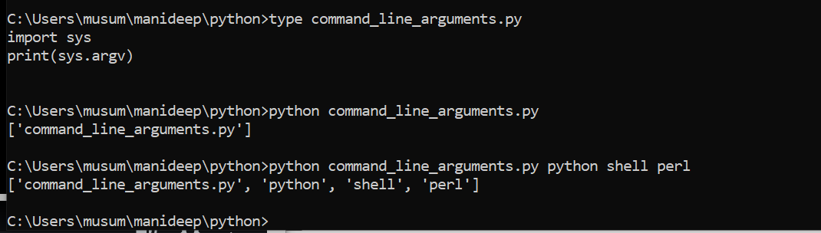

**What ever you are passing all will be treated as a string by your python.**



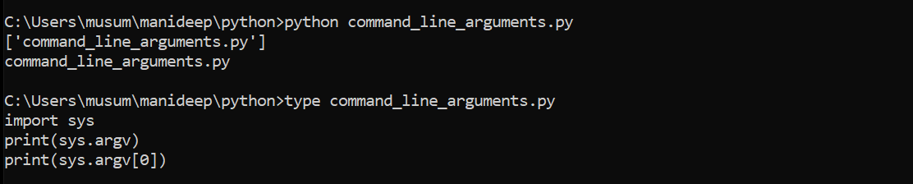

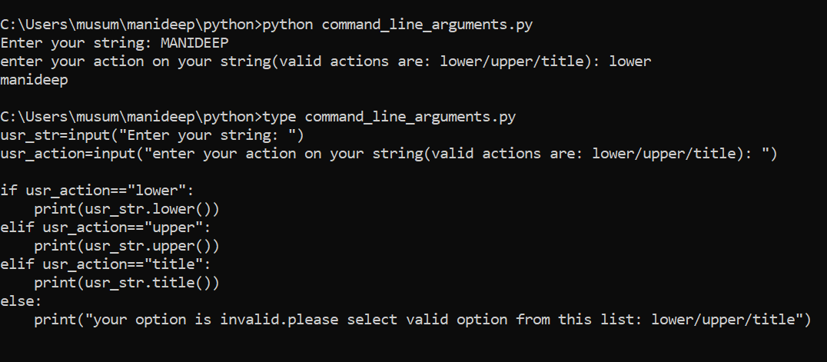

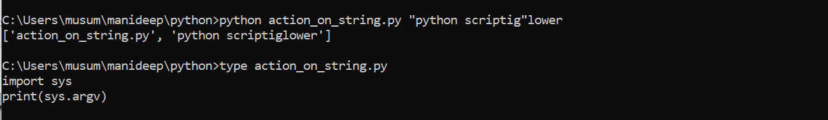

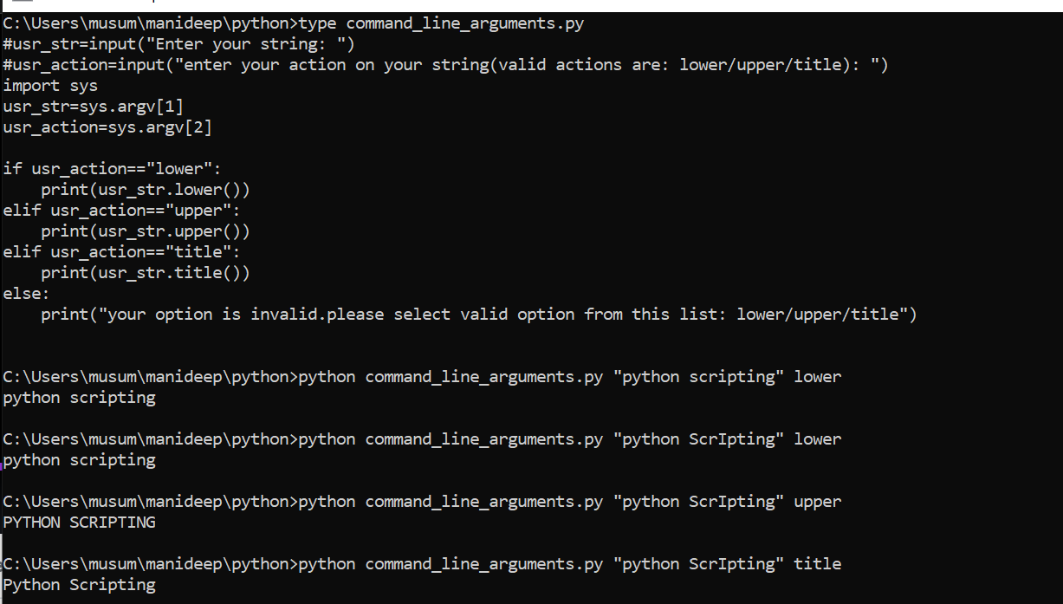

**Instead of giving every thing in the script we are giving each and every thing.**

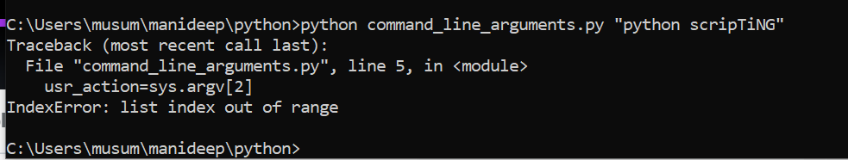

**In the script we have mentioned the two values argv[1] & argv[2]. This two are mentioning the two different values. But while passing we are not passing them correctly so there is an error again.**

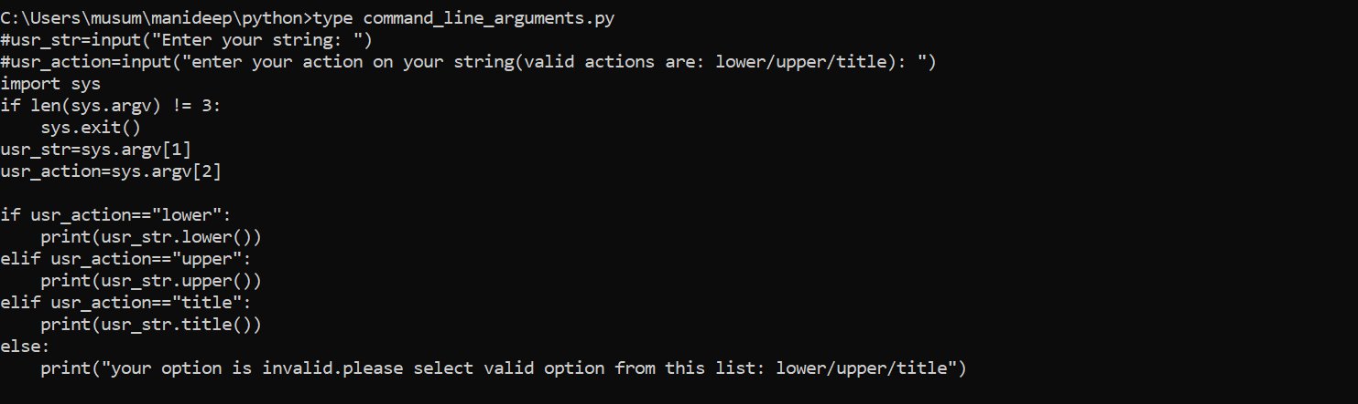

**In the above program we have described the values so we are not getting any error.**

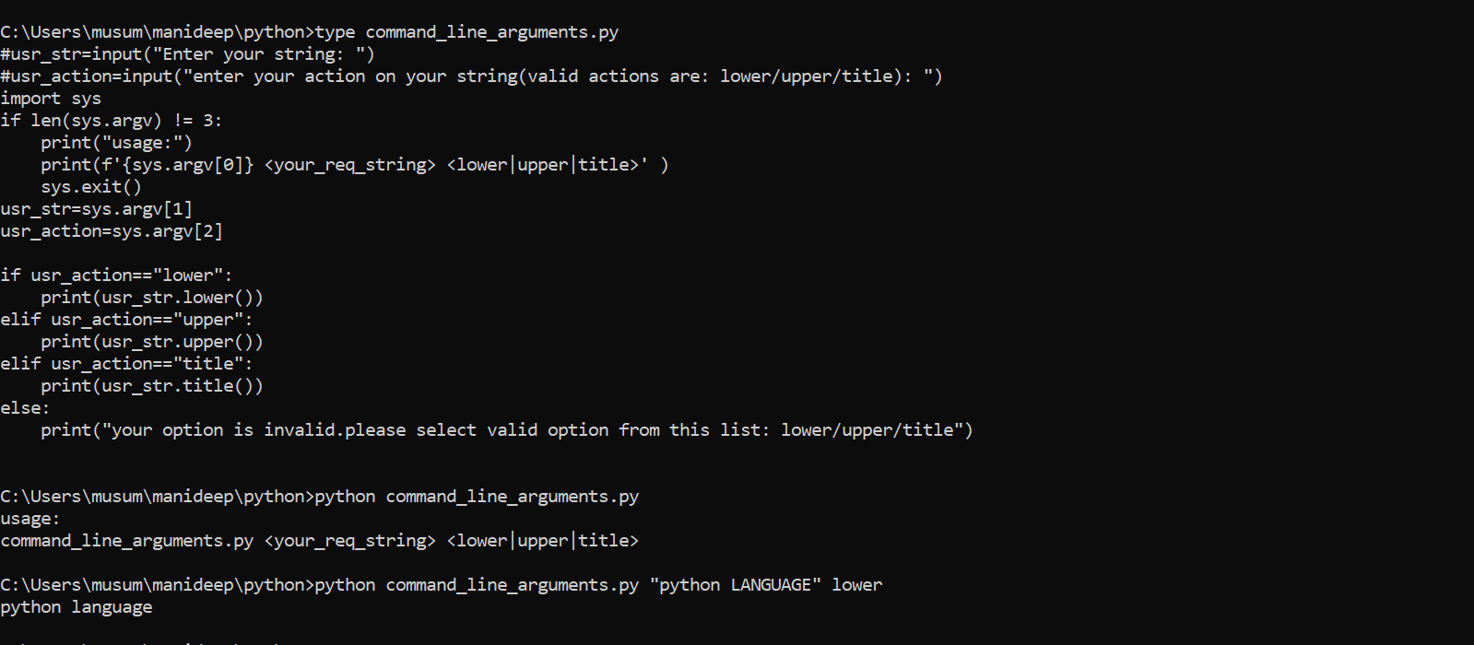

**In th above program it is clearly mentioning that the mentioned details needs to be passed in the given args like command_line_arguments.py <your_req_string> <lower|upper|title>.**

**If you are passing it correctly it is printing the correct output.**

**INTRODUCTION TO os MODULE and BASIC operations:**

**This module is used to work/interact with operating system to automate many more tasks like creating directory, removing directory,identifying current directory and many more.**

**Operations of os module four parts of os:**

**Simple os operations:**

**Os.sep**

**/var/log/mani--🡪 this / represents the os separator.**

**Os.getcwd()**

**Os.chdir(path)**

**Os.listdir(path)**

**Os.mkdir(path)**

**Os.makedir(path) (recursive directory creation function.)**

**Os.remove(path)**

**Os.removedirs(path)(remove directories recursively)**

**Os.rmdir(path)**

**Os.rename(src,dst)**

**Os.environ**

**Os.getuid()**

**Os.getpid()**

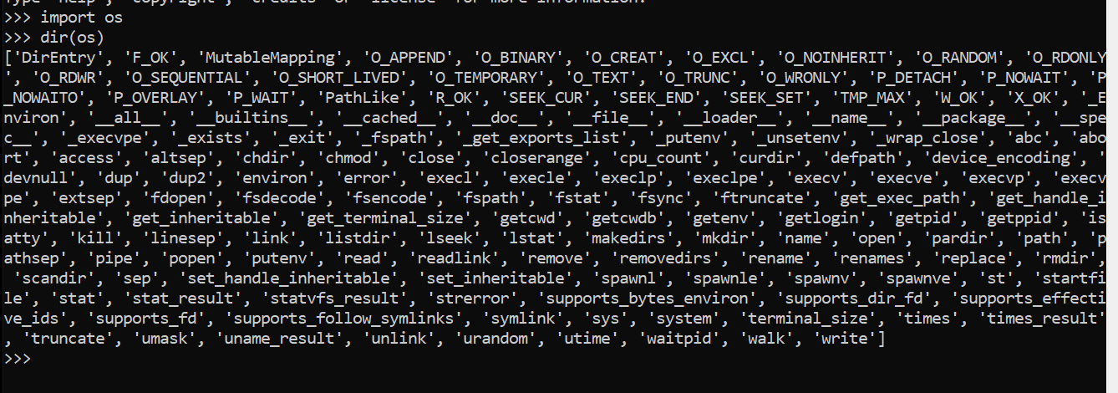



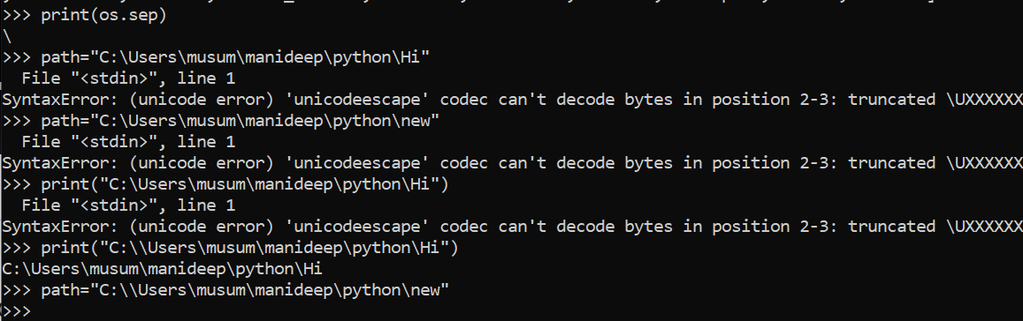

**Os.getcwd()--🡪it will print the current working directory irrespective of the operating system.**

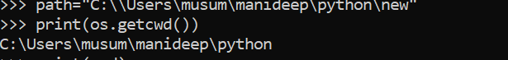

**Os.chdir(“c:\\users\\automation”)---🡪 for changing the directory**

**Os.chdir(“c:\\users”)**

**Print(os.getcwd())**

**C:\users**

**Os.listdir()----🡪for listing the directories.**

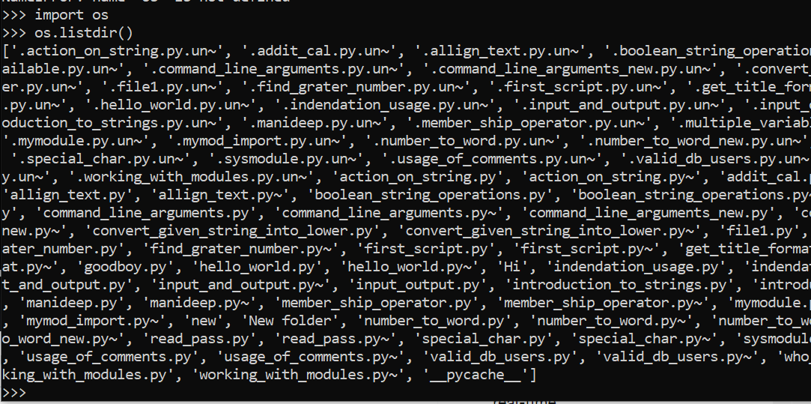

**Print(os.listdir(“c:\\users\\automation”)---🡪 for listing the directories present in the given path.**





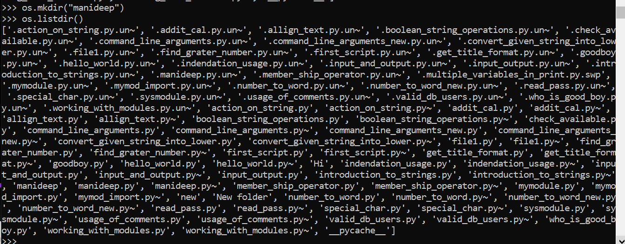

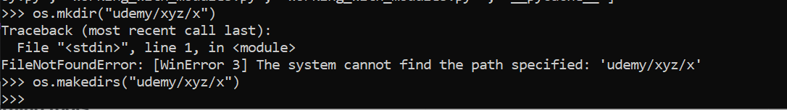

**Os.makedir--🡪 this is used to create a single dir if we need to create a multiple directories like directories inside directories we will be using os.makedirs(“udemy/xyx/x”)**

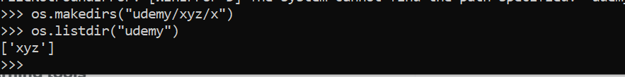

**Tree udemy-🡪 this will use to list the directories inside directories**

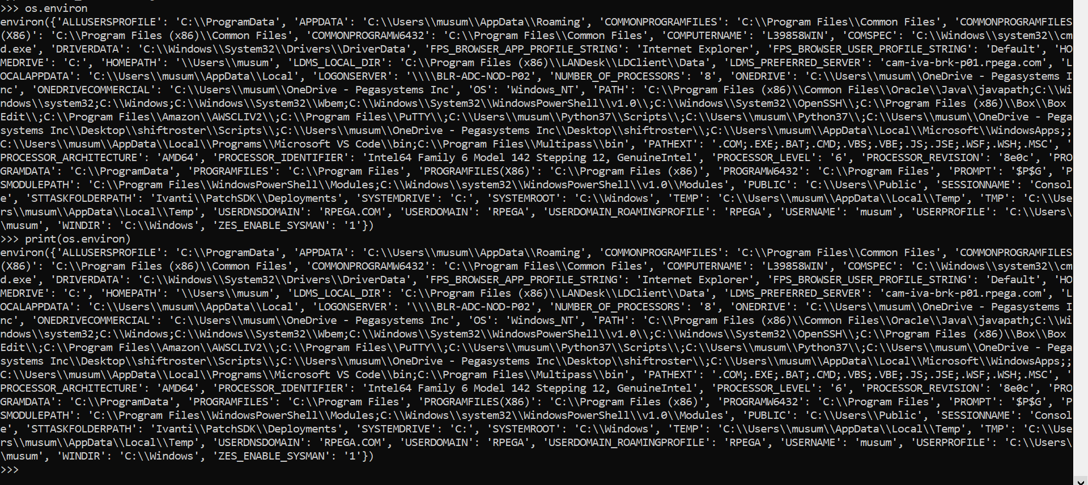

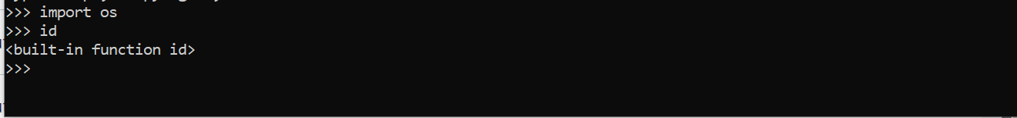

**This is used to get the details od the user user id etc.**

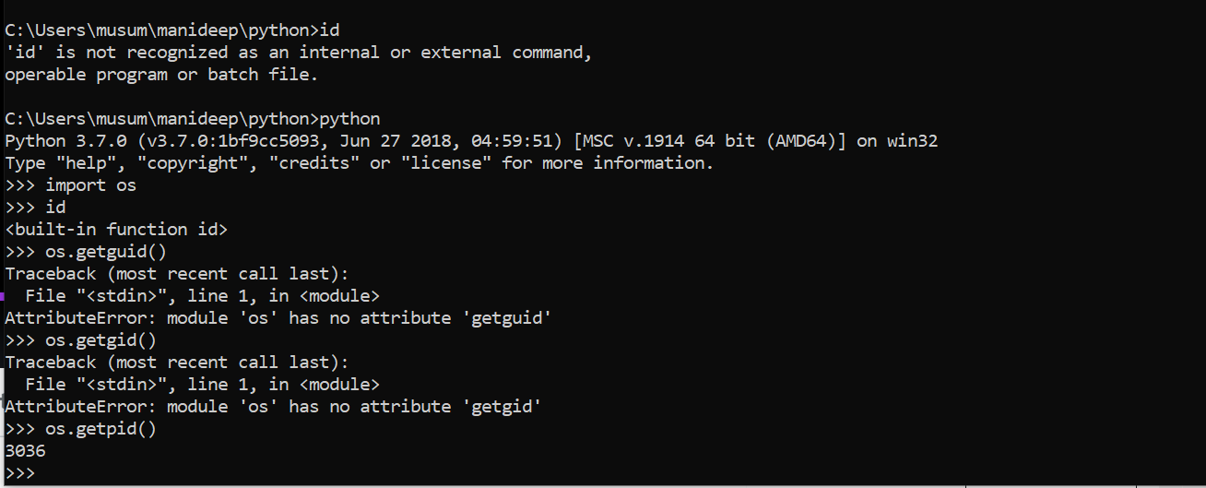

**Os.path module:**

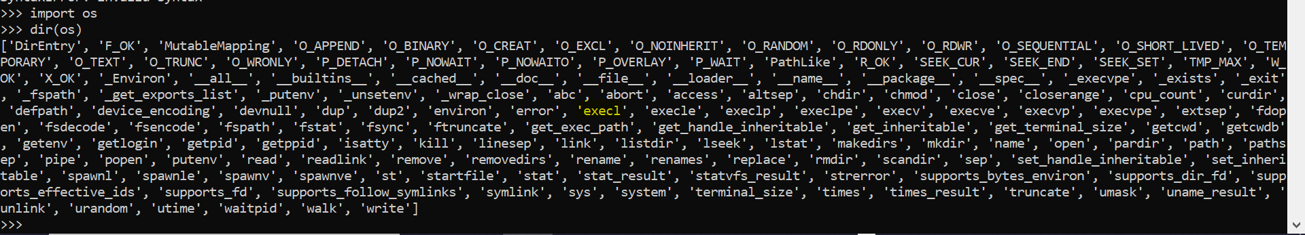

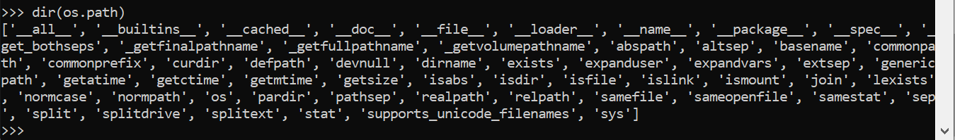

**Os.path is a sub module of as (os.path is used to work on paths).**

**Os.path**

**Os.path.sep**

**Os.path.basename(path)**

**Os.path.dirname(path)**

**Os.path.join(path1,path2)**

**Os.path.split(path)-🡪is used to split the path name into a pair head and tail.**

**Os.path.getsize(path)--🡪 in byte**

**Os.path.exists(path)**

**Os.path.isfile(path)**

**Os.path.isdir(path)**

**Os.path.islink(path)**

**After time module we will discuess:getatime,getctime and getmtime**

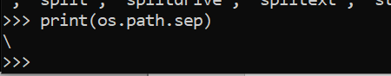

**Os.path.**

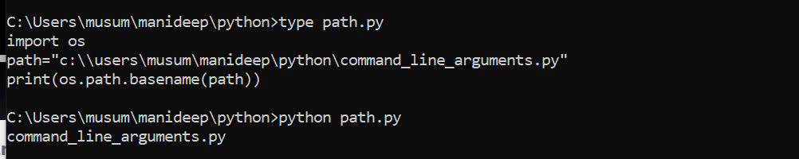

**Base name is nothing but name of the script in that directory**

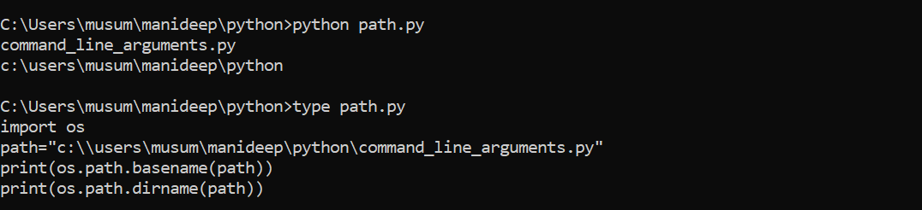

**Base name means we are getting command_line_arguments.py**

**And directory name means c:\users\musum\manideep\python**

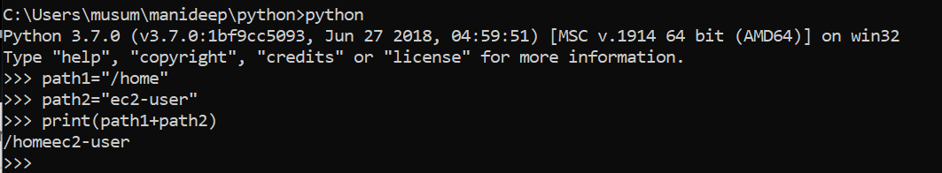

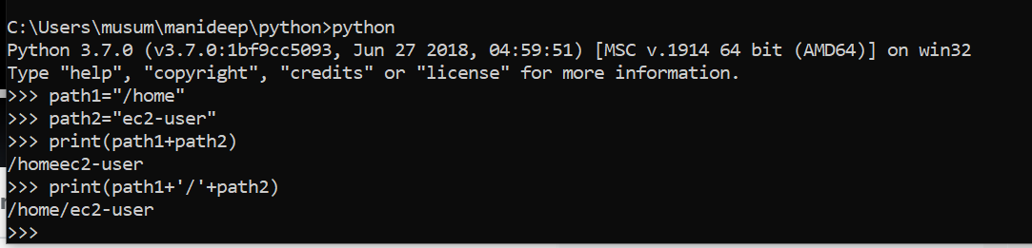

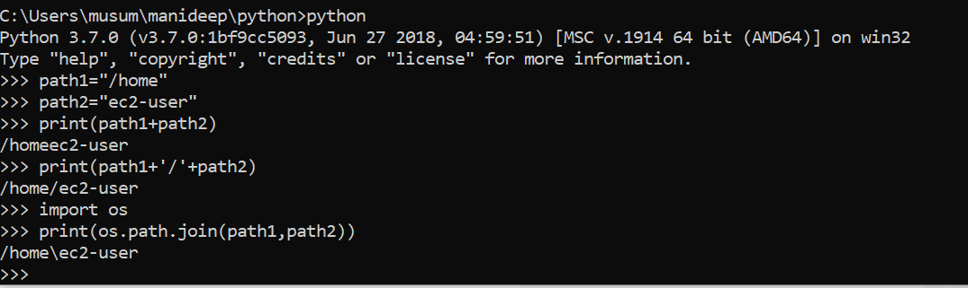

**Print(os.path.join(path1,path2)--🡪 both the paths will joined in a single line.**

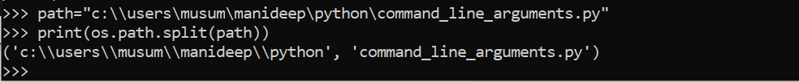

**Os.path.getsize(path)---🡪 in bytes**

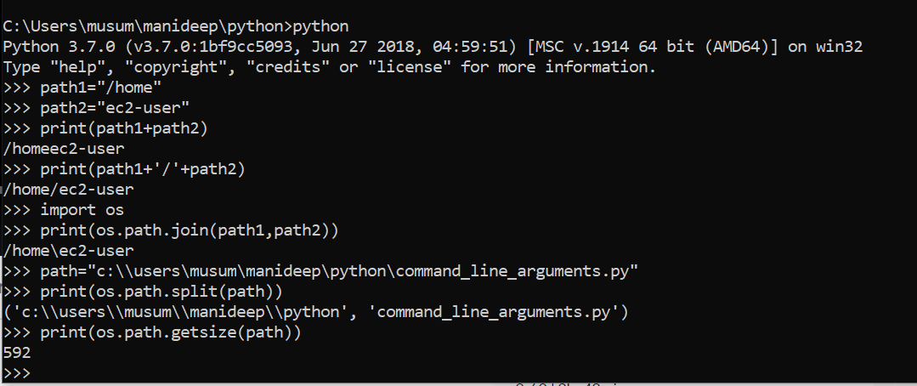

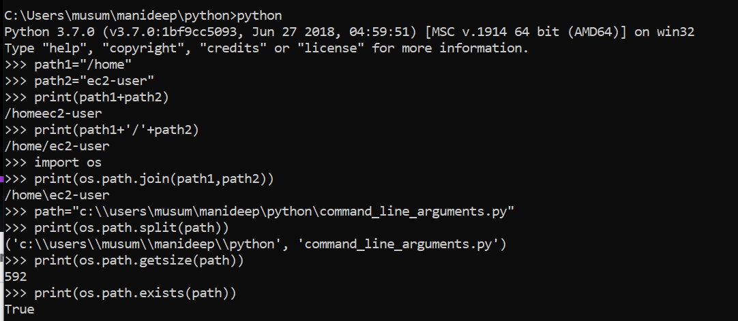

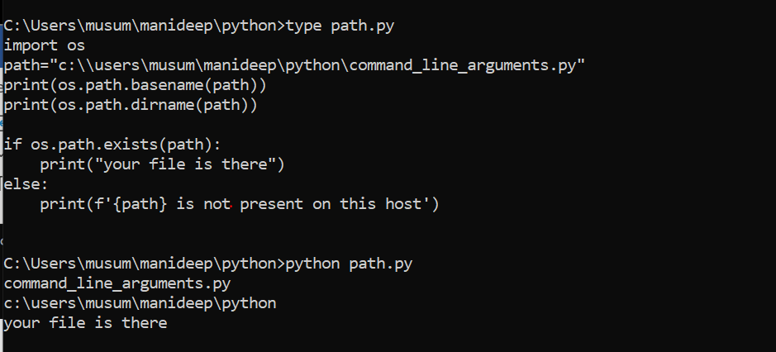

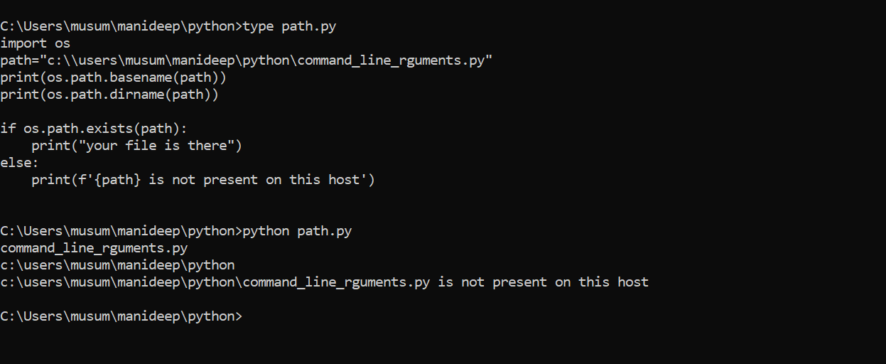

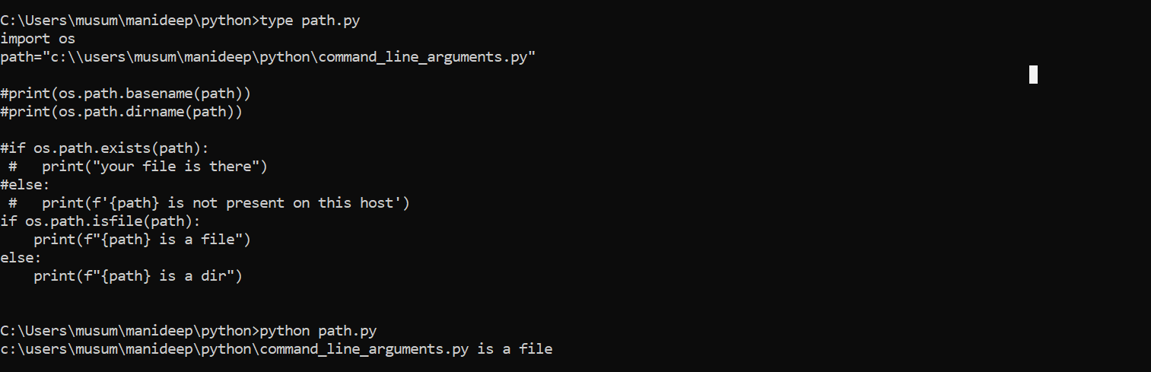

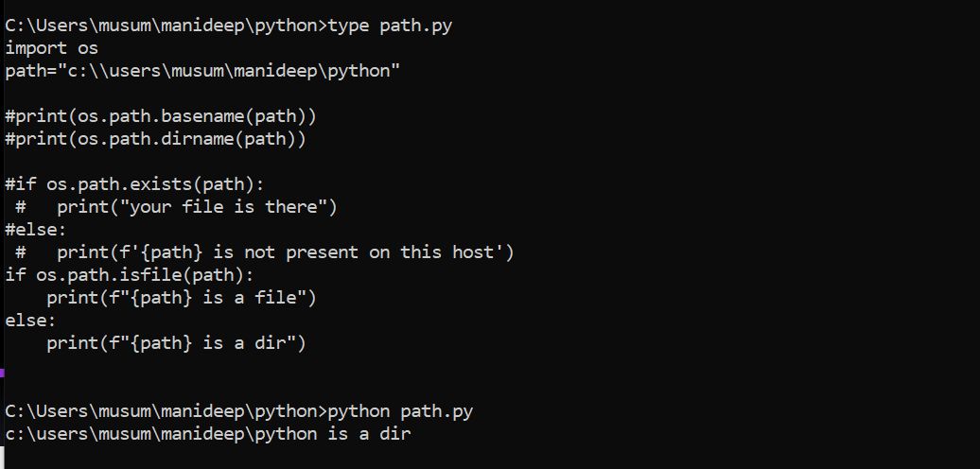

**Import os**

**Print(os.path.islink(“myos”))**

**True**

**Print(os.path.islink(“os_path.py”))**

**False**

**Os.system()function from os module:**

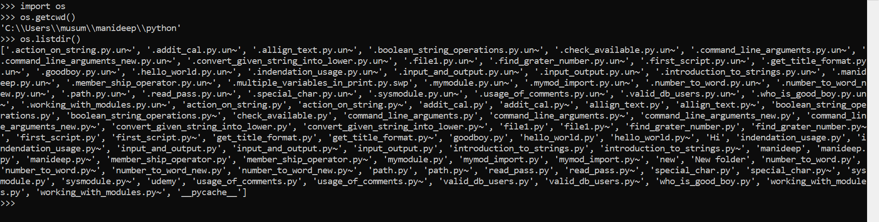

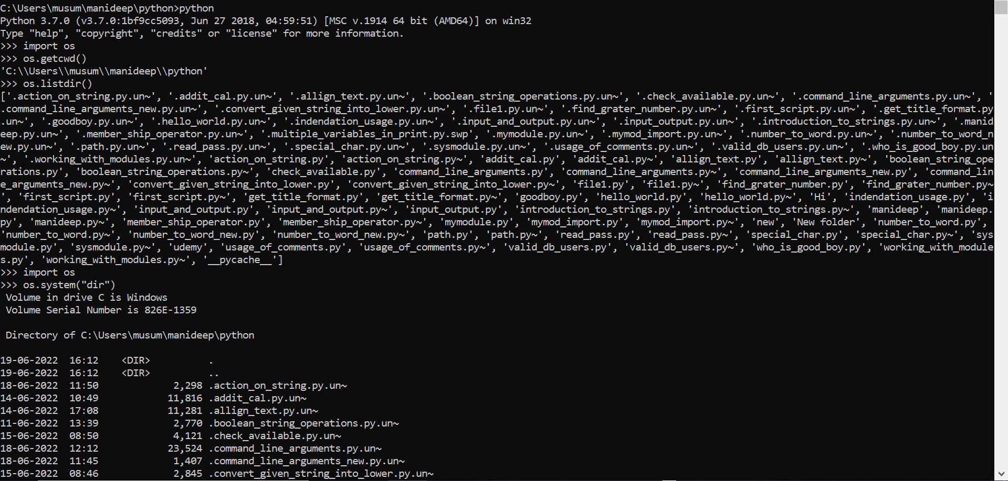

**In window for listing the directories we use os.system(“dir”)**

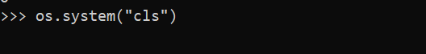

**We can clear the screen by using above command.**

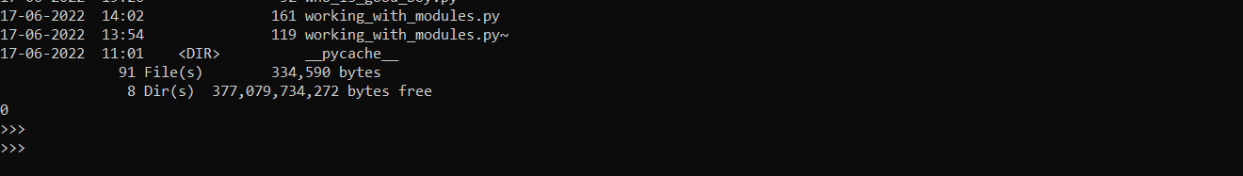

**After running the able we are getting the result as zero, so command executed successfully. If we are getting one command was not executed so we are getting one.**

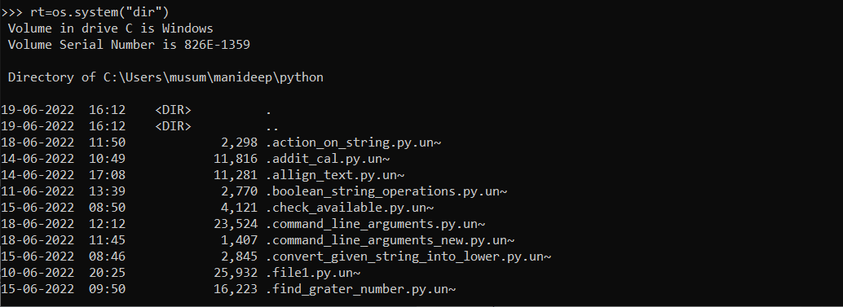

**We are having the result like rt=os.system(“dir”) this will store the result in rt either zero or one**

**Rt will store the executed command status either it is true or false. (oor1).**

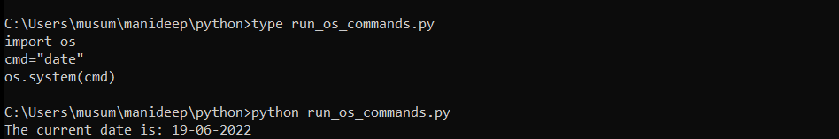

**It will print the output on the screen itself.**

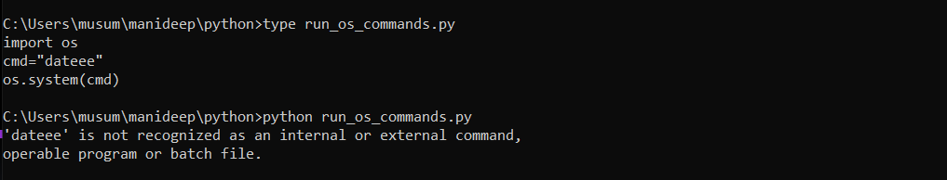

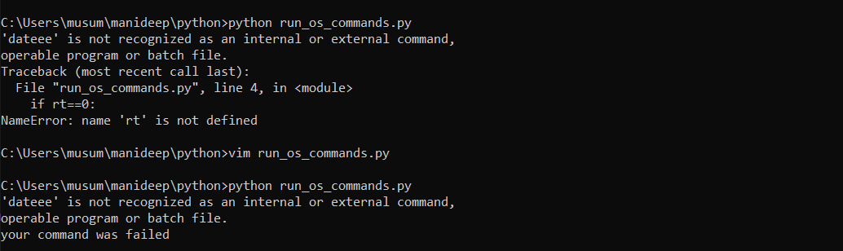

**The above will run the script if there is any error it will throw the error like your command was failed.**

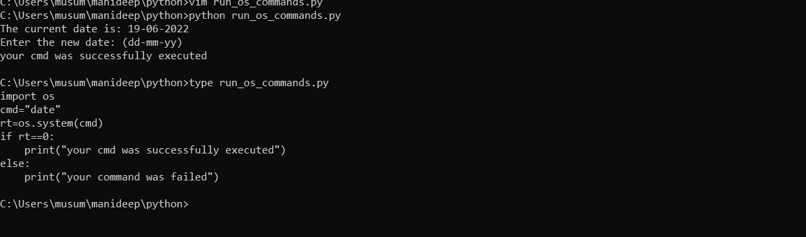

**It is saying that the command was successfully executed.**

**Os.system is used to execute any operating system commands.**

**Practice with platform and os modules:**

**Write a single python script to clear terminal of any operating system**

**Or**

**Write a platform independent script to clear terminal**

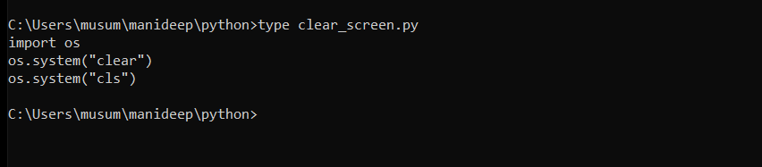

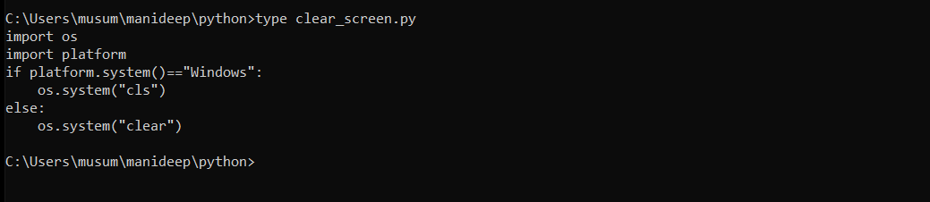

**Os.walk(path):**

**Used to generate directory and file names in a directory tree by walking.**

**Note:first complete for loop then start this os walk**

**Section11-loops for and while loop with:**

**Read the path and check if given path is a file or directory.**

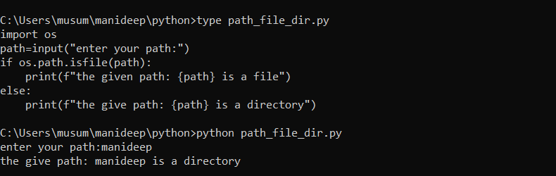

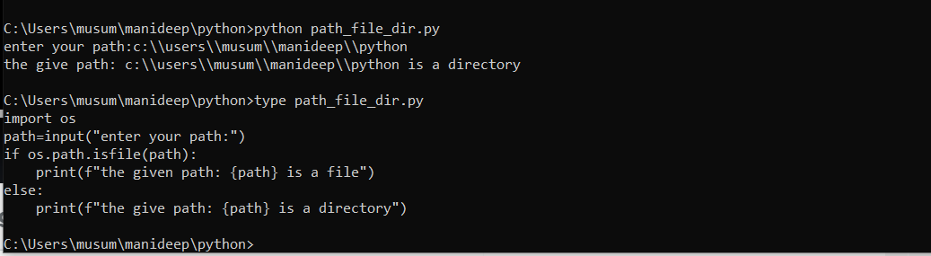

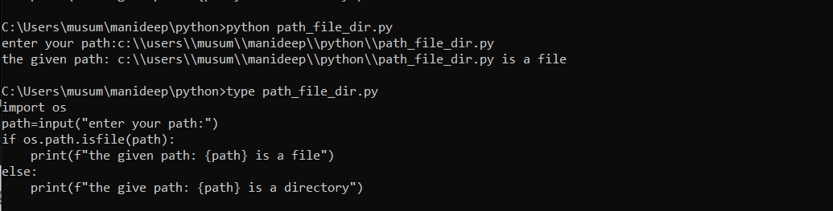

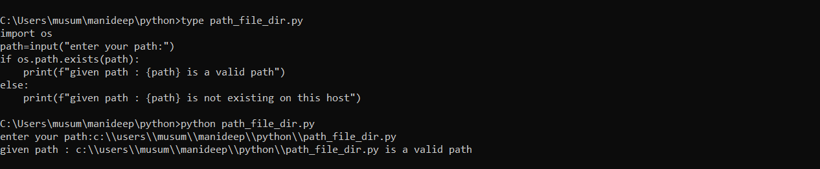

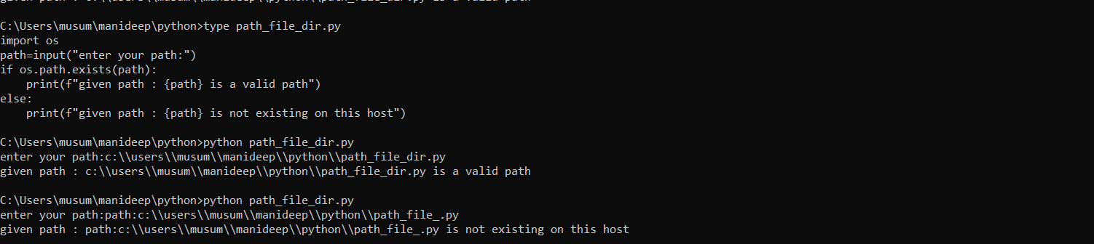

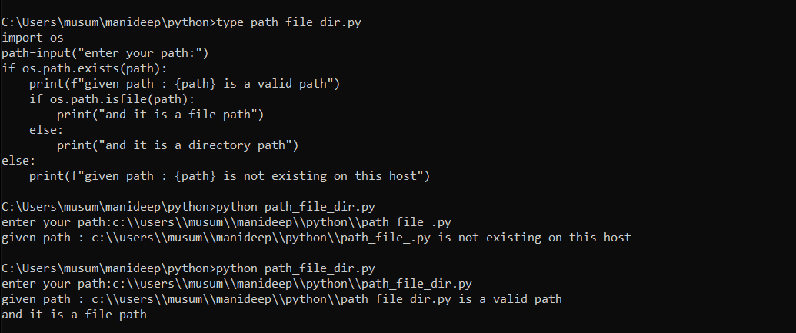

**Introduction to loops with an example:**

**Read a directory path and identify all files and directory:**

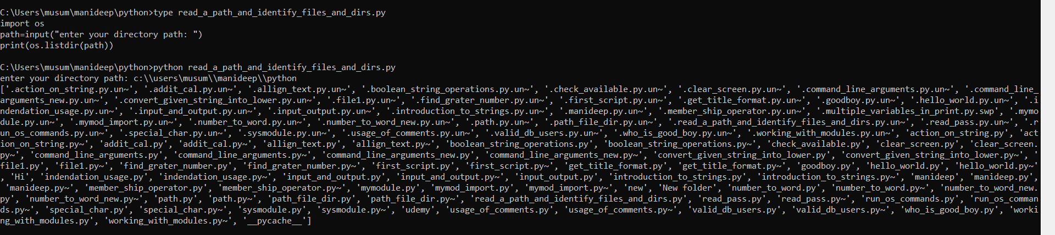

**Files and directories are listed**

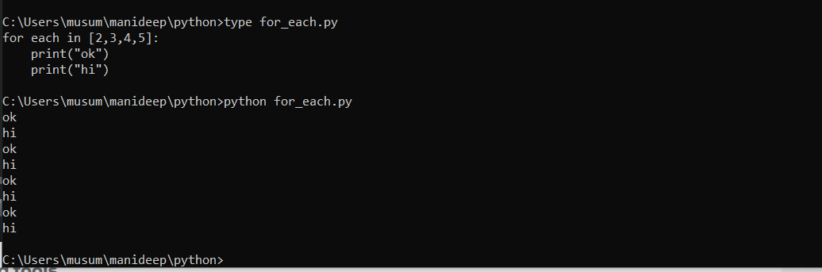

**How many times it will repeat=the number of words repeat In for each that is 2345(4)**

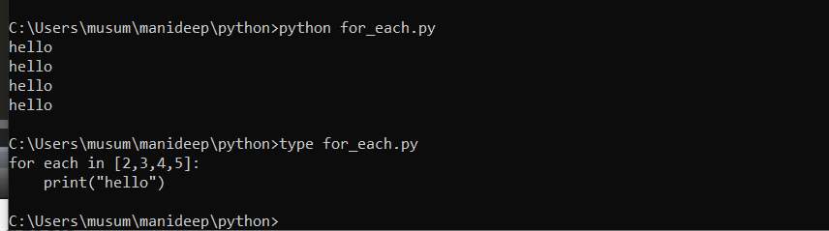

**Each in having 4 values so it is running 4 times.**

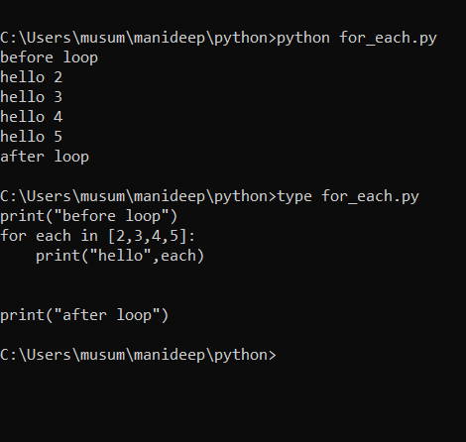

**'''**

**import os**

**import sys**

**path=input("Enter your directory path: ")**

**if os.path.exists(path):**

**df_l=os.listdir(path)**

**else:**

**print("please provide valid path")**

**sys.exit()**

**print(df_l)**

**p1=os.path.join(path,df_l[0])**

**p2=os.path.join(path,df_l[1])**

**if os.path.isfile(p1):**

**print(f"{p1} is a file")**

**else:**

**print(f"{p1} is a directory")**

**if os.path.isfile(p2):**

**print(f"{p2} is a file")**

**else:**

**print(f"{p2} is a directory")**

**'''**

**'''**

**print("befor loop")**

**for each in [2,3,4,5]:**

**print("hello",each)**

**print("after loop")**

**'''**

**import os**

**import sys**

**path=input("Enter your directory path: ")**

**if os.path.exists(path):**

**df_l=os.listdir(path)**

**else:**

**print("please provide valid path")**

**sys.exit()**

**list_of_files_dir=os.listdir(path)**

**print("all files and dirs: ",list_of_files_dir)**

**for each_file_or_dir in list_of_files_dir:**

**f_d_p=os.path.join(path,each_file_or_dir)**

**if os.path.isfile(f_d_p):**

**print(f'{f_d_p} is a file')**

**else:**

**print(f'{f_d_p} is a directory')**

**loops working with loops: working with for loops**

**why loops:**

**all programming languages need a way to execute block of code many times, this is possible with loops.**

**python has two types of loops**

**for loop**

**while loop**

**for loop:**

**the for loop in python is used to iterate over a sequence (list,tuple,string) or other iterable objects.**

**execute a block of code many times.**

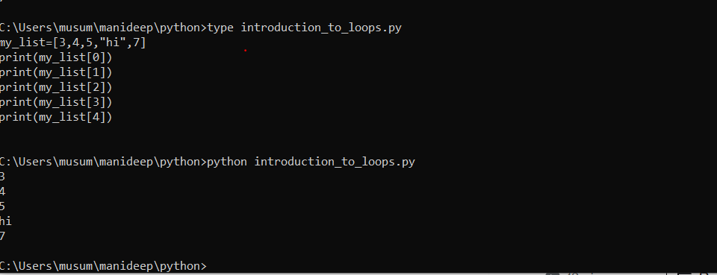

**In the above code we are defining all of them one by one with index we can provide all of them in a single loop.**

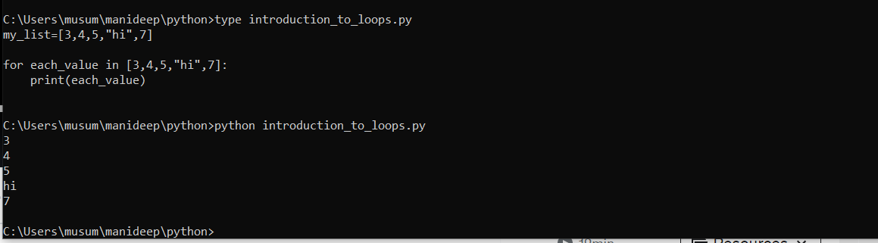

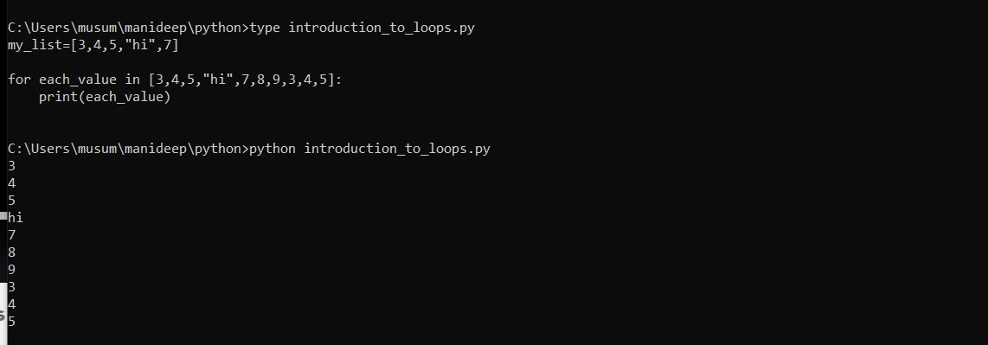

**Instead of writing the things in loops we are writing this in a single loop and all the values are printing.**

**Each time it will take one value and print it in each_value every time it will print one value.**

**Execute a block of code many times:**

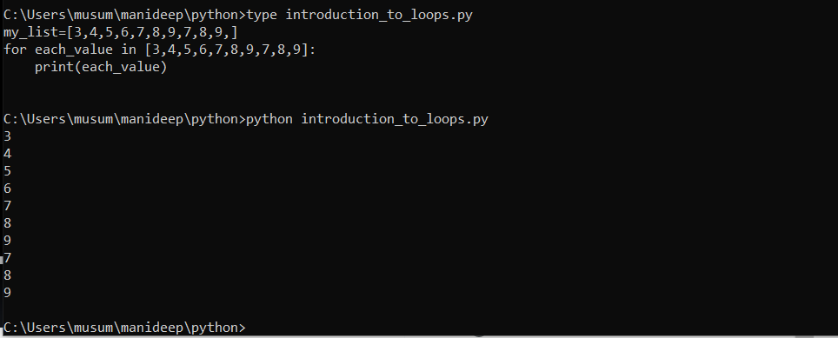

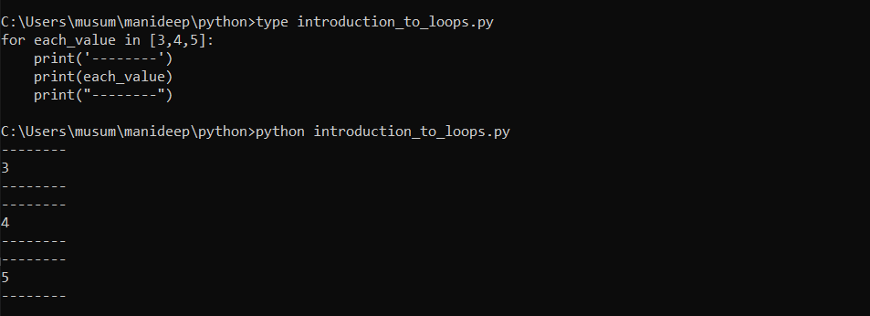

**It will print each value one one time and it is having three values so each value at a time and finally three values will print three times.**

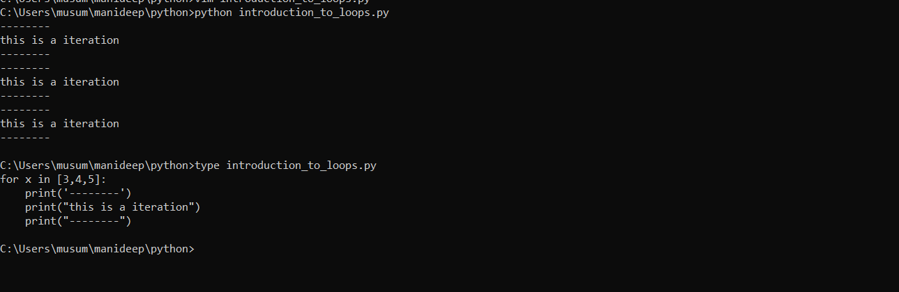

**Above is having values like 3,4,5 and it will print all the values below.**

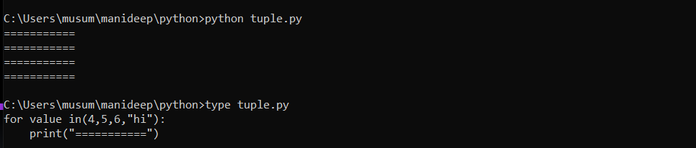

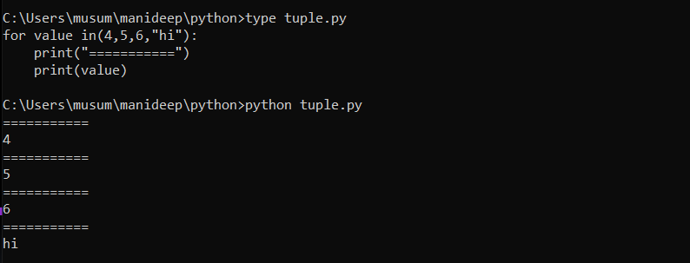

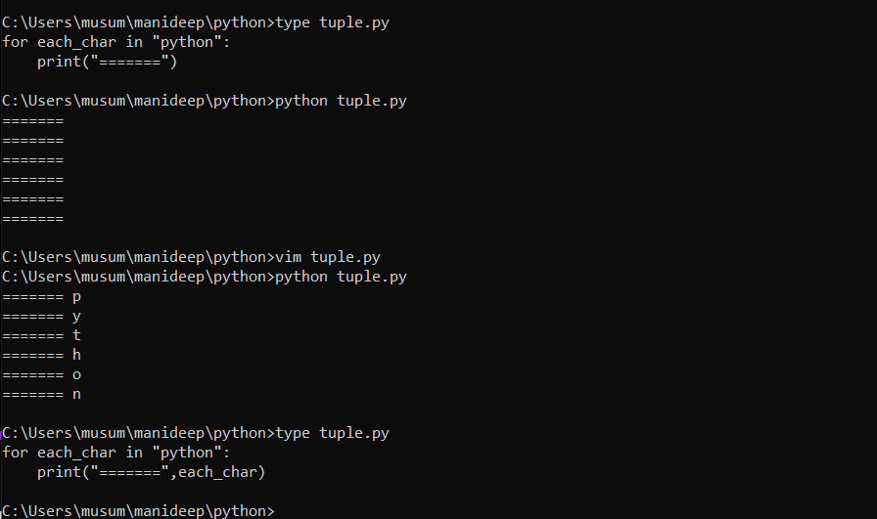

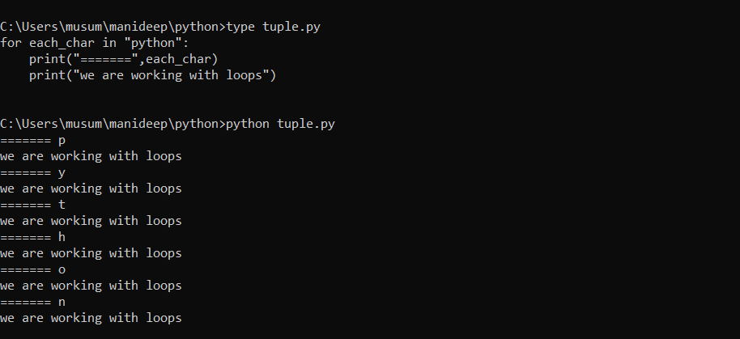

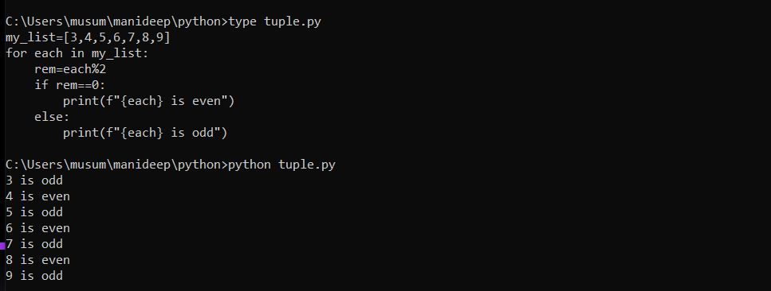

**Simple practice with for loop:**

**Read a string and print chars and their index values:**

**Input is: python**

**Output is:**

**p-🡪0**

**y🡪1**

**t🡪2**

**h🡪3**

**0🡪4**

**n🡪5**

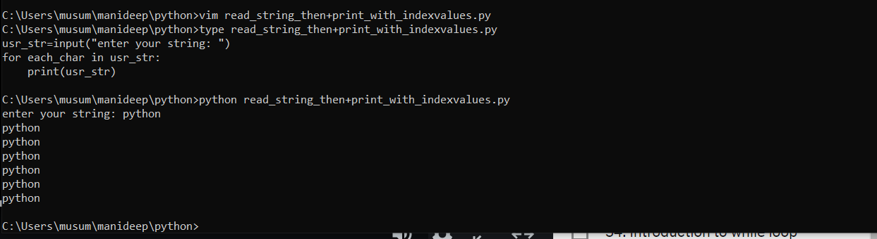

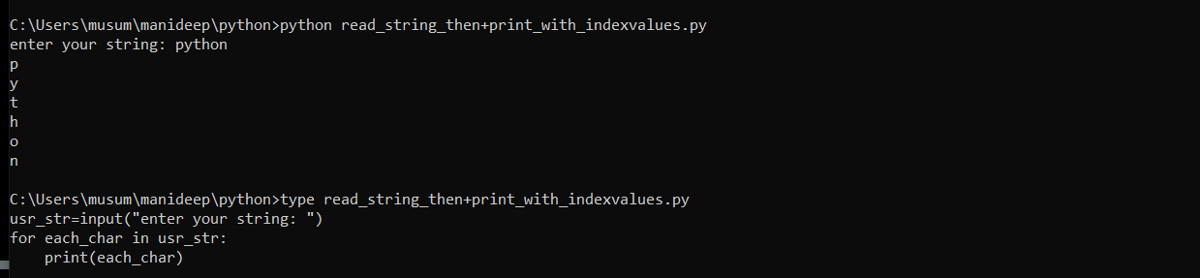

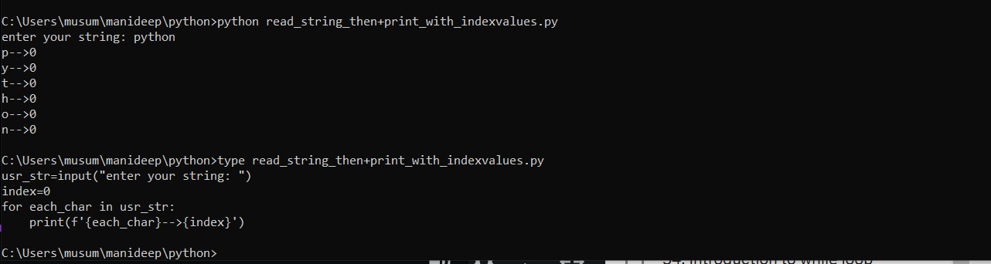

**Above one is wrong because for each letter we are representing a single index.**

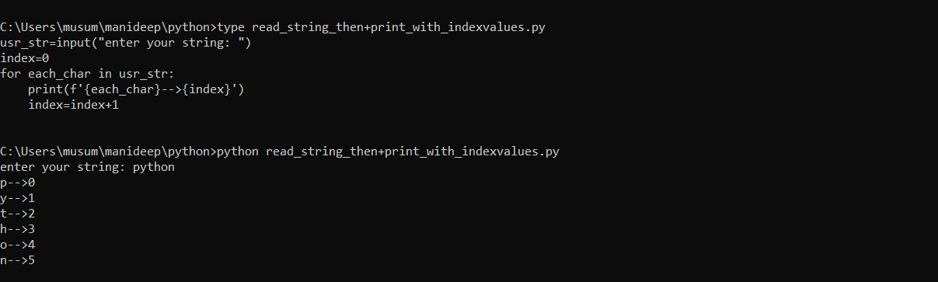

**Find all files in a directory with extension.py/.sh/.log/.txt etc:**

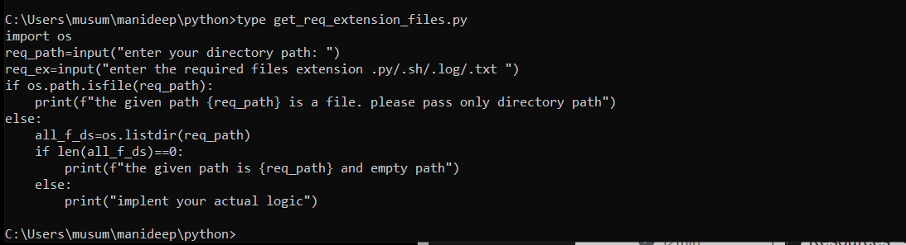

**#!/usr/local/bin/python3**

**import os**

**req_path=input("Enter your directory path: ")**

**#req_ex=input("Enter the required files extention .py/.sh/.log/.txt: ")**

**if os.path.isfile(req_path):**

**print(f"The given path {req_path} is a file. Please pass only directory path")**

**else:**

**all_f_ds=os.listdir(req_path)**

**if len(all_f_ds)==0:**

**print(f"The given path is {req_path} an empty path")**

**else:**

**req_ex=input("Enter the required files extention .py/.sh/.log/.txt: ")**

**req_files=[]**

**for each_f in all_f_ds:**

**if each_f.endswith(req_ex):**

**req_files.append(each_f)**

**if len(req_files)==0:**

**print(f"There are no {req_ex} files in the logcation of {req_path}")**

**else:**

**print(f"There are {len(req_files)} files in the location of {req_path} with an extention of {req_ex}")**

**print(f"So, the files are: {req_files}")**

**complete range () function:**

**built in function**

**generates integers as a list**

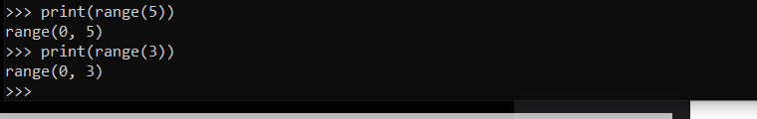

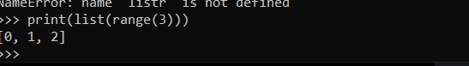

**it will print the values and sequence of values.**

**Syntax:**

**Range(start,stop,step)**

**3-arguments🡺print(range(5)) it will stop at certain value by default start=0,stop=1**

**If you are not providing any number it will start with 0 and end till the last value.**

**The difference between two successive numbers is step**

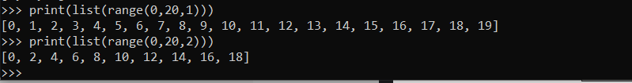

**N+2**

**Max number -9 we are generating it a step2, so we are getting as 18.**

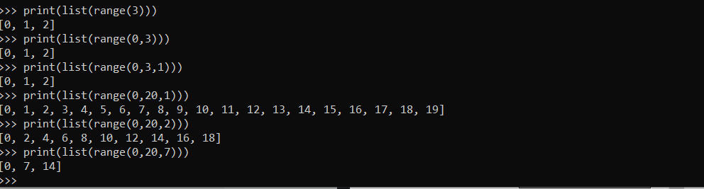

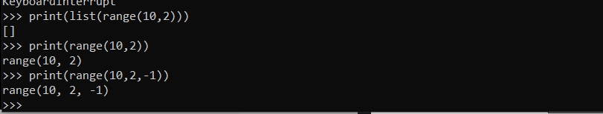

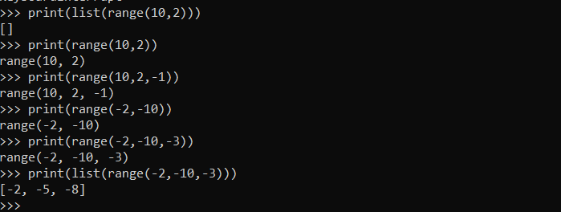

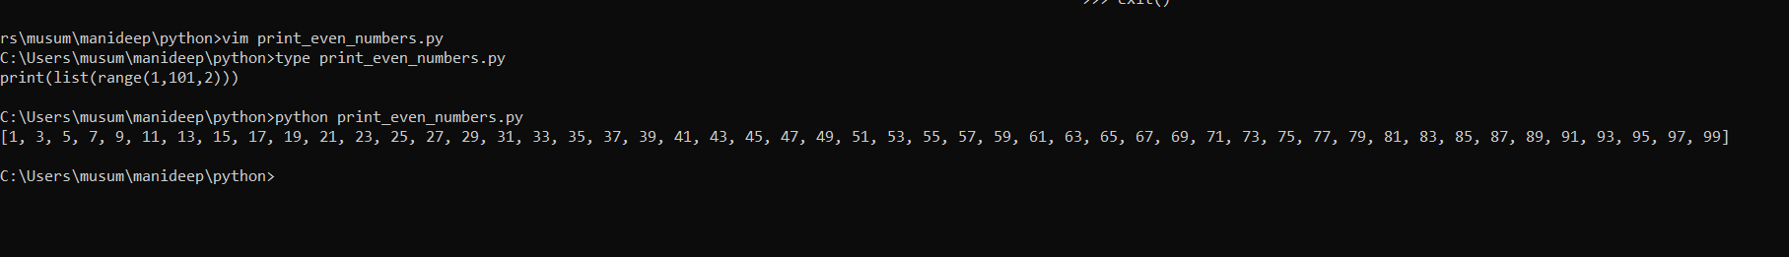

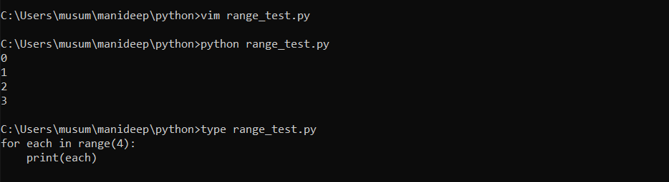

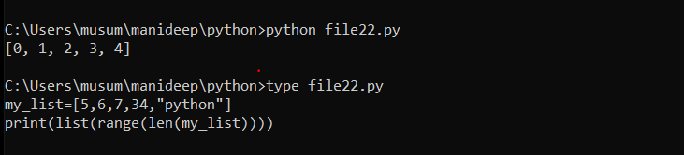

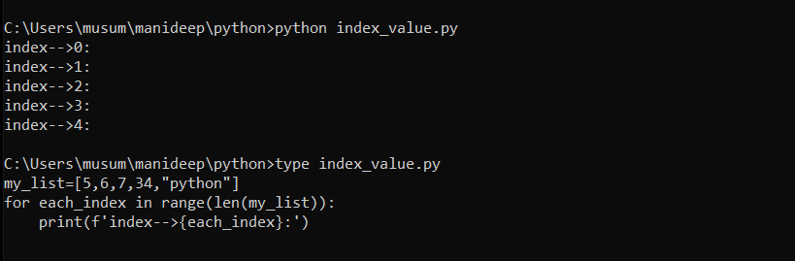

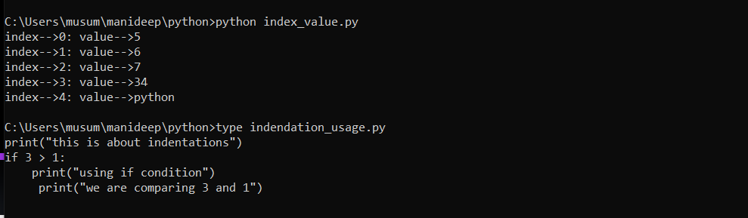

**For loop to work with string,list,tuple and dictionaries:**

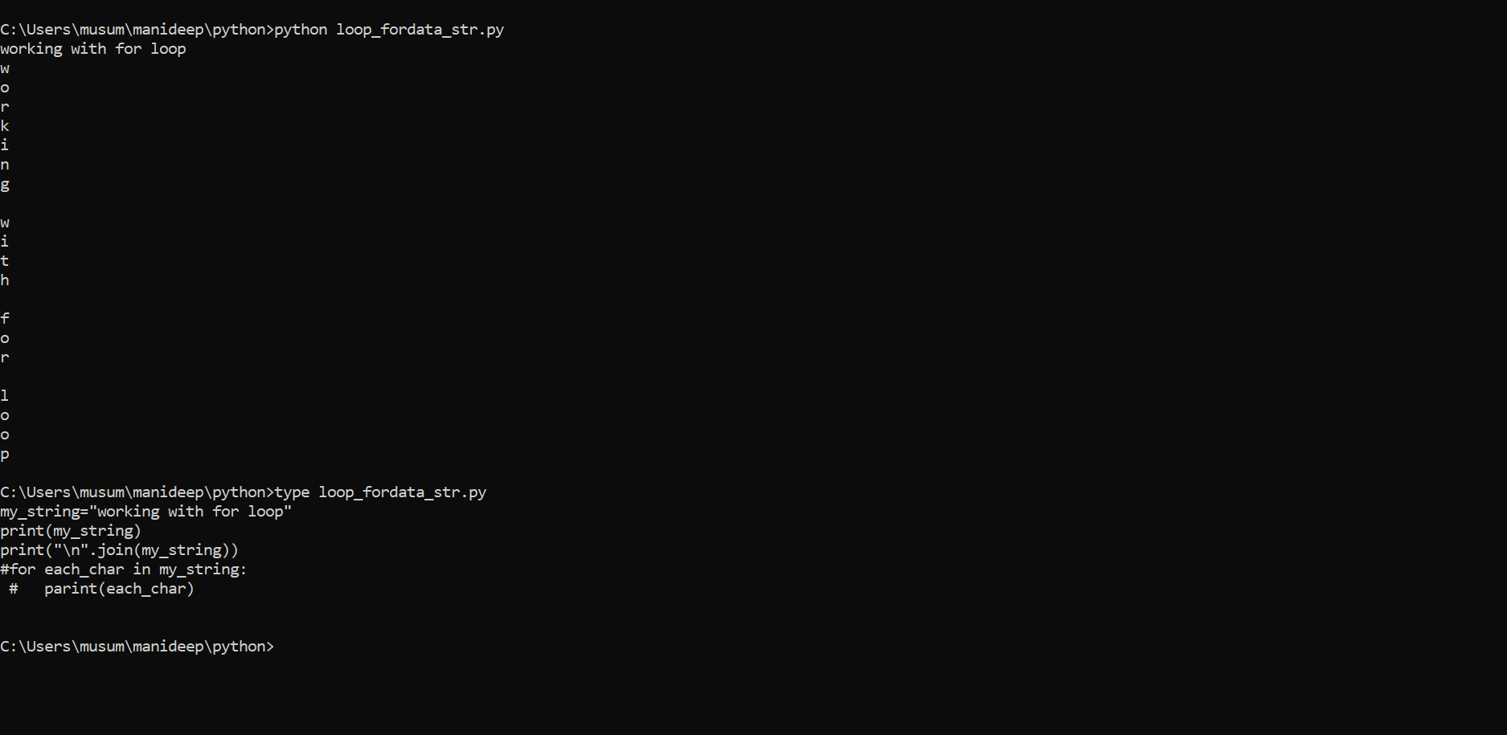

**Instead of printing we can use this single line print print(“\n”.join(ny_string)-🡪this will give the output of the string mentioned above in line by line.**

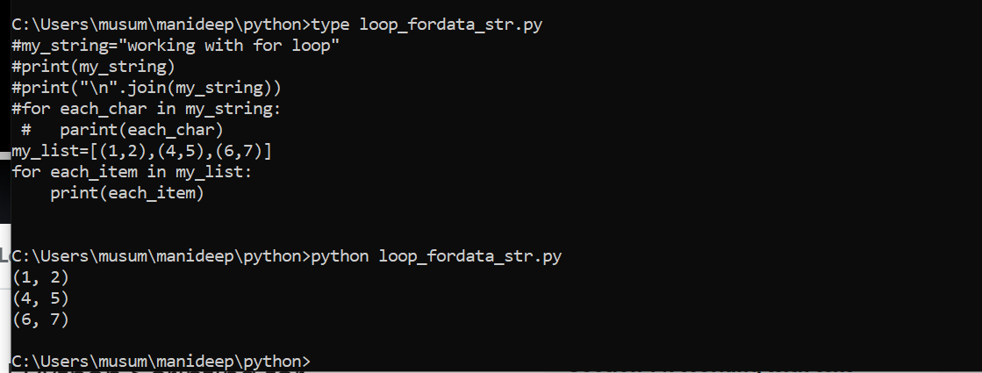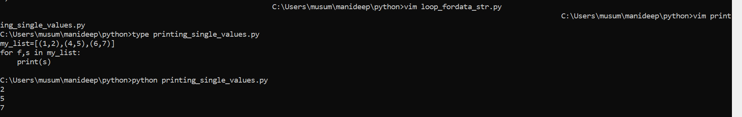

**The above script is printing only the f values (f,s)🡪 in (f,s) we are printing only f values**

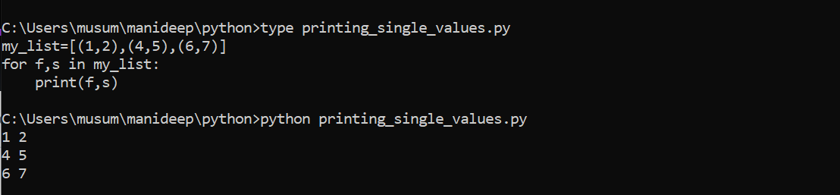

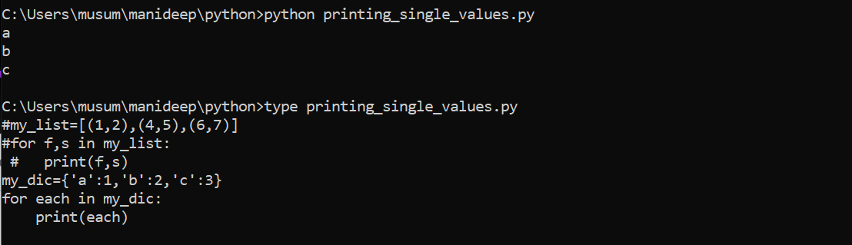

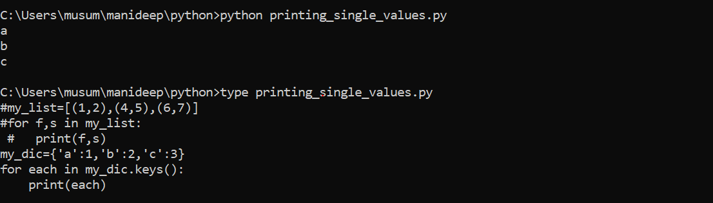

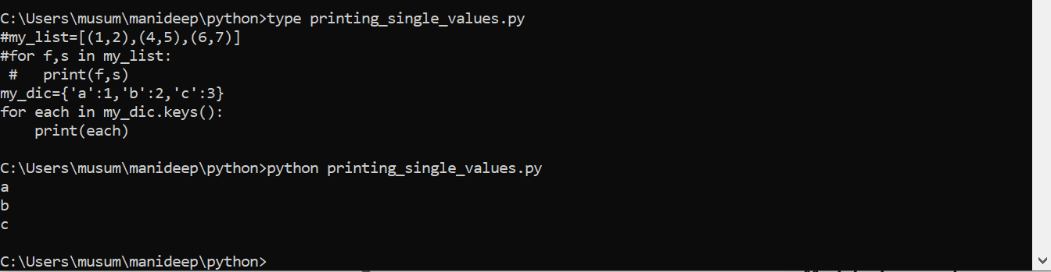

**The above program is also printing the only keys.**

**Print(each)-🡪key,value**

**Print(key)--🡪only key**

**Print(value)-🡪only value**

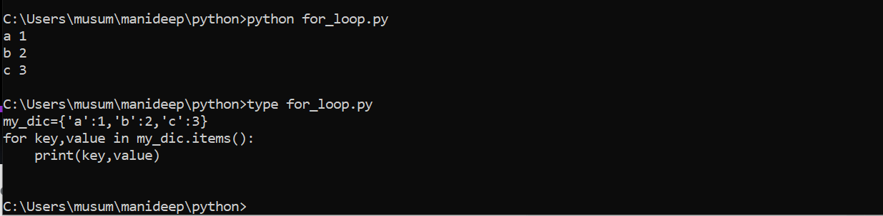

**Introduction to while loops:**

**If you want to repeat the things infinity number of times you need to do it with while loops.**

**The while loop in python is used to iterate over a block of code as long as the test expression(condition) is true.**

**We generally use this loop when we don’t know beforehand, the number of times to iterate.**

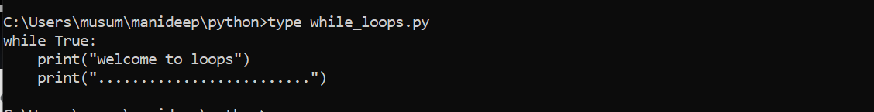

**It will repeat the loops infinity number of times.**

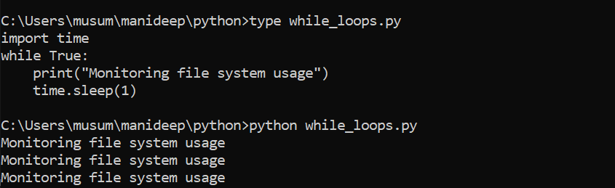

**This above one will execute the code for every second.**

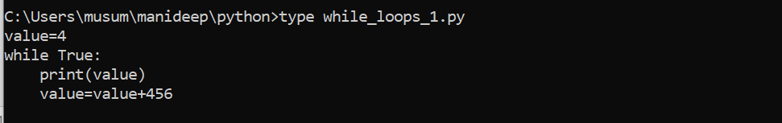

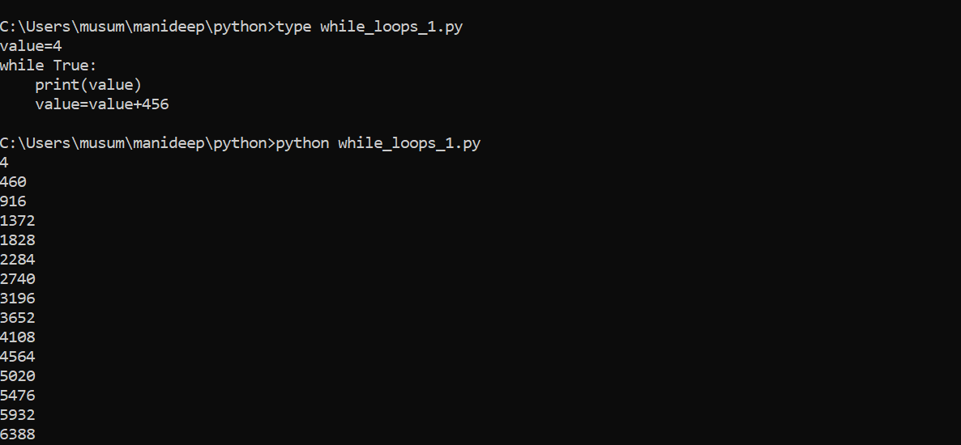

**It started adding values.**

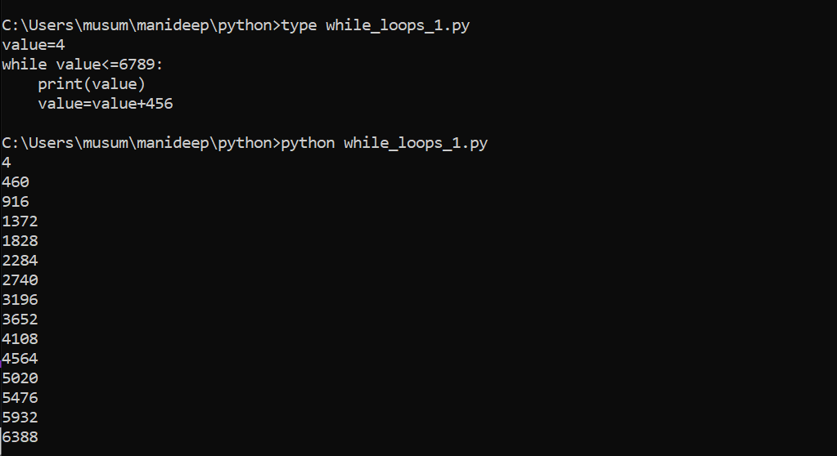

**The above will print the details. Up to the values which are lesser than or equal to 6789**

**Loop control statements:**

**To control the iteration parts of the loops:**

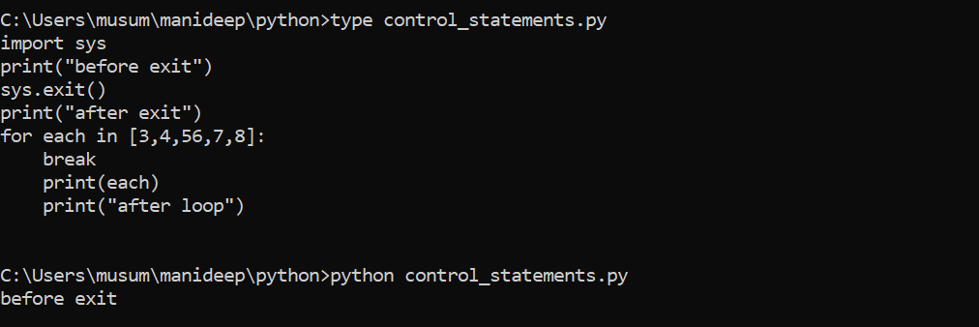

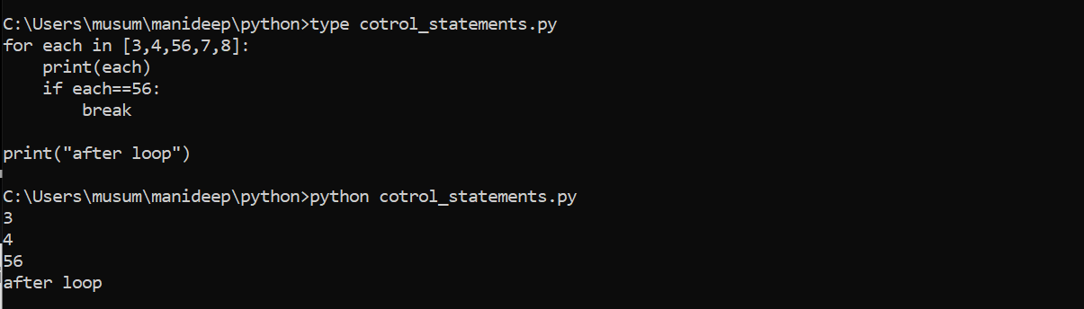

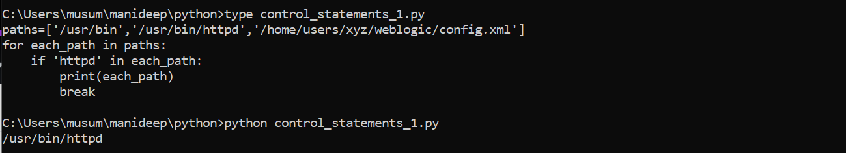

**Above is searching for a path mentioned in each_path if the condition satisfies it is terminating the loop break the loop so the execution will get stopped.**

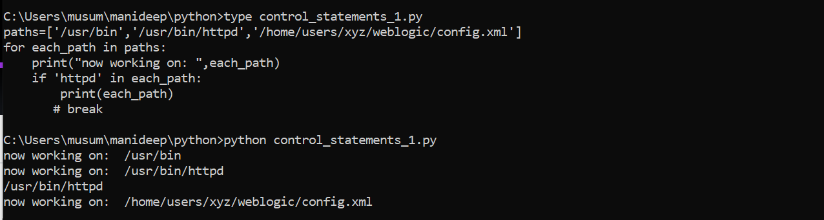

**The above is not having any break statements so the loop is executing again and again.**

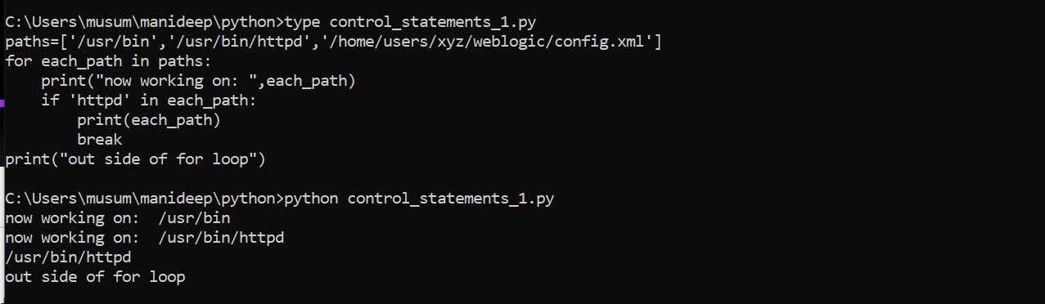

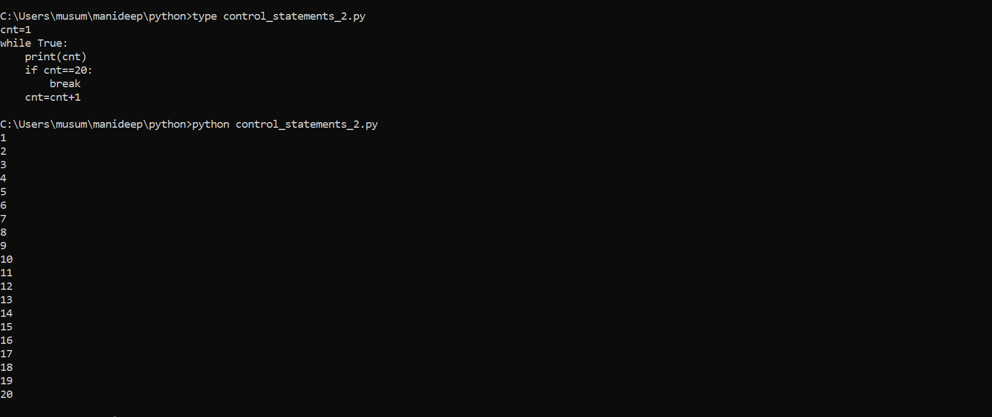

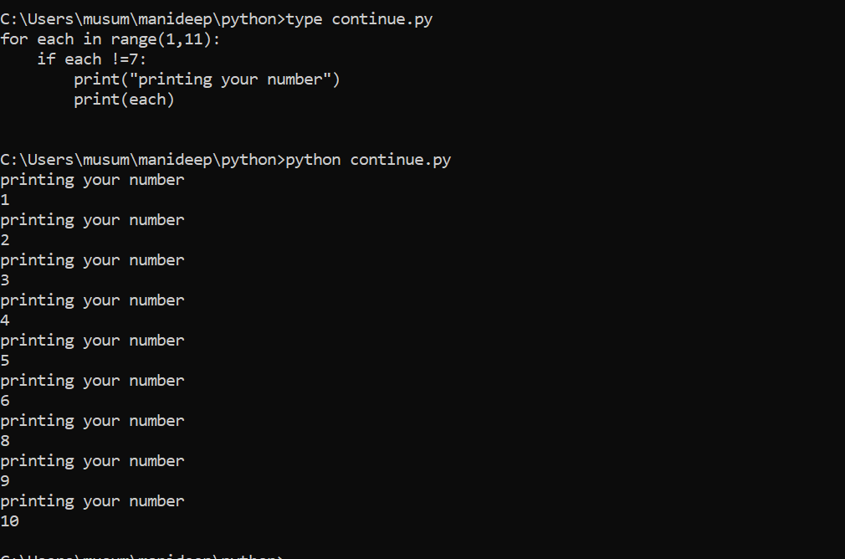

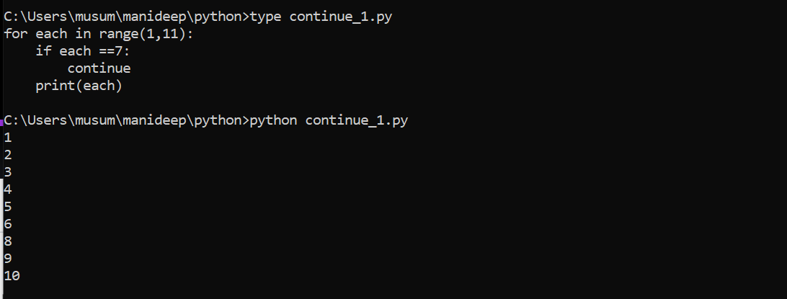

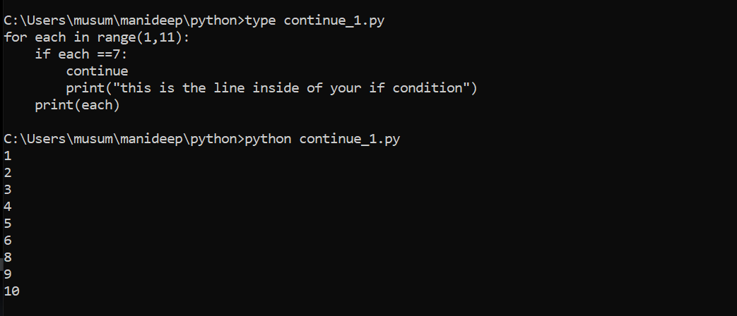

What ever the code exists after continuing will get exit and it wont execute. The code after continue.

Control statements:

Break

Continue

Pass

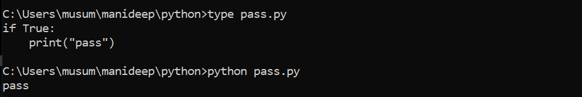

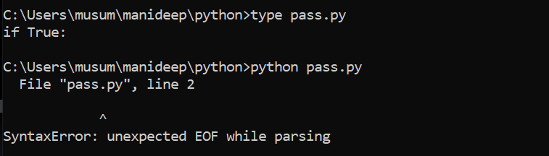

We are getting syntax error because we didn’t passed any value after True there should be some code inside it.

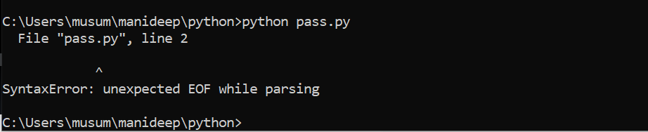

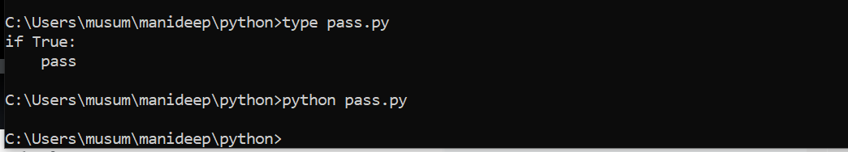

We are not getting any error because we are using pass it will make block of statement but wont get execute.

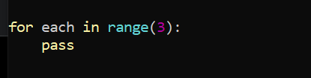

To avoid error, we will be using pass key word.

Introduction to Datetime module:

(Python built-in or default modules and used to work with dates and times):

Import datetime

Import pytz

Req_timez=pytz.timezome(“”)

Print(datetime.datetime.now(req_timez))

Date,time,datetime

Print(datetime.datetime.now())

Strftime(“”)

#strftime.org

From datetime import datetime

Print(datetime.now())





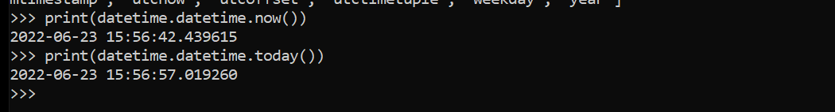

Now()🡪 this is used to get the details of other time zones.

Today()🡪this is used to get the details of time zone for that specific day local time zone.

For getting the time zone we need to create an object using ist=pytz

Import pytz

Ist=pytz.timezone(‘Asia/Kolkata’)--🡪 change the time zone and pass it in the local host

Print(datetime.datetime.now())🡪

Print(datetime.datetime.now(ist))🡪 if you are defining it will provide the output.

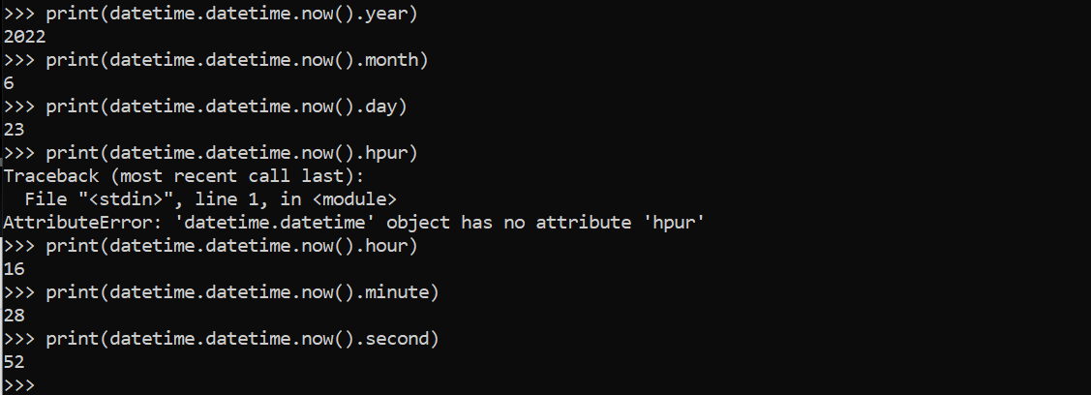

Print(datetime.datetime.now().strftime(“%y-%m-%d”))

Print(datetime.datetime.now().strftime(“%y-%m-%d”))

Stringformattime.org

Print(datetime.datetime.now().strftime(”%c”))

Print(datetime.datetime.fromtimestamp(155555))

Datetime.datetime.max

Find all the files which are older than x days:

import os

import sys

import datetime

req_path=input("Enter your path: ")

age=3

if not os.path.exists(req_path):

print("Please provide valid path ")

sys.exit(1)

if os.path.isfile(req_path):

print("Please provide directory path ")

sys.exit(2)

today=datetime.datetime.now()

for each_file in os.listdir(req_path):

each_file_path=os.path.join(req_path,each_file)

if os.path.isfile(each_file_path):

file_cre_date=datetime.datetime.fromtimestamp(os.path.getctime(each_file_path))

#print(dir(today-file_cre_date))

dif_days=(today-file_cre_date).days

if dif_days > age:

print(each_file_path,dif_days)

1)introduction to subprocess module:

2)import subprocess

sp=subprocess.popen(cmd,shell=true/false,stdout=subprocess.pipe,stderr=subprocess.pipe)-🡪for running this sub process it will take some time so we need to wait for some time.

3)rc=sp.wait()

Out,error=sp.communicate--🡪 to separate output and error

Ptint(f OUTPUt IS: {out}’)

Print(f’ERROR IS : {err}’)

Cmd=’dir’

Cmd=’ls-lrt’

Shell=true

Cmd=[‘ls’,’-lrt’]

Shell=false

used to execute operating system commands

universal_newlines=True-----🡪this will give the output as a string.

Shell=true for getting the env varible or else we won’t get the correct value.

Shell=true command should be string

Shell=false command should be list

Is shell =True then your cmd is a string (as your os command)

Note:shell=false don’t work on your os environment variables

Ex: cmd=”ls -lrt” =🡺shell=true

Shell=false🡺cmd=”ls -lrt”.split() or [‘ls’,’lrt’]

Shell=true--🡪 always in windows

* 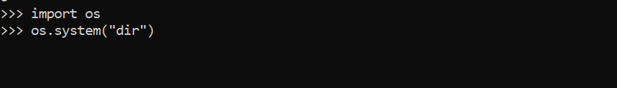

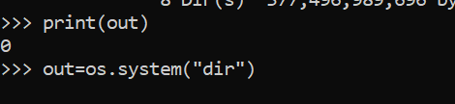

It will only show the status of the command if it was executed successfully or not.

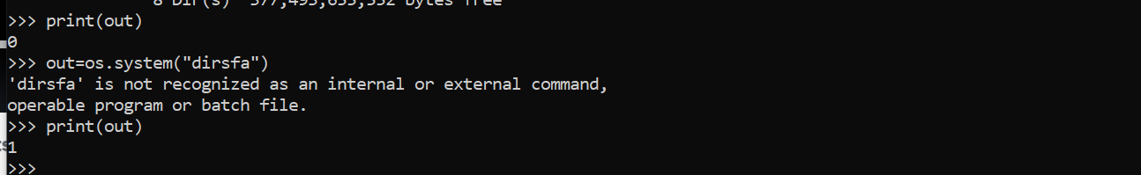

Output 1 --🡪fale

Output 0--🡪 true

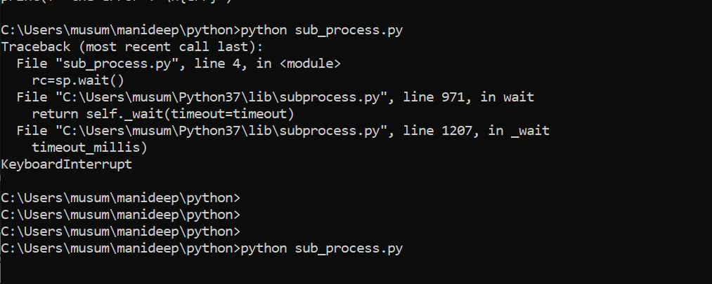

The above will give the output like if the code executed successfully or not.

Error 0

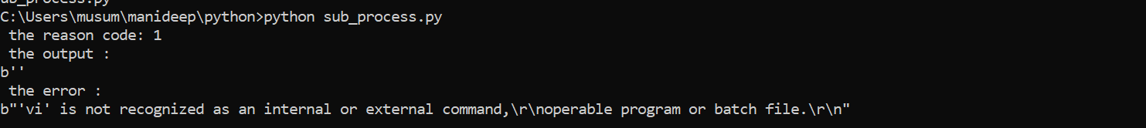

This above is not having any valid command called vi so it is throwing this error. Like code1 and the error also.

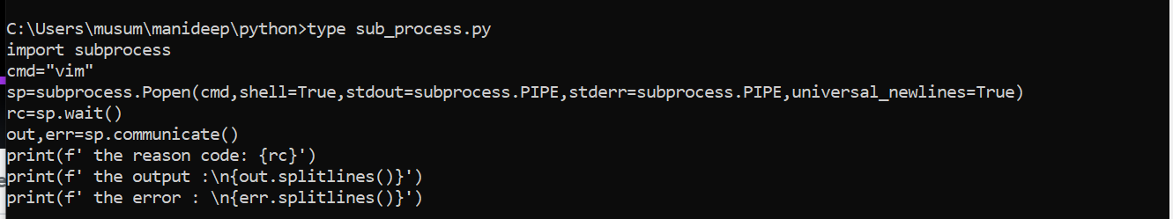

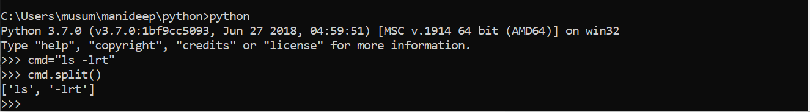

The above is going to split the output.

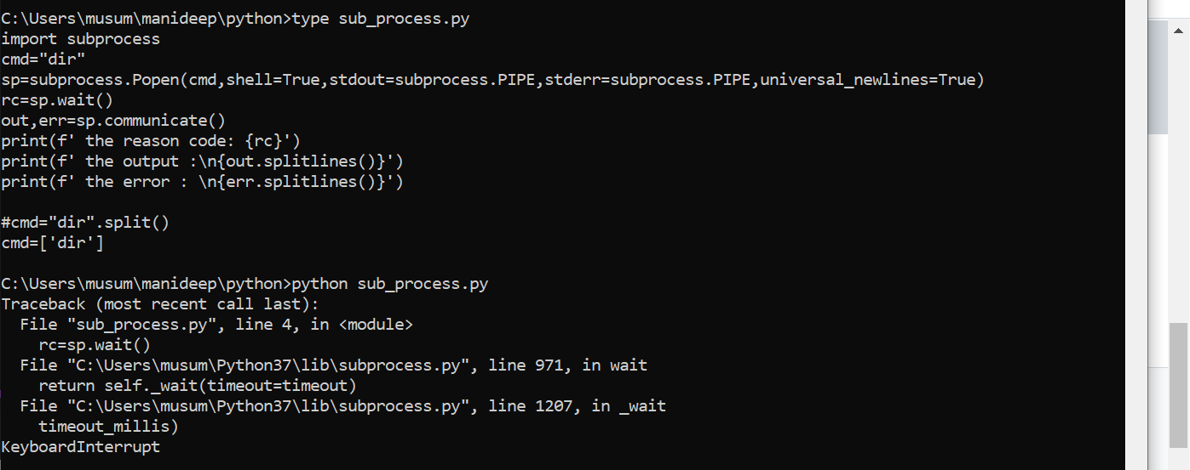

Shell=true for getting the env varible or else we won’t get the correct value.

Shell=true command should be string

Shell=false command should be list

Executing script in windows:

Import subprocess

Sp=subprocess.Popen(‘dir’,shell=True,stdout=subprocess.PIPE,stderr=subprocess.PIPE)

rt=sp.wait()

rt

o,e=sp.communicate()

print(0)

print(type(0))---🡪 this is giving the output as bytes

for listing the files, we need to add these below lines and we need to run them.

Sp=subprocess.Popen(‘dir’,shell=True,stdout=subprocess.PIPE,stderr=subprocess.PIPE,universal_newline=true)

Rt=sp.wait

O,es=sp.communicate()

Print(o.splitlines())

Practice with Subprocess Module:

Find bash version of linux os:

import subprocess

cmd=["bash","--version"]

sp=subprocess.Popen(cmd,shell=False,stdout=subprocess.PIPE,stderr=subprocess.PIPE,universal_newlines=True)

rc=sp.wait()

o,e=sp.communicate()

if rc==0:

for each_line in o.splitlines():

if "version" in each_line and "release" in each_line:

print(each_line.split()[3].split('(')[0])

else:

print("Command was failed and error is: ",e)

platform independent script to find the java version:

if you are taking cmd as a string them shell=true.

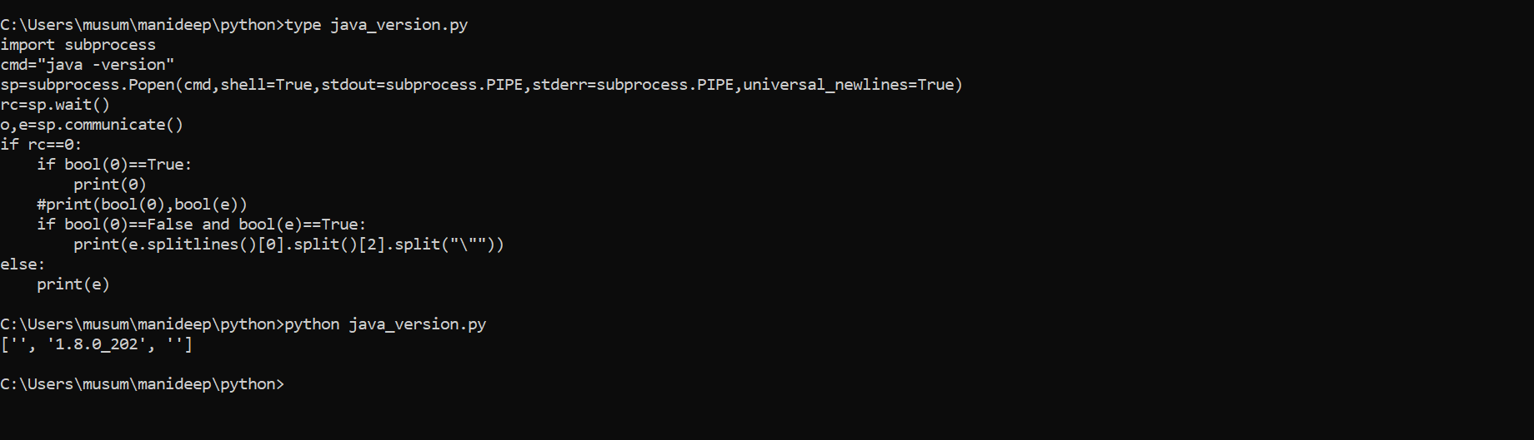

import subprocess

cmd="java -version"

sp=subprocess.Popen(cmd,shell=True,stdout=subprocess.PIPE,stderr=subprocess.PIPE,universal_newlines=True)

rc=sp.wait()

o,e=sp.communicate()

if rc==0:

if bool(o)==True:

print(o)

#print(bool(o),bool(e))

'''

if bool(o)==False and bool(e)==True:

print(e.splitlines()[0].split()[2].strip("\""))

'''

if bool(o)==False:

if bool(e)==True:

print(e.splitlines()[0].split()[2].strip("\""))

else:

print(e)

Working with Text files: reading and writing to text files:

1)create a new file.

2)add context to an existing file.

3)read a file content.

4)open🡪write

-🡪Append

---🡪Read

#creation of empty file

Fo=open(‘newfile.txt’,’w’)

Fo.close()

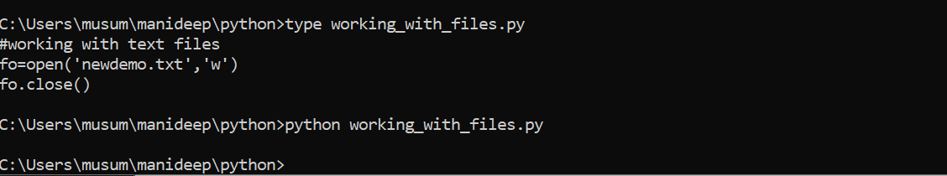



See the above screenshot a new file called new demo was created.

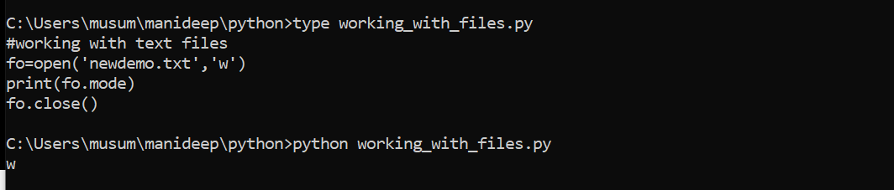

Fo.mode--🡪 this is used to get the details like on which mode this file is opened.

Fo.readable()-🡪 this is used to get the details like if this file is opened as a readable mode or not

Fo.writable()-🡪 this will show if the file is opened for writable or not

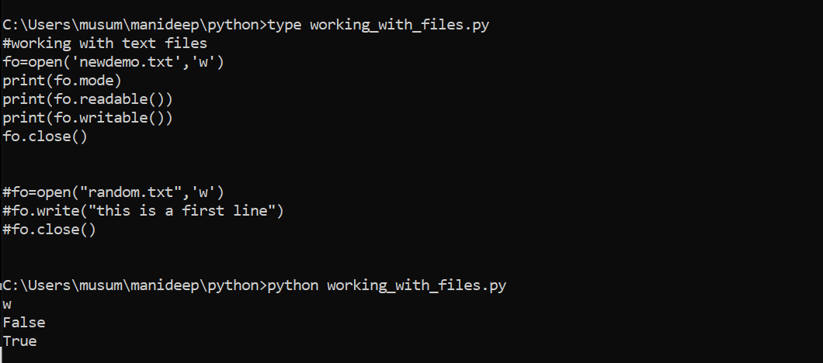

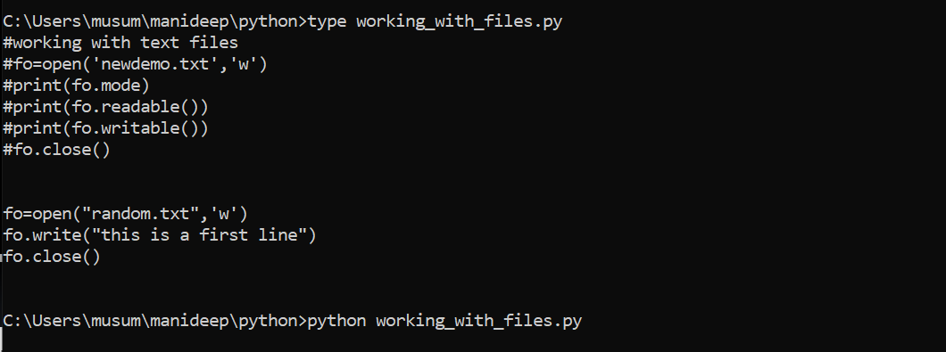

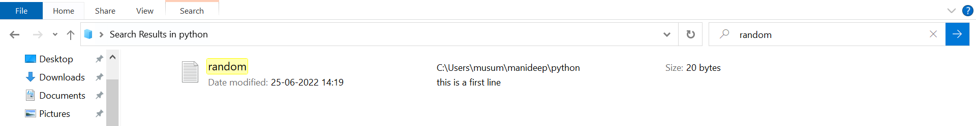

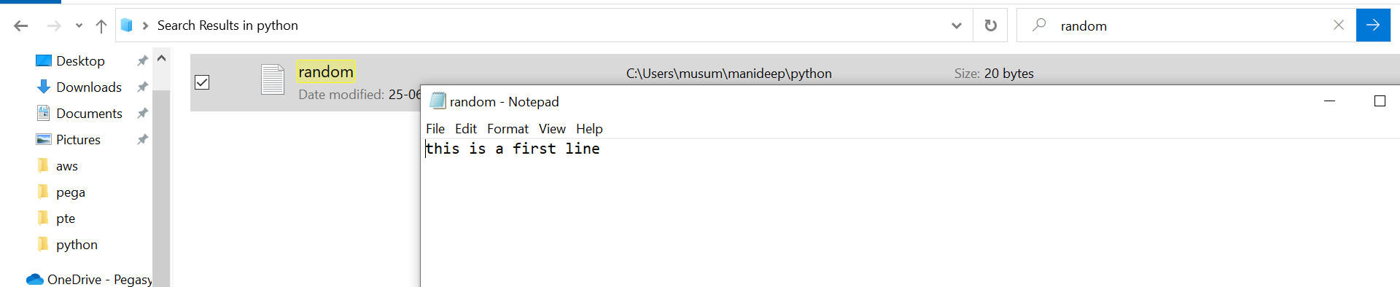

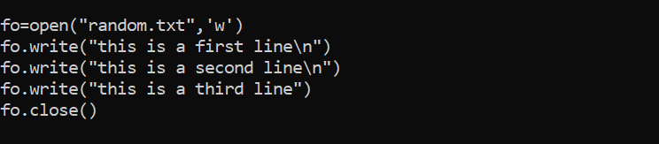

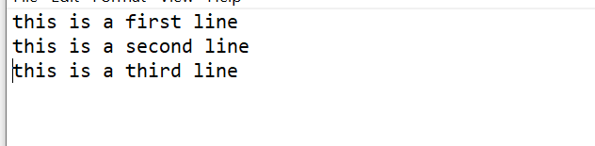

By using the above logic content will get override if the file is not there file will get created and data will upload if the file if the file already exists data will get over ride from the file.

My_content=[“This is a data-1\n”,”This is a date-2\n”,”This is a date-3”]-🡪 this is used to write the data in a single line instead of writing it in multiple lines.

my_content=['This is using loop-iteratioin-1','This is using loop-iterantion-2','This is using loop-iteratioin-3']

fo=open("with_loop.txt",'a')

for each_line in my_content:

fo.write(each_line+"\n")

fo.close()

'''

'''

fo=open("with_loop.txt","r")

data=fo.read()

fo.close()

print(data)

this above code I used to update the data it will not touch the data present in the file it will update the data in the file.

Below scrip tis used to read data from the file.

o=open("with_loop.txt","r")

print(fo.readline())

print(fo.readline())

fo.close()

how to copy file into another file using python:

copy the contents of a file to another file:

if you want to read the data from a file you wan to open it in a read mode

if you want to write the data from a file you want to open it in a write mode

#sfile="C:\\Users\\Automation\\Desktop\\random.txt"

#dfile="C:\\Users\\Automation\\Downloads\\newrandom.txt"

sfile=input("Enter your source file: ")

dfile=input("Enter your destination file: ")

sfo=open(sfile,'r')

content=sfo.read()

sfo.close()

dfo=open(dfile,'w')

dfo.write(content)

dfo.close()

note: if you are opening your file with out defining any mode by default it is read mode.

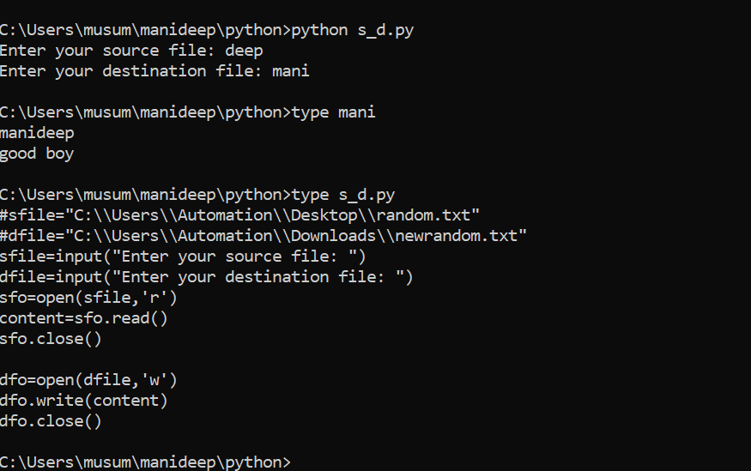

Introduction to csv files and how to read a csv file using python.

Firs of all,what is a csv?

Csv🡪 comma separated values

It is a simple file format used to store tabular data, such as a spreadsheet/excel or database.

Note: if you are working with files, it is always a good practice is to provide the path.

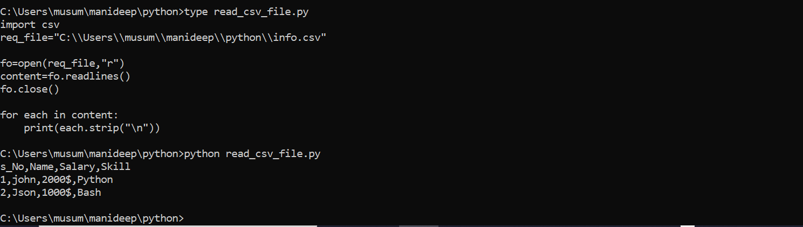

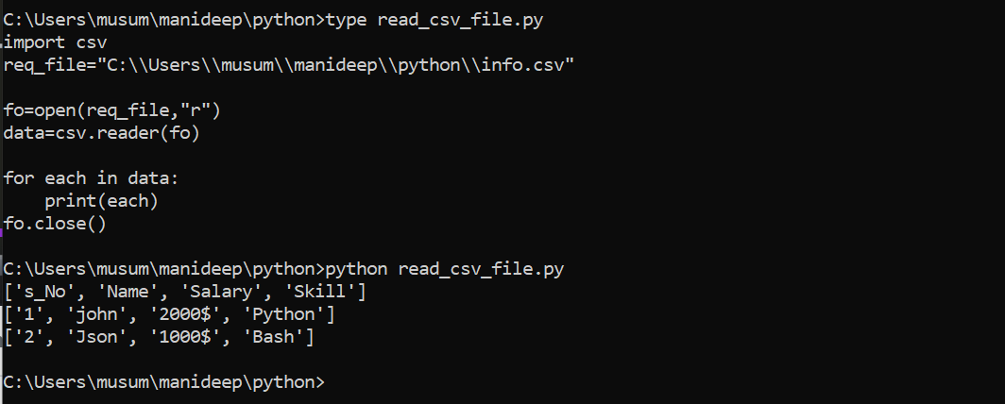

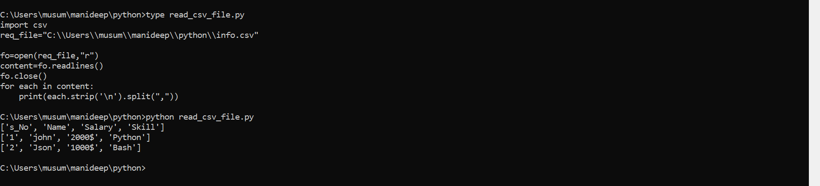

Csv is convenient way to export data to spreadsheets and databases as well as import or use it in other programs.

(How to get header and no of rows in a csv file).

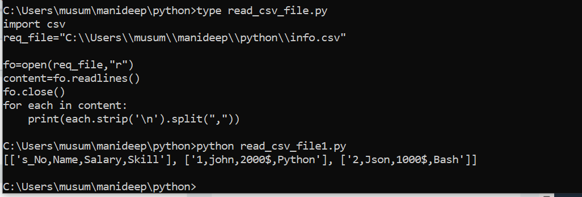

Converting csv data into list.

import csv

req_file="C:\\Users\\Automation\\Desktop\\hi\\new_info.csv"

fo=open(req_file,"r")

content=csv.reader(fo,delimiter="|")

#print(list(content))

#print(f'The header is:\n {list(content)[0]}')

#header=next(content)

#print("The header is: ",header)

print("The no of rows are: ",len(list(content))-1)

'''

for each in content:

print(each)

'''

fo.close()

creating csv file:

import csv

#req_file="C:\\Users\\Automation\\Desktop\\hi\\new_info.csv"

'''

fo=open(req_file,'r')

csv_reader=csv.reader(fo,delimiter="|")

for each_row in csv_reader:

print(each_row)

fo.close()

'''

req_file="C:\\Users\\Automation\\Desktop\\hi\\demo.csv"

fo=open(req_file,'w',newline="")

csv_writer=csv.writer(fo,delimiter=",")

'''

csv_writer.writerow(['S_No',"Name",'Age'])

csv_writer.writerow([1,"John",23])

csv_writer.writerow([2,"Cliton",24])

'''

my_data=[['S_No',"Name",'Age'],[1,"John",23],[2,"Cliton",24]]

csv_writer.writerows(my_data)

fo.close()

Working with files like json

Json:

Json(javascript object notation) is a popular data format used for representing structured data.

Its common to transmit and receive data between a server and web application in json format.

Python json equivalent

Dict object

List,tuple array

Str string

Int,float,int number

True true

False false

None null

If we want to read the data using json and you need to convert it we can do it using this below lines

Print(json.load(fo))

import json

#Read a json file

'''

req_file="myjson.json"

fo=open(req_file,'r')

#print(fo.read())

print(json.load(fo))

fo.close()

'''

#Write data(dictionary data) into a json file

my_dict={'Name':'Narendra','skills':['Python','shell','yaml','AWS']}

req_file="myinfo.json"

fo=open(req_file,'w')

json.dump(my_dict,fo,indent=4)

fo.close()

introduction to exception handling.

A python program terminates as soon as it encounters an error.

Errors are two types:

Syntax errors: no way to handle syntax errors

Runtime errors-🡪excetions,there is a way to handel runtime errors.

How to handel exceptions

Ans:

With try exception block

Try:

Statement1:

Statement2:

Statement3:

Except Exception as e:

Print (“This is because of”,e)

When you are not using try and catch it is terminating at specific point and the code didn’t get executes the next point if try and catch are used it will stop termination with the error and it will execute the other parts of the program.

Exceptions can be handled using try and except statement

Syntax:

Try : run this code

Except: run this code if an exception occurs

Exceptions examples:

Index error

Zero division error

Import error

Value error

Type error

Name error

Filenotfounderror

'''

print("Welcome to exceptions concept")

print("Now it is fine")

fo=open("nari.txt")

'''

'''

try:

fo=open("nari.txt")

print(fo.read())

fo.close()

except Exception as e:

print(e)

'''

my_list=[3,4,5]

'''

try:

print(my_list[4])

except Exception as e:

print(e)

'''

#print(my_list[4])

#print("This code will also execetues")

try:

import fabric

except Exception as e:

print(e)

exception handling for known Exceptions:

try:

print(“this is simple exceptions”)

print(a)

except Exception as e:

print(e)

try:

print(“this is simple exceptions”)

print(a)

except exception as e:

print(e)

finally:

print(“this will execute after trying with try and except blocks”)

program example

#NameError

#TypeError

#FileNotFoundError

#ZeroDivisionError

try:

print("This is try block")

import fabric

print(a)

#print(4+"hi")

#open('asdfas.txt')

#print(5/0)

except FileNotFoundError:

print("File is not present to open it")

except NameError:

print("Variable is not defined")

except TypeError:

print("Adding number and string is not possible")

except ZeroDivisionError:

print("Division with zero is not possible")

except ModuleNotFoundError:

print("Please install fabric to use it")

except Exception as e:

print(e)

finally:

print("Finally this will executes")

Difference between try except finally and try except else:

Try and else --🡪 if there is no exception in try block them else will execute. If there is any exception then else will wont execute.

Try,else,finally--🡪 finally will always execute .

try:

a=9

print(a)

except NameError:

print("Variable is not defined")

except Exception as e:

print("Exception occured:",e)

else:

print("This will execute if there is no exceptions in try block")

finally:

print("This will executes always")

Raise user defined exception:

Creating custom exceptions:

We can create custom exceptions using wontedly if you want to raise an exception we can use this.

Raise (used to raise an existing exceptions)

Assert (used to create an assertion error)-🡪 assert error is used to create your own error wontedly you can create it.

'''

age=23

if age>30:

print("Valid age")

else:

raise ValueError("Age is less than 30")

'''

age=20

try:

assert age>30

print("Valid age")

except AssertionError:

print("Raised with assert because age is lessthan 30")

except:

print("Exception occured")

Functions:

A function is a block of code for some specific operation.

Function code is re-usable

A function executes only when it is called.

Introduction to functions:

Instead of writing this each time we can use the same name given to code.

import os

import time

import platform

def mycode(cmd1,cmd2):

print("Please wait. Cleaning the screen....")

time.sleep(2)

os.system(cmd1)

print("Please wait finding the list of dir and files")

time.sleep(2)

os.system(cmd2)

if platform.system()=="Windows":

mycode("cls","dir")

else:

mycode('clear','ls -lrt')

the above details will give us the example of functions we are reusing the functions like def my code(cmd1, cmd2):

hear in the above program my code is the function.

Example f(x)=3x+2

How to define a function and use defined function:

Rules to define function name:

Function name should have only a-z,A-Z,0-9,--

Function should not start with number but can it be start with-

Don’t include any space

Function must be defined before calling it.

Called function calling function 1st one is called called function 2nd one is called calling function.

Function:

A function is a block of code for some specific operation.

Function code is re-usable

It will execute only when it is called.

Why are function used?

Code reusable

Improve modularity

Types of functions:

Basically, we can divide functions into the following two types:

Built-in functions: functions that are built into python.

User-defined functions:

Functions defined by the users themselves

Def display ():

Print (“welcome to functions concept”)

Print (“simple way to define your function”)

When function is written it won’t execute when function is called then only it executes.

Def display ():

Print (“this is first line”)

Print (“this is two lines”)

Display ()

Display ()

Print (“now we called display function two times”)

Display ()

Def display ():

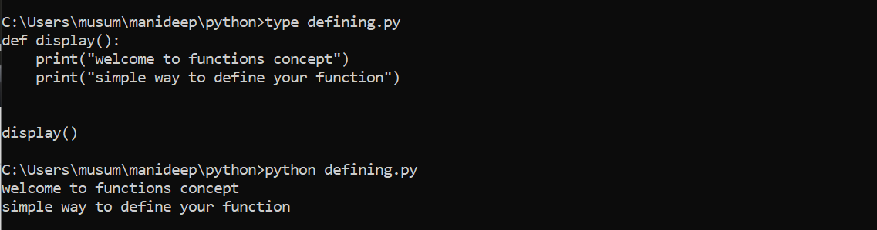

Return none--🡪at the end of it we can define it.

def display():

print("Welcome to functions concept")

print("Simple way to define your function")

return None

display()

print(len("hi"))

x=40

print(id(x))

#Rules to define function name:

#Function name should have only a-z,A-Z,0-9, _

#Function shuold not start with number but can it be start with _

#Dont include any space.

#Function must be define befor calling it

x=(5,6)

print(len(x))

print(min(x))

print(max(x))

x="5"

print(int(x))

converting given code in terms of functions without changing output:

def welcome_msg():

print(“welcome to python scripting”)

print(“python is easy to learn”)

return none

def known_concepts():

print (“now we are good with basics”)

print (“we are about to start functions concepts in python”)

return none

def new_concetps():

print(“function are very easy in python”)

print(“now we are writing simple functions”)

return none

welcome_msg()

known_concepts()

new_concepts()

where there is a def it wont execute the code it will consider as a function

def welcome_msg():

print("Welcome to Python Scripting")

print("Python is easy to learn")

return None

def known_concepts():

print("Now we are good with bascis")

print("We are about to start functions concepts in python")

return None

def learning_concepts():

print("Function are very easy in python")

print("Now we are writing simple functions")

return None

welcome_msg()

known_concepts()

learning_concepts()

scope of variables:

def myfunction1():

x=60 #This is local variable

print("Welcome to functions")

print("x value from fun1: ",x)

#myfunction2()

return None

def myfunction2(y): #Parameter

print("Thank you!!")

print("x value from fun2: ",y)

return None

def main():

#global x

x=10

myfunction1()

myfunction2(x) #Argument

return None

main()

Simple Functions with Arguments:

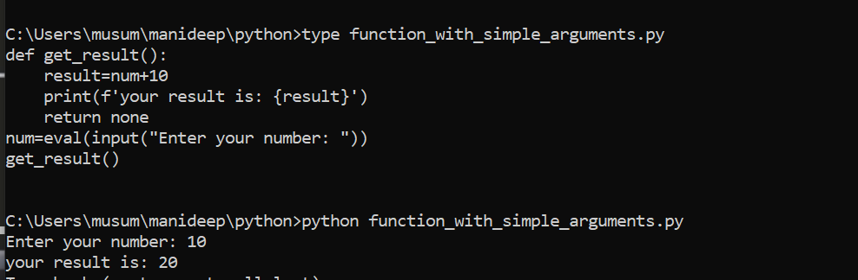

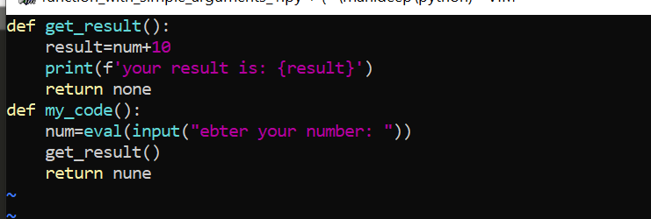

in the above screenshot:

'''

def get_result(value): #parameters/positional arguments

result=value+10

print(f'Your result is: {result}')

return None

def main():

#global num

num=eval(input("Enter your number: "))

get_result(num) #Arguments

return None

main()

'''

def get_add(p,q):

aresult=p+q

print(f'The addition of {p} and {q} is: {aresult}')

return None

def get_sub(m,n):

sresult=m-n

print(f'The sub of {m} and {n} is: {sresult}')

return None

def main():

a=eval(input("Enter your first num: "))

b=eval(input("Enter your second num: "))

get_add(a,b)

get_sub(a,b)

#x=50

#get_sub(19,x)

return None

main()

Functions with arguments and return value:

If you want to send the function to where it was called

'''

def get_addition(a,b):

result=a+b

#print(f"The addition of {a} and {b} is: {result}")

return result

def main():

a=eval(input("Enter your first number: "))

b=eval(input("Enter your second number :"))

result=get_addition(a,b)

print(f"The addition of {a} and {b} is: {result}")

return None

main()

'''

def multiply_num_10(value):

#result=value*10

#return result

return value*10

def main():

num=eval(input("Enter your number: "))

result=multiply_num_10(num)

print("The result is: ",result)

main()

functions with default arguments:

'''

def display(a=1):

print("The value of a is: ",a)

return None

display(4)

display(5)

display()

'''

'''

def add_numbers(a,b=0):

result=a+b

print("The result is: ",result)

return None

add_numbers(4,5)

add_numbers(5)

add_numbers(7)

'''

def working_on_some(user="root"):

print(f"working with {user}")

return None

working_on_some("weblogic_admin")

in the above example we are passing the default values like if a=10 then the value of b is defined below like display (4). other value will be fetched from a value default which was defined above.

Function with keyword-based arguments:

How to pass variables to your called function based on your variables: this below script is the example for the same

def display(a,b):

print(f'a={a}')

return None

display (3,4)

display (a=3, b=4)

display (b=4, a=3)

Function with variable length argument:

def display(*arg):

for each in arg:

print(type(each))

return None

#display()

#display(4)

display(4,5,67)

print('-------------')

display("hi",4.65)

functions with variable length keyword-based arguments.

def display(p,**karg):

print(p)

print(karg)

return None

#display(4,5)

#display(b=5,a=4)

#display(a=4,b=5,c=6)

display(56,x=5,y="Hi",z=6.7,user="root")

How to use functions of one python script into another python script?

What is_name_variable?

And

How to create user defined modules?

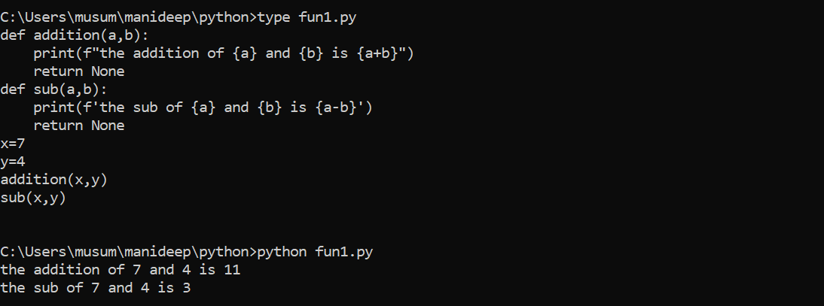

We are importing other values in the script to this below new script instead of writing this sub and addition we can directly import this script and we can execute it from there.

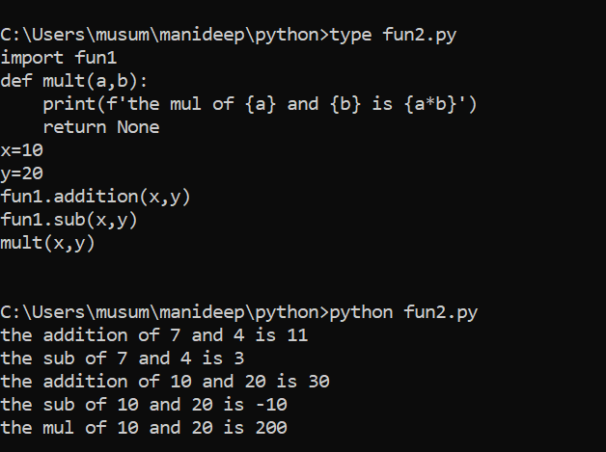

We have imported the values from the above script to this new script we have imported addition and subtraction to this script.

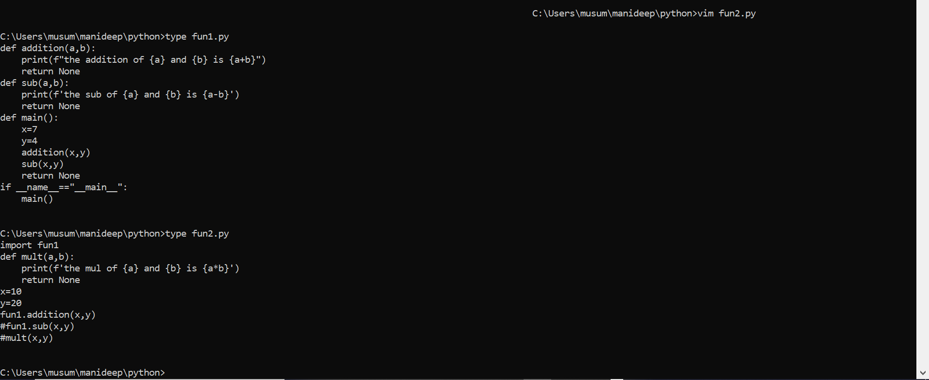

The above syntax is used to program the values and called only the values which are defined in script 2 not in script 1

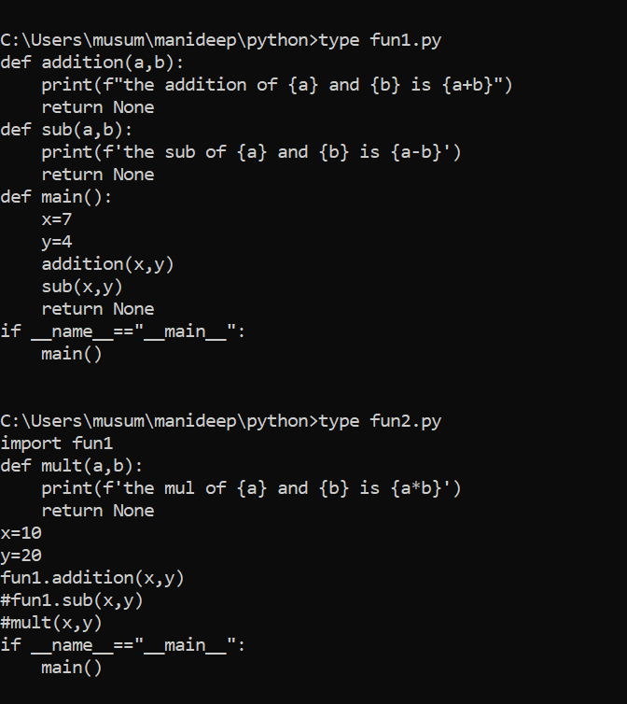

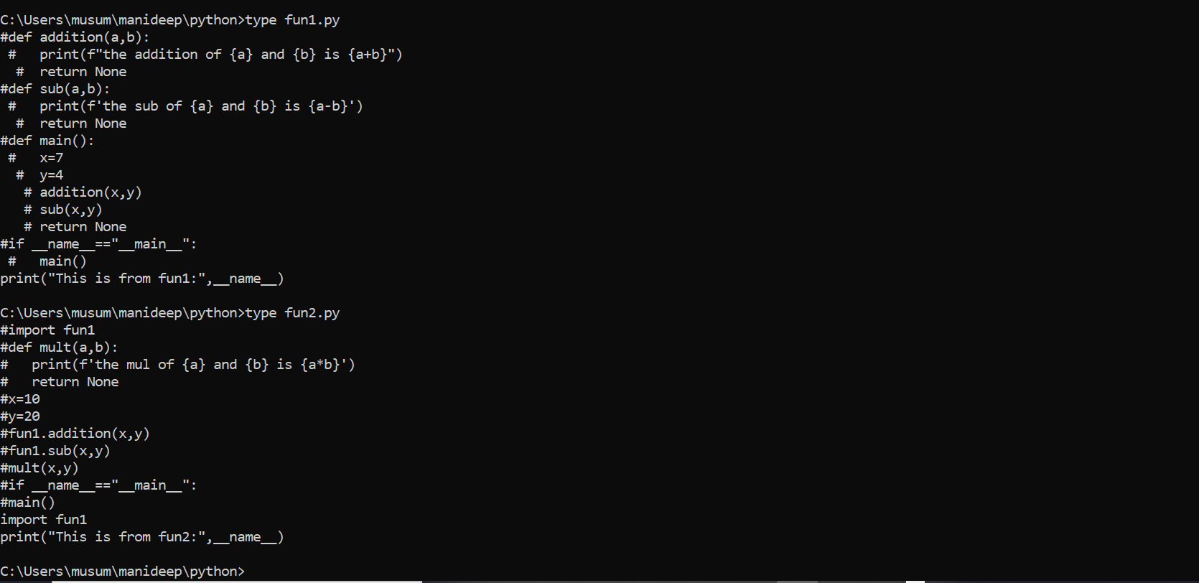

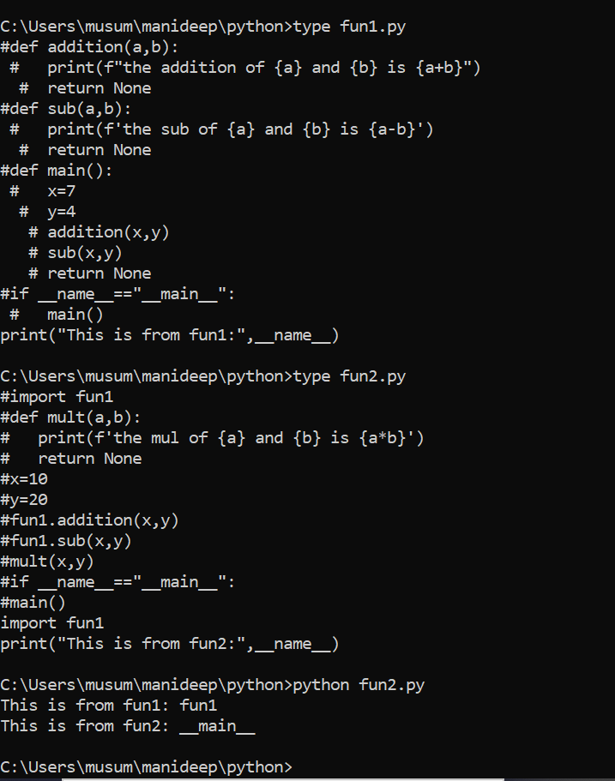

2nd script is running 1st script

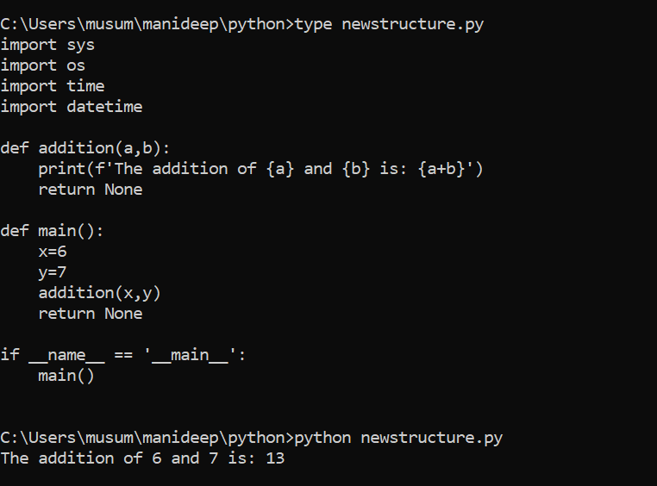

The above-defined structure is a perfect structure.

How to change the current working directory with python:

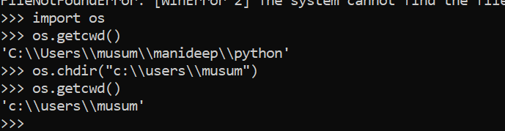

When you are giving a name inside the directory like c:\\users\\musum\\hi.txt we will get the error like directory not find because hi.txt is not a directory it is a file

NotADirectoryError: [error 20] not a directory: ‘c:\\users\\musum\\hi.txt’

FileNotFounderror:

PermisionError:

#!/usr/local/bin/python3

import os

'''

req_path=input("Enter path to change working dir: ")

print("The current working dir is: ",os.getcwd())

try:

os.chdir(req_path)

print("Now your new working dir is: ",os.getcwd())

except FileNotFoundError:

print("Given path is not a valid path. So cant change working directory")

except NotADirectoryError:

print("Given path is a file path. So cant change working directory")

except PermissionError:

print("Sorry you dont have access for the given path. So cant chagne working directory")

except Exception as e:

print(e)

'''

def main():

req_path=input("Enter path to change working dir: ")

print("The current working dir is: ",os.getcwd())

try:

os.chdir(req_path)

print("Now your new working dir is: ",os.getcwd())

except FileNotFoundError:

print("Given path is not a valid path. So cant change working directory")

except NotADirectoryError:

print("Given path is a file path. So cant change working directory")

except PermissionError:

print("Sorry you dont have access for the given path. So cant chagne working directory")

except Exception as e:

print(e)

return None

if __name__=="__main__":

main()

Python Regular Expression:

What is a regular expression(regex):

the regex is a procedure in any language to look for a specified pattern in given text

what is a patter n:it is a sequence of charactrs ,which represents multiple strings

ex: ‘i[st]’ 🡪is,it

‘python[23]’-🡪 python2,python3

Python module for regular expressions:re

The different operations in python re are:

Match()

Search()

Findall()

Finditer()

Sub()

Split()

Compile() etc

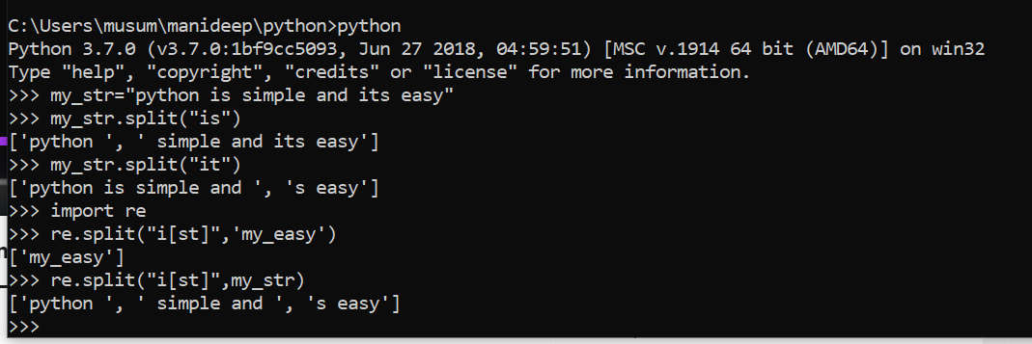

Regular expression (regex):

The regex is a procedure in any language to look for a specified pattern in a given text

Re Is the module to perform regex in python.(use import re in scripts)

There are different operations in re like:

Search match finditer findall split sub etc

Syntax:

Re.search(pattern,text)

Re.match(pattern,text)

Re.match(pattern,text)

Re.findall(pattern,text)

Pattern is a sequence of characters,which represents multiple strings.

Simple examples for pattern:

“Python”-🡪this is a string and we can use it as regulerexpression

If we are using this string inside regular expression, it is a pattern.

“Python[23]”🡪”python2” “python3”-🡪 this is a regular expression.

---pattern

R”python” or r”python[23]”

Learning pattern creation with findall operation:

How to use findall?

Import re

Print(re.findall(pattern,text))

How to use findall?

Import re

Print(re.findall(pattern,text))

Rules to create a pattern:

A,x,9-ordinary characters that matches themselves

[abc]-matches a or b or c

[a-c]-matches a or b or c

[a-zA-Z0-9]-matches any latter from (atoz) or (atoz)or(0-9)

\w-matches any single letter,digit or underscore

\W-matches an character not part of \w

\d-matches decimal digit 0-9

-matches any single character except newline character

.(.)-🡪 it will give each and every text including space

\.--> to get all the details.

import re

text="This . is a python and it is easy to learn and it is popular one for dev and automation"

'''

my_pat= 'i[ston]' #is,it,io,in

#print(len(re.findall(my_pat,text)))

print(re.findall(my_pat,text))

'''

#my_pat="x[abcdeflmnopq]y" ==> xay,xby.....xqy

# ="x[a-fl-q]y"

'''

my_pat='\.'

print(re.findall(my_pat,text))

'''

'''

text="This is a ip address of my db1 server: 255.255.255.255 2456234512341234"

my_pat="\d\d\d\.\d\d\d\.\d\d\d\.\d\d\d"

print(re.findall(my_pat,text))

'''

'''

text="This is python @ 345 _ - ("

print(re.findall('\w',text))

#print(re.findall('.',text))

print(re.findall("\W",text))

'''

text="456 90 this is about deciaml re98gex"

print(re.findall('\d\d',text))

rules to create pattern2:

^-start of the string(and start of the line i-case of multiline string)

$-end of the string(and newline character in-case of multiline string)

\b-empty string at the beginning or end of a word

\B-empty string at the beginning or end of a word

\t,\n,\r-matches tab,newline,return respectively

import re

text='isa python l earn and \n itis easy to'

#my_pat='^i[ts]'

#my_pat="learn$"

#my_pat=r"\blearn\b"

#my_pat=r"\Blearn\B"

my_pat=r"\n"

print(re.findall(my_pat,text))

Rules to create pattern part 3:

{2} exactly 2 times

{2,4} 2,3 or 4 times

{2,} 2 or more times.

+ one or more times

*0or more times

? once or none(lazy)

import re

'''

text="This is a pythonnnn and python aaa haaaafd xyzaaaaaaaa"

#my_pat=r'\bpython{4}\b'

my_pat=r'\bxyza{8}\b'

print(re.findall(my_pat,text))

'''

text="xaz asdfa sdf xaaz xaaaaaaaz xaaaaz xz"

#my_pat=r'\bxa{2,}z\b'

#my_pat=r'xa{1,}z'

#my_pat=r'xa*z'

my_pat=r'xa?z'

print(re.findall(my_pat,text))

Regex with flags.

| **Flag** | **long syntax** | **Meaning** |
| --- | --- | --- |
| re.A | re.ASCII | Perform ASCII-only matching instead of full Unicode matching |
| re.I | re.IGNORECASE | Perform case-insensitive matching |
| re.M | re.MULTILINE | This flag is used with metacharacter ^ (caret) and $ (dollar). When this flag is specified, the metacharacter ^ matches the pattern at beginning of the string and each newline’s beginning (\n). And the metacharacter $ matches pattern at the end of the string and the end of each new line (\n) |
| re.S | re.DOTALL | Make the DOT (.) special character match any character at all, including a newline. Without this flag, DOT(.) will match anything except a newline |
| re.X | re.VERBOSE | Allow comment in the regex. This flag is useful to make regex more readable by allowing comments in the regex. |
| re.L | re.LOCALE | Perform case-insensitive matching dependent on the current locale. Use only with bytes patterns |

import re

'''

text="this is a string ThIs is a new staring THIS"

my_pat=r'this'

print(re.findall(my_pat,text,re.I))

'''

text="""this is a string EnD

this is second line enD

This is third line end

asfasd this end"""

#print(text)

#my_pat=r'^this'

my_pat=r'end$'

print(re.findall(my_pat,text,re.M|re.I))

Working with Search and match operations from re module:

It look through the entire string and returns the first match.

Re.search(pattern,string,flags)

Re.match(pattern,string,flags)

import re

text="""This is for

python2 and there are two major

vers python3 and python in future python4"""

pat=r'\bpython[23]?\b'

'''

#print(re.findall(pat,text))

match_ob=re.search(pat,text)

#rint(match_ob)

if match_ob:

print("match from ur pattern: ",match_ob.group())

print('Starting index: ',match_ob.start())

print('Ending index: ',match_ob.end()-1)

print("Length: ",match_ob.end()-match_ob.start())

else:

print("No match found")

'''

text="""PYTHON2 and there are two major

vers python3 and python in future python4"""

pat=r'\bpython[23]?\b'

match_ob=re.match(pat,text,re.I)

if match_ob:

print("match from ur pattern: ",match_ob.group())

print('Starting index: ',match_ob.start())

print('Ending index: ',match_ob.end()-1)

print("Length: ",match_ob.end()-match_ob.start())

else:

print("No match found")

findall and finditer operations of re module:

import re

my_str="This is python and we are having python2 and python3 version"

my_pat=r'\bpython[23]?\b'

#print(re.search(my_pat,my_str))

#print(len(re.findall(my_pat,my_str)))

#print(re.findall(my_pat,my_str))

for each_ob in re.finditer(my_pat,my_str):

print(f'The match is: {each_ob.group()} starting index: {each_ob.start()}, ending index {each_ob.end()-1}')

split and sub,subn operations of re module:

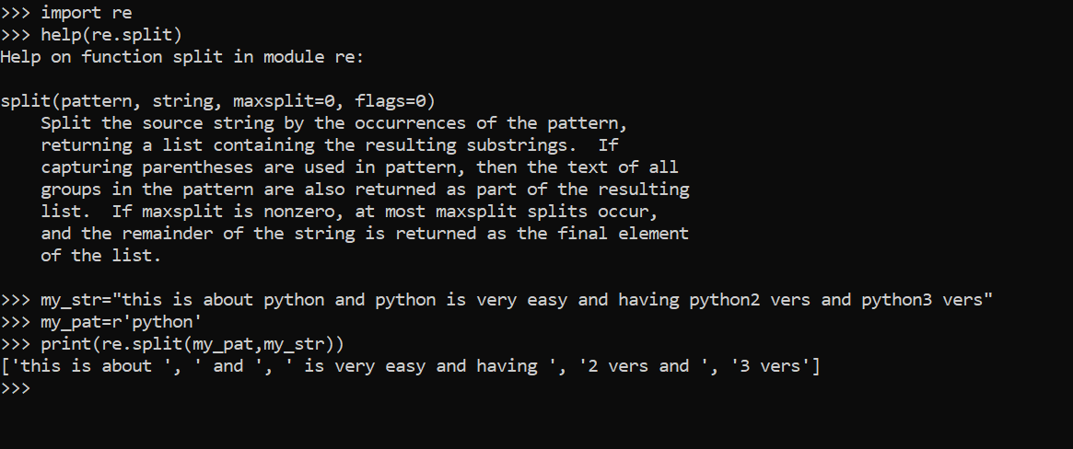

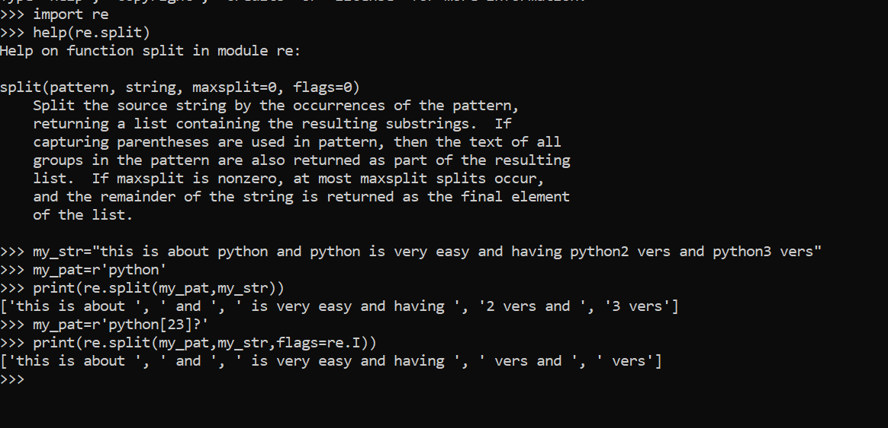

where we want split there we need to write pattern

print(re.split(my_pat,my_str,maxsplit=2,flags=re.I))

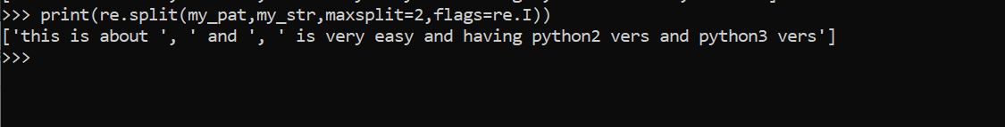

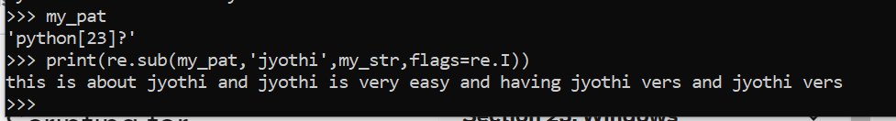

We are replacing python 23 with Jyothi.



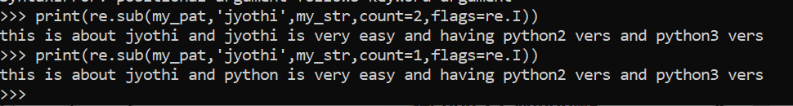





Subn with count is used to substitute the values based on numbers in how many times we can replace the values.

Compile operations of re module:

import re

my_str="This is about python. Python is easy to learn and we have two major versions: python2 and python3 "

my_pat=r'\bPython[23]?\b'

#print(re.search(my_pat,my_str))

#print(re.findall(my_pat,my_str,flags=re.I))

#print(re.split(my_pat,my_str))

pat_ob=re.compile(my_pat,flags=re.I)

print(pat_ob)

print(pat_ob.search(my_str))

print(pat_ob.findall(my_str))

#re.findall(my_pat,my_str)===> re.complie(my_pat).findall(my_str)

Working with remote linux server from linux/windows using paramiko of python:

Ssh or sshv2 protocol to run this module:

Paramaiko module will create a ssh client and by using this it will connect to remote server and executes commands.

We can also transfer files from the remote machine to the local or vice versa using paramiko.

Two ways to connect with remote server:

Using username and password

Using username and cryptographic key

We can connect to linux/windows <-> linux/windows.

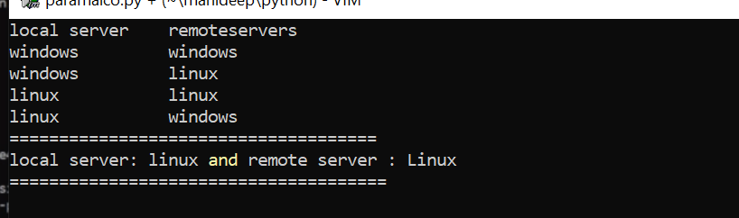

Pip install paramaico.

Pip.exe install paramaico.

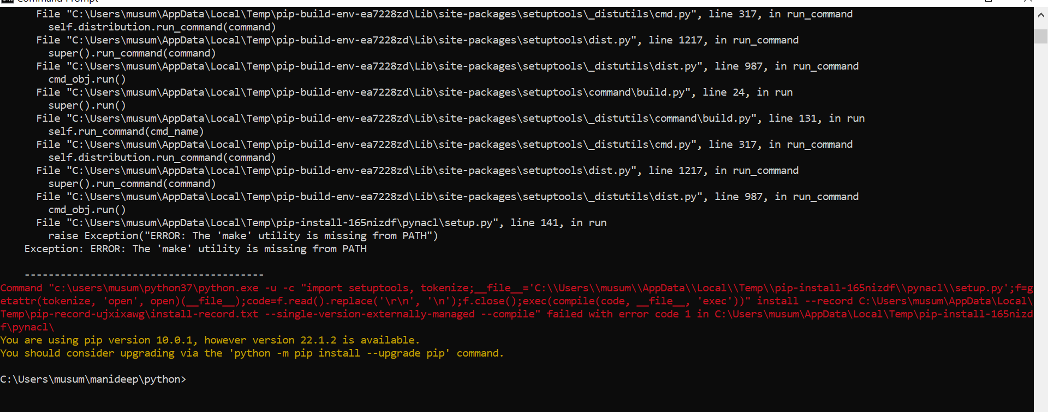



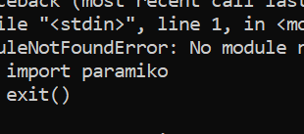

For creating private and public key

Cd .ssh/

Ssh-keygen

Id_rsa id_rsa.pub

Ssh-copy-id [ec2-user@3.92.79.119(key](mailto:ec2-user@3.92.79.119(key) will be shared with the remote host)

#!/bin/python

import paramiko

ssh = paramiko.SSHClient()

ssh.set_missing_host_key_policy(paramiko.AutoAddPolicy())

#ssh.connect(hostname='3.92.79.119',username='ec2-user',password='paramiko123',port=22)

ssh.connect(hostname='3.92.79.119',username='ec2-user',key_filename='/home/Automation/.ssh/id_rsa',port=22)

#stdin, stdout, stderr = ssh.exec_command('whoami')

#stdin, stdout, stderr = ssh.exec_command('uptime')

stdin, stdout, stderr = ssh.exec_command('free -m')

print("The output is: ")

print(stdout.readlines())

print("THe error is: ")

print(stderr.readlines())

Transfer a file from local server to remote server and vice versa using Paramiko of python:

Import paramiko

import paramiko

ssh = paramiko.SSHClient()

ssh.set_missing_host_key_policy(paramiko.AutoAddPolicy())

ssh.connect(hostname='54.165.97.91',username='ec2-user',password='paramiko123',port=22)

sftp_client=ssh.open_sftp()

#sftp_client.get('/home/ec2-user/paramiko_download.txt','paramiko_downloaded_file.txt')

#sftp_client.chdir("/home/ec2-user")

#print(sftp_client.getcwd())

#sftp_client.get('demo.txt','C:\\Users\\Automation\\Desktop\\download_file.txt')

sftp_client.put("transfer_files.py",'/home/ec2-user/transfer_files.py')

sftp_client.close()

ssh.close()

Python Shutil Module:

Python shutil module provides us a number of high values work with files and directories.

Shutil module part-1:

Copy file(s) with shutil module :

Python shutil module provides us a number of high level operations on files and folders/directories like copy, move,remove and much more.

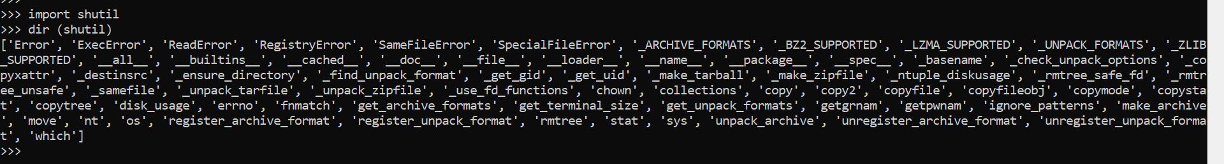

Shutil.copyfile(src,dest)-🡪 this will copy the data from source to destination but not permissions

Shutil.copy(src,dest)-🡪 this will copy data including permissions

Shutil.copy2(src,dest)-🡪same permissions and time stamp also.

Shutil.copymore(src,dest)-🡪it is only giving permission from src to dest

Shutil.copystat(src,dest)-🡪it is giving permissions and time stamp for source to destination

f1=open(‘xyz.txt,’r’)

f2=open(‘pqr.txt’,’w’)

shutil.copyfileobj(f1,f2) copy data from one file to another file

shutil.copytree(src,’/tmp/tomcat7.8’)🡪copy data by using the same hair arty.and metadata

remove directory structure recursively

shutil.rmtree(‘/tmp/tomcat’)

#!/usr/local/bin/python3

import shutil

#copy', 'copy2', 'copyfile', 'copyfileobj', 'copymode', 'copystat', 'copytree'

#copyfile-->copy --> copy2

#src="/home/Automation/working_with_remote_server.py"

src="/home/Automation/shutil_part_1.py"

dest="/home/Automation/working_with_remote_server.py_bkp"

#shutil.copyfile(src,dest)

#shutil.copy(src,dest) #same permissions for src and dest

#shutil.copy2(src,dest) #same meta data for dest as well

#shutil.copymode(src,dest)

#shutil.copystat(src,dest)

#f1=open('xyz.txt','r')

#f2=open('pqr.txt','w')

#shutil.copyfileobj(f1,f2)

#src="/home/Automation/tomcat7"

#shutil.copytree(src,'/tmp/tomcat')

shutil.rmtree('/tmp/tomcat')

Introduction to oops:

It is about:class,object,inheritance,polymorphish,data abstraction and data encapsulation.

What is an object:

Object could be any thing exists in real-time,like human,fan,car,email,anyapplication,Jenkins,weblogic,tomcat,apache etc..

Each object has characteristics and functions

Person/human:

Characteristics:name,age

Functions:walking,talking and running,

Why oops:

To group relational functions(methods)

To create a template/blueprint

Writing code in terms of block is called as object.

Template is a calss from that template you can create any number of objects

Oops is a concept where characteristic and functions of a real-life object is packaged as a single entity in a code.

Template(start with capital)--🡪 defining a class,preparing template

Grouping some related functions under one name , we call as template

#!/bin/bash/python

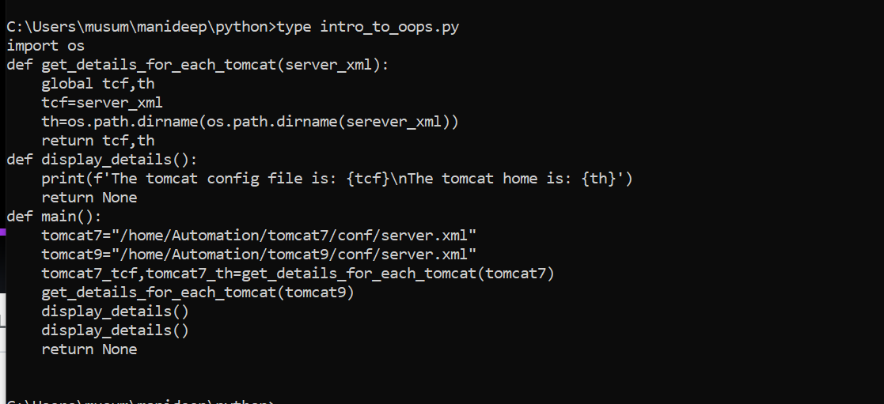

T7 object🡪 tcf variable th variable

T9 objec🡪tcf variable th variable.

import os

class Tomcat:

def get_details_for_each_tomcat(self,server_xml):

self.tcf=server_xml

self.th=os.path.dirname(os.path.dirname(server_xml))

return None

def display_details(self):

print(f'The tomcat config file is: {self.tcf}\nThe tomcat home is: {self.th}')

return None

def main():

tomcat7=Tomcat()

tomcat9=Tomcat()

tomcat7.get_details_for_each_tomcat("/home/Automation/tomcat7/conf/server.xml")

#get_details_for_each_tomcat('tomcat7',"/home/Automation/tomcat7/conf/server.xml")

tomcat9.get_details_for_each_tomcat("/home/Automation/tomcat9/conf/server.xml")

#get_details_for_each_tomcat('tomcat9',"/home/Automation/tomcat9/conf/server.xml")

#print(tomcat9.tcf)

#print(tomcat7.th)

#print(tomcat9.th)

#print(tomcat7.tcf)

tomcat9.display_details()

tomcat7.display_details()

#display_details('tomcat7')

tomcat9.display_details()

return None

if __name__=="__main__":

main()

Concept: class and object Attributes:

Class:

Class is a template/blueprint to create an object

Class is the combination of attributes and methods

We can define attributes for class and objects

Class emp()==-🡪 this is a class

def gat_name_age_salary-🡪 method

def display_details(self)--🡪 method

note:if you want to display a method inside of a class you need to write self.

If you want to call method outside of a class then you need to define Objectname.methodname

Program example:

class emp:

count=0

def get_name_age_salary(self,name,age,salary):

self.name=name

self.age=age

self.salary=salary

self.increase_count_for_emp()

#self.display_details()

return None

def increase_count_for_emp(self):

emp.count=emp.count+1

return None

def display_details(self):

print(f'The name is: {self.name}\nThe age is: {self.age}\nThe salary is: {self.salary}')

return None

emp1=emp()

emp2=emp()

emp1.get_name_age_salary('John',34,45000)

#emp1.increase_count_for_emp()

emp2.get_name_age_salary('Cliton',25,54000)

#emp2.increase_count_for_emp()

print(emp.count)

Constructor of a class:

A constructor is a special method that is called by default whenever you create an object from a class.

Class Emp:

Count=0--🡪 variable

def __init__(self):-🡪 method

Emp.count=Emp.count+1--🡪 class variable

Print(“This is a init method”)

return None

def display(self):-🡪method

Print(“this is a display method”)

Return None

emp1=emp()

emp2=emp()

#-------above two are objects.

Emp1.display()

Emp2.display()

o/p

This is a init method

This is a init method

Class Emp(object)

Def name_salary(self,name,salary):

Self.name=name

Self.salary=salary

Return None

def display(self):

print(f”The name is: {self.name}\nthe salary is: {self.salary}”)

return None

emp1=Emp()

emp2=Emp()

emp1.name_salary(‘ramu’,560000)

emp.name_salary(“Narendra”,90000)

emp2.display()

========================================================================================

Program for initialization:

Class Emp:

Count=0

def __init__(self):

Emp.count=Emp.count+1

Return None

def display(self):

print(“this is a display method”)

return None

emp1=Emp()

emp2=Emp()

print(‘the number of objects created from emp class are: ‘,Emp.count’)

=========================================================================================

example2:

class Emp(object):

def __init__(self,name,salary):

self.name=name

self.salary=salary

return None

def display(self):

print(f"The name is: {self.name}\nThe salary is: {self.salary}")

return None

emp1=Emp('Ramu',56000)

emp2=Emp("Naren",90000)

emp1.display()

emp2.display()

def __init__(self,name,salary):🡪if you are using init method we can use this so you can initialize the values at the end we can call this values.

Python Script to find all tomcats home and config file locations:

With oops :

#!/bin/python3

import os

class Tomcat(object):

def get_home_conf_file(self,server_xml):

self.t_home=os.path.dirname(os.path.dirname(server_xml))

self.conf_file=server_xml

return None

def display_details(self):

print("Tomcat home is: ",self.t_home)

print("Tomcat conf file is: ",self.conf_file)

return None

def get_all_tomcats():

list_of_config_files=[]

for r,d,f in os.walk("/"):

for each_file in f:

if each_file=='server.xml':

list_of_config_files.append(os.path.join(r,each_file))

return list_of_config_files

def main():

print("Finding list of tomcats...")

list_of_tomcats=get_all_tomcats()

tomcat_objects=[]

for each_file in list_of_tomcats:

tomcat_object=Tomcat()

tomcat_object.get_home_conf_file(each_file)

tomcat_objects.append(tomcat_object)

for each_ob in tomcat_objects:

each_ob.display_details()

return None

if __name__ == '__main__':

main()

with out oops :

#!/bin/python3

import os

def get_all_tomcats():

list_of_config_files=[]

for r,d,f in os.walk("/"):

for each_file in f:

if each_file=='server.xml':

list_of_config_files.append(os.path.join(r,each_file))

return list_of_config_files

def display_details(home_cnf_files):

for each_key in home_cnf_files.keys():

print(f'The Tomcat home is: {home_cnf_files[each_key][0]}')

print(f'The Tomcat config file is:{home_cnf_files[each_key][1]}' )

return None

def main():

print("Finding list of tomcats...")

list_of_tomcats=get_all_tomcats()

#print(list_of_tomcats)

cnt=1

home_cnf_files={}

for each_config_file in list_of_tomcats:

t_home=os.path.dirname(os.path.dirname(each_config_file))

t_cnf_file=each_config_file

home_cnf_files['tomcat'+str(cnt)]=[t_home,t_cnf_file]

cnt+=1

#print(home_cnf_files)

display_details(home_cnf_files)

return None

if __name__ == '__main__':

main()

Distractor of a class:

Constructor: a constructor is a special method that is called by default whenever you create an object from a class.

Destructor:

Destructors are called when an object gets destroyed.

In python, destructors are not needed as much needed in c++ because python has a garbage collector that handles memory management automatically.

Def __del__(self):

========================================================================================

Class person(object):

def __init__(self):--🡪 constructor of a class

print(“an object has been created”)

return None

class Person(object):

def __init__(self,name,age):

print("an object has been created")

self.name=name

self.age=age

return None

def __del__(self):

print("object has been deleted")

return None

per1=Person('Jhon',26)

Concept: inheritance and polymorphism of oops:

Polymorphism:

Polymorphism allow us to define same methods in different classes.

This process is also known as method overriding.

def __init__(self,home,ver):

def __init__(self,home,ver)

we are calling the above method two times in the same program given below.

class Tomcat(object):

def __init__(self,home,ver):

self.home=home

self.version=ver

return None

def display(self):

print("This is from tocmat class")

print(self.home)

print(self.version)

return None

class Apache(object):

def __init__(self,home,ver):

self.home=home

self.version=ver

return None

def display(self):

print("This is from apache class")

print(self.home)

print(self.version)

return None

tom_ob=Tomcat('/home/tomcat9','7.6')

apa_ob=Apache("/etc/httpd",'2.4')

tom_ob.display()

apa_ob.display()

Inheritance:

Inheritance is a mechanism that allows us to create a new class known as child class-that is based upon an existing class the parent class.

Advantages with inheritance:

This saves you from duplicating a lot of code.

We can use previous class methods into the current methods also.

class Tomcat(object):

def __init__(self,home,ver):

self.home=home

self.version=ver

return None

def display(self):

print(self.home)

print(self.version)

return None

class Apache(Tomcat):

def __init__(self,home,ver):

self.home=home

self.version=ver

return None

tom_ob=Tomcat('/home/tomcat9','7.6')

apa_ob=Apache("/etc/httpd",'2.4')

tom_ob.display()

apa_ob.display()

class Apache (Tomcat):--🡪 we are giving the class name of Apache in to below so we are using the same values in object to below also.

Class Apache (Tomcat)--🡪 tomcat super class Apache subclass.

Encapsulation:

Using oop in python, we can restrict access to methods and variables.

This prevent data from direct modification which is called encapsulation.

If you are defining a method with two __ then we cannot access this method outside of a class

__age.age

Self.__age

We can call this method inside the class itself def__display(self)

class Person(object):

def assing_name_and_age(self,name,age):

self.name=name

self.__age=age

self.__display()----🡪we are calling this method hear itself.

return None

def __display(self):

print(self.name,self.__age)

return None

per1=Person()

per1.assing_name_and_age('John',32)

#per1.__display()

#print(per1.name)

#print(per1.__age)

Windows subsystem for linux:

Windows subsystem for linux (wsl) is an optional feature on windows 10.

We can run ubuntu fedora and openSUSE on windows using wsl feature, and more Linux distributions coming soon,

This feature doesn’t work on the 32-bit version of windows 10,so ensuring you’re using the 64-bit version windows.

Advantage:we can access windows files in bash,and bash files in windows.

Open:start🡪turn windows feature on and off=🡺click windows subsystem for linux

Once done open Microsoft store and install ubuntu.

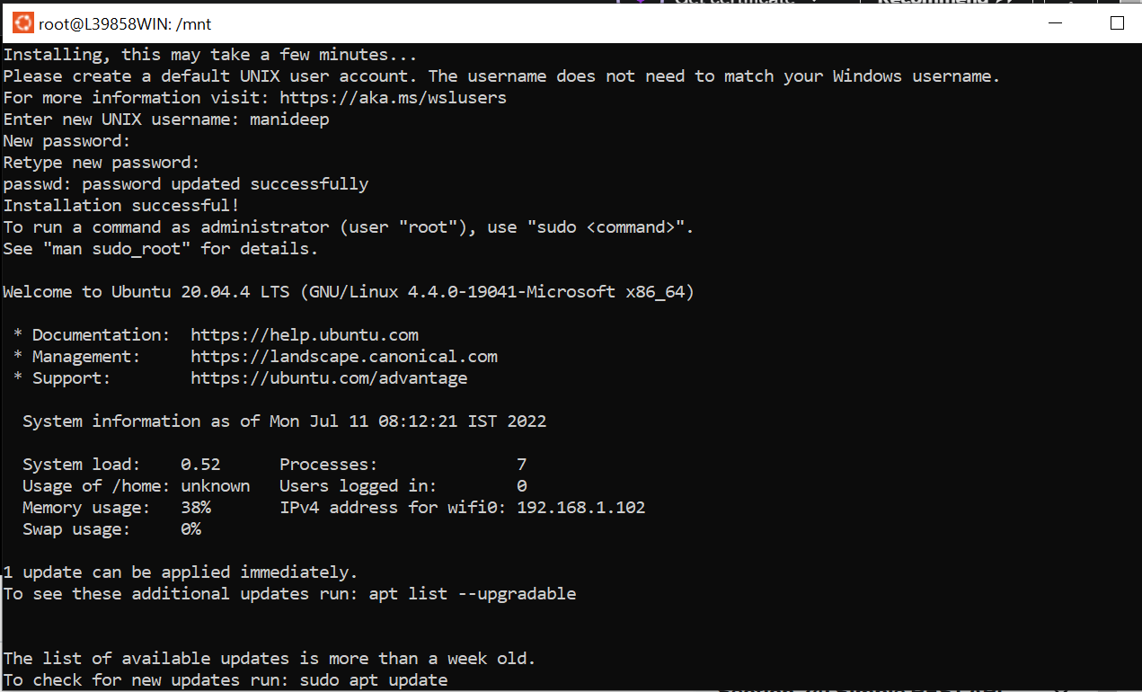

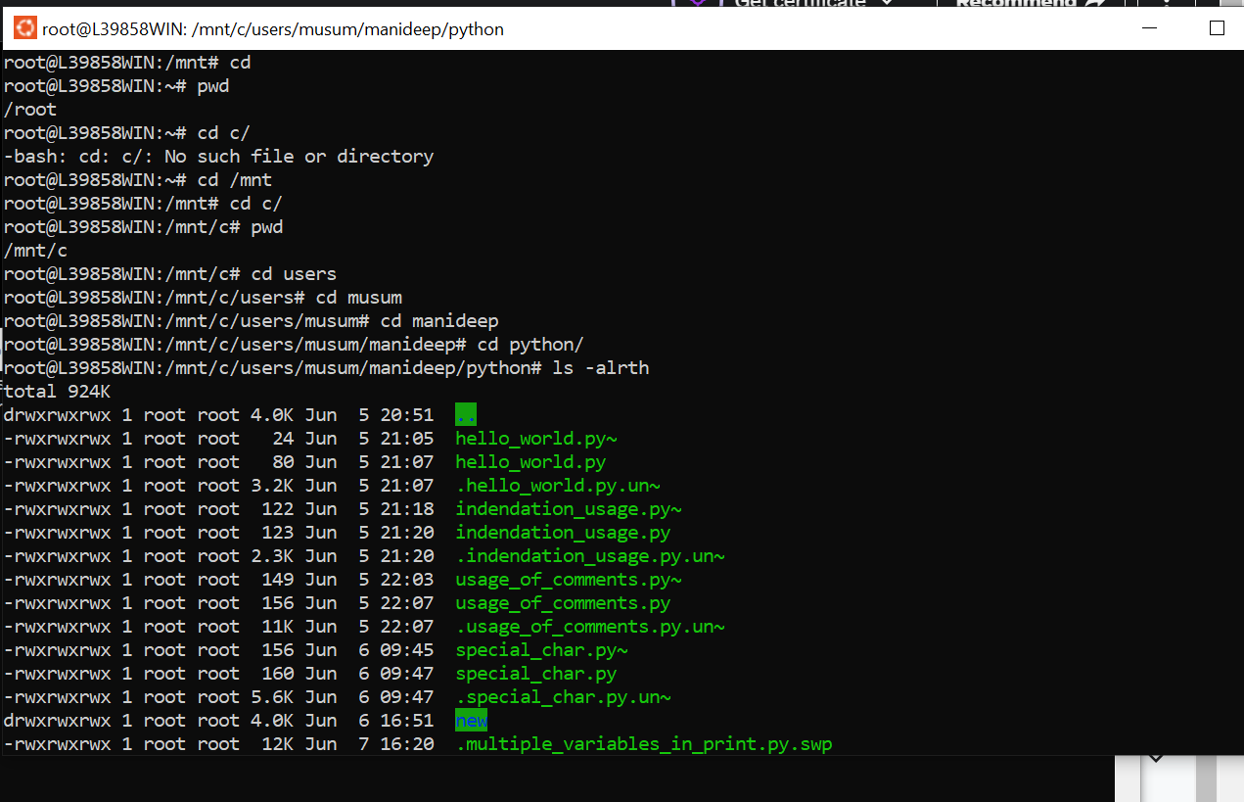

We can directly access data from windows to linux

SENDING MAILS USING PYTHON FLASK REST API:

Open below link and follow the steps

<https://github.com/NarendraPAutomationEngineer/sendMailAPI>

os.Walk(path):

used to generate directories and file names in a directory tree by walking:

find path -name *.txt

/home/xyz

/home/xyz/dir1

/home/xyz/dir1/sub1

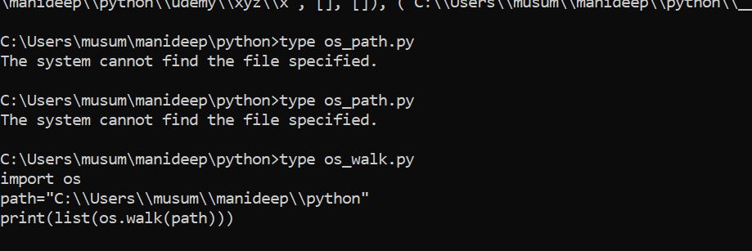

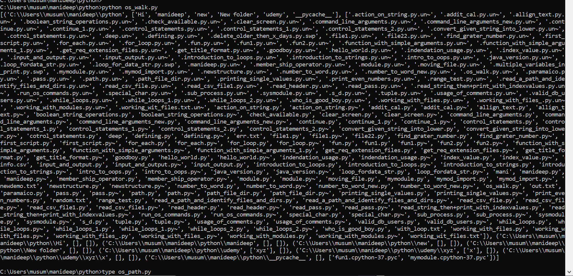

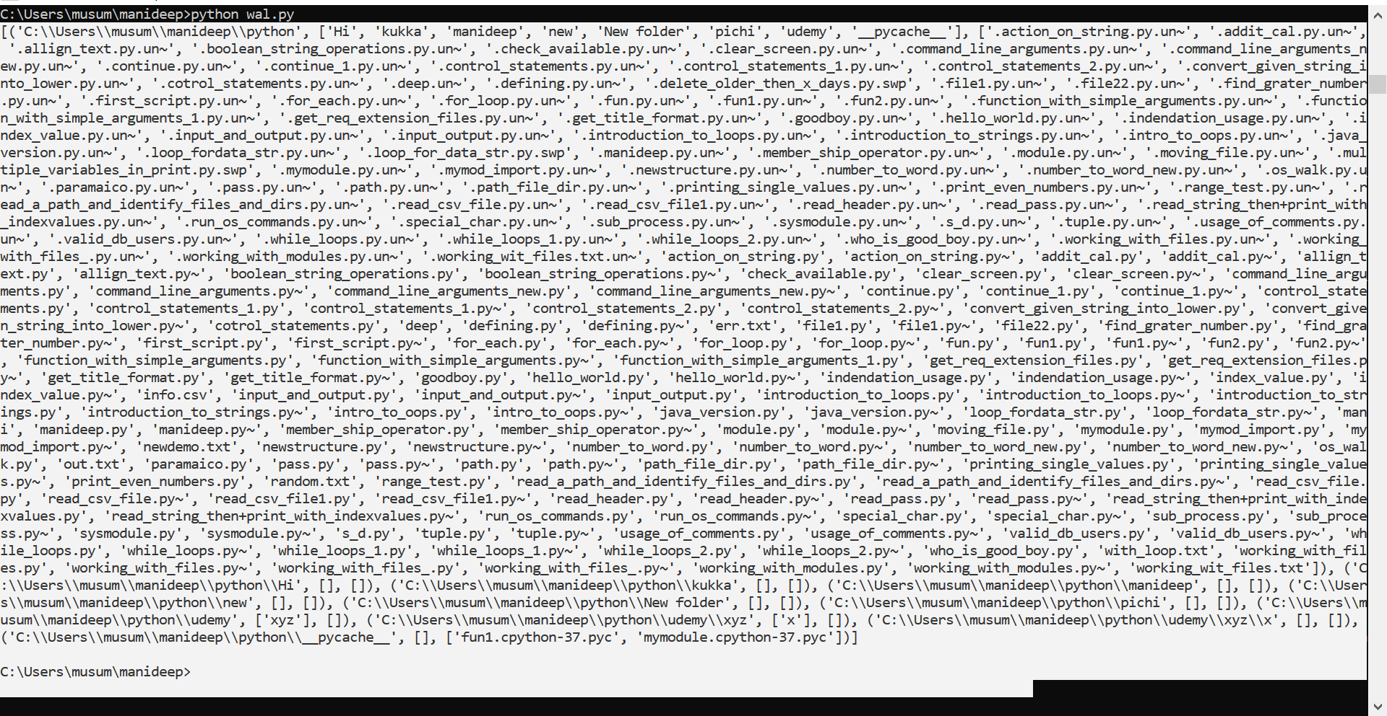

From the path python will automatically provide the paths and directories required.

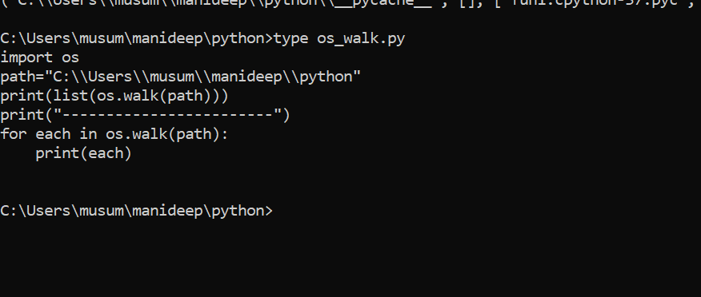

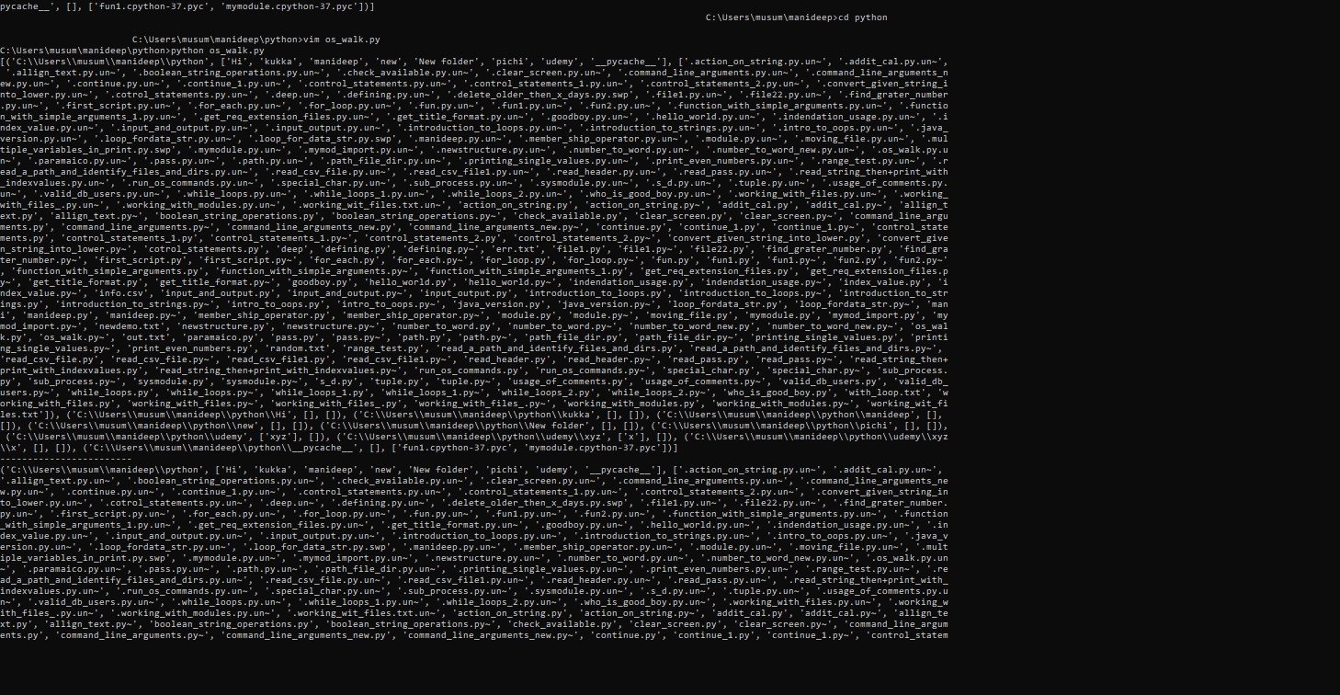

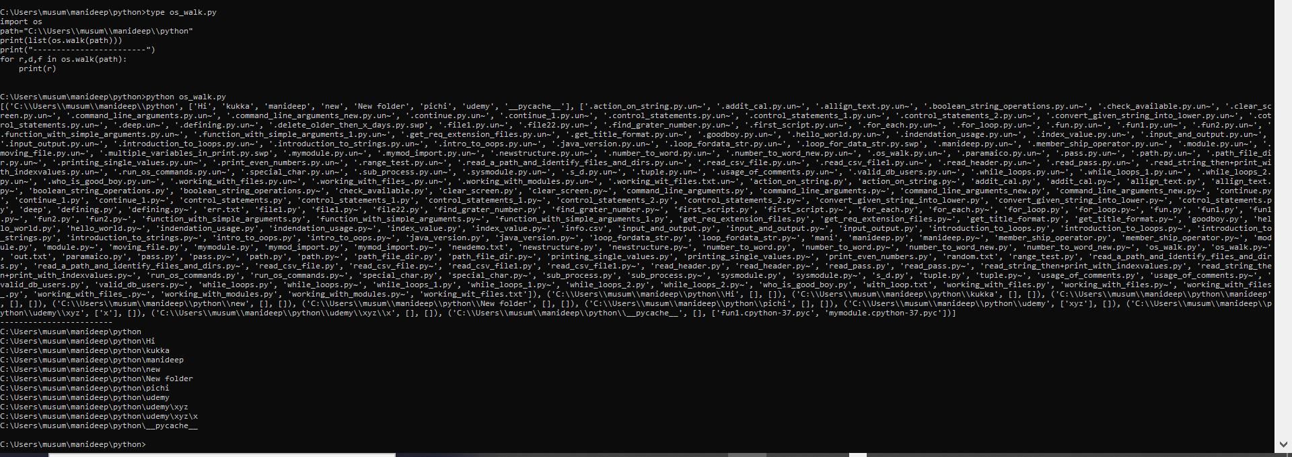

It is showing only root directories as we have mentioned only root in this.

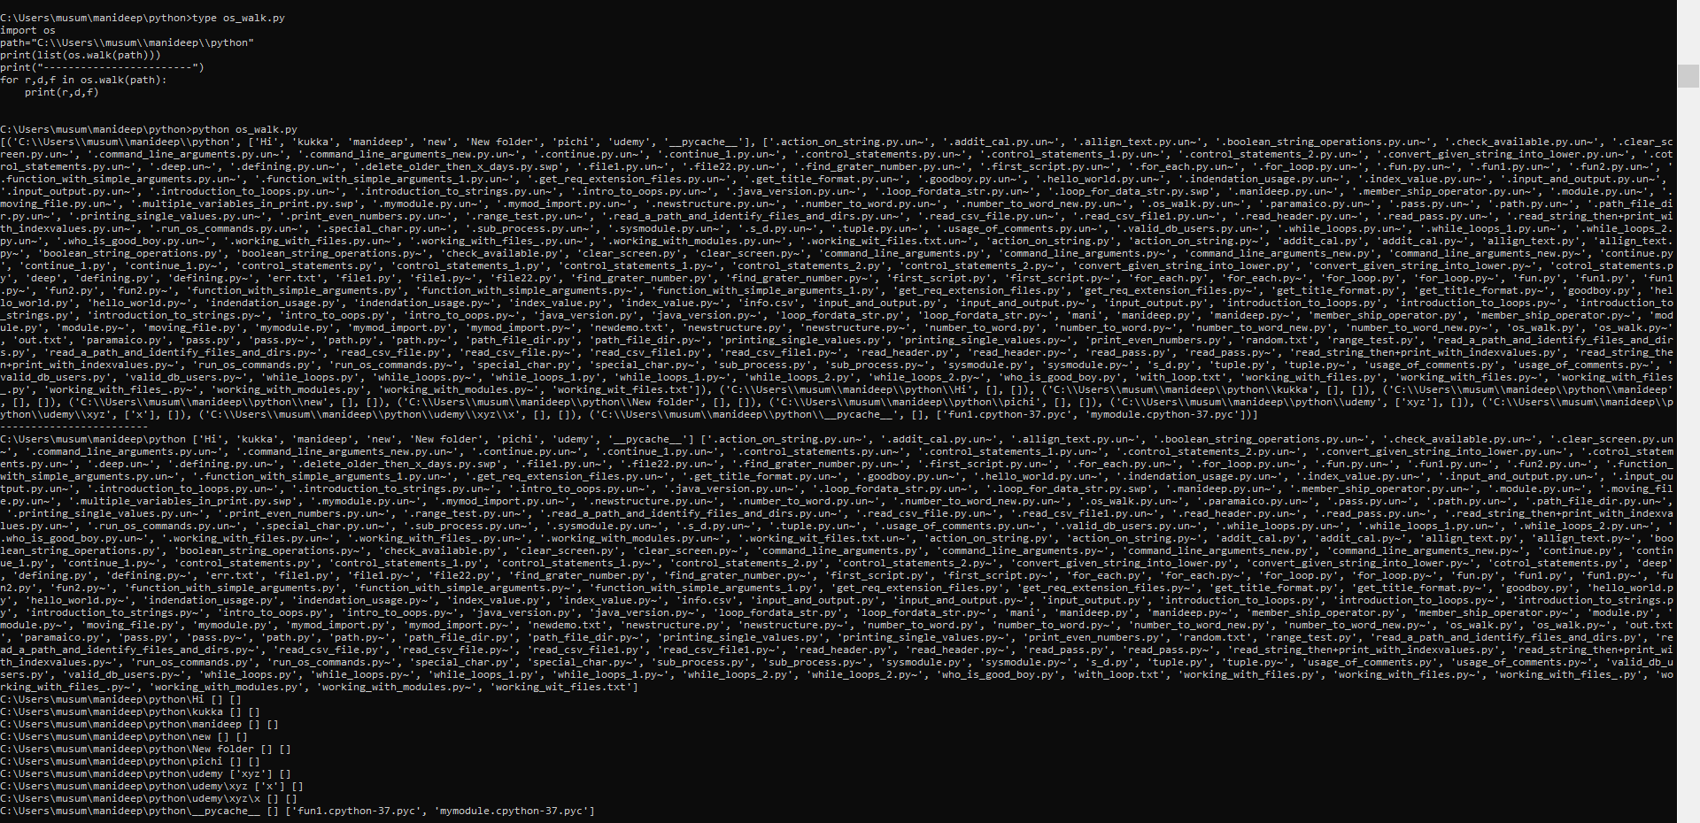

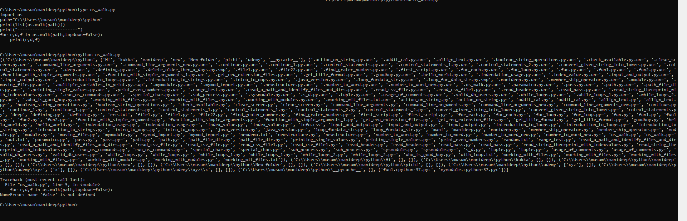

if you are giving topdown=false then it will give the details in the bottom to top by default this value topdown=true.

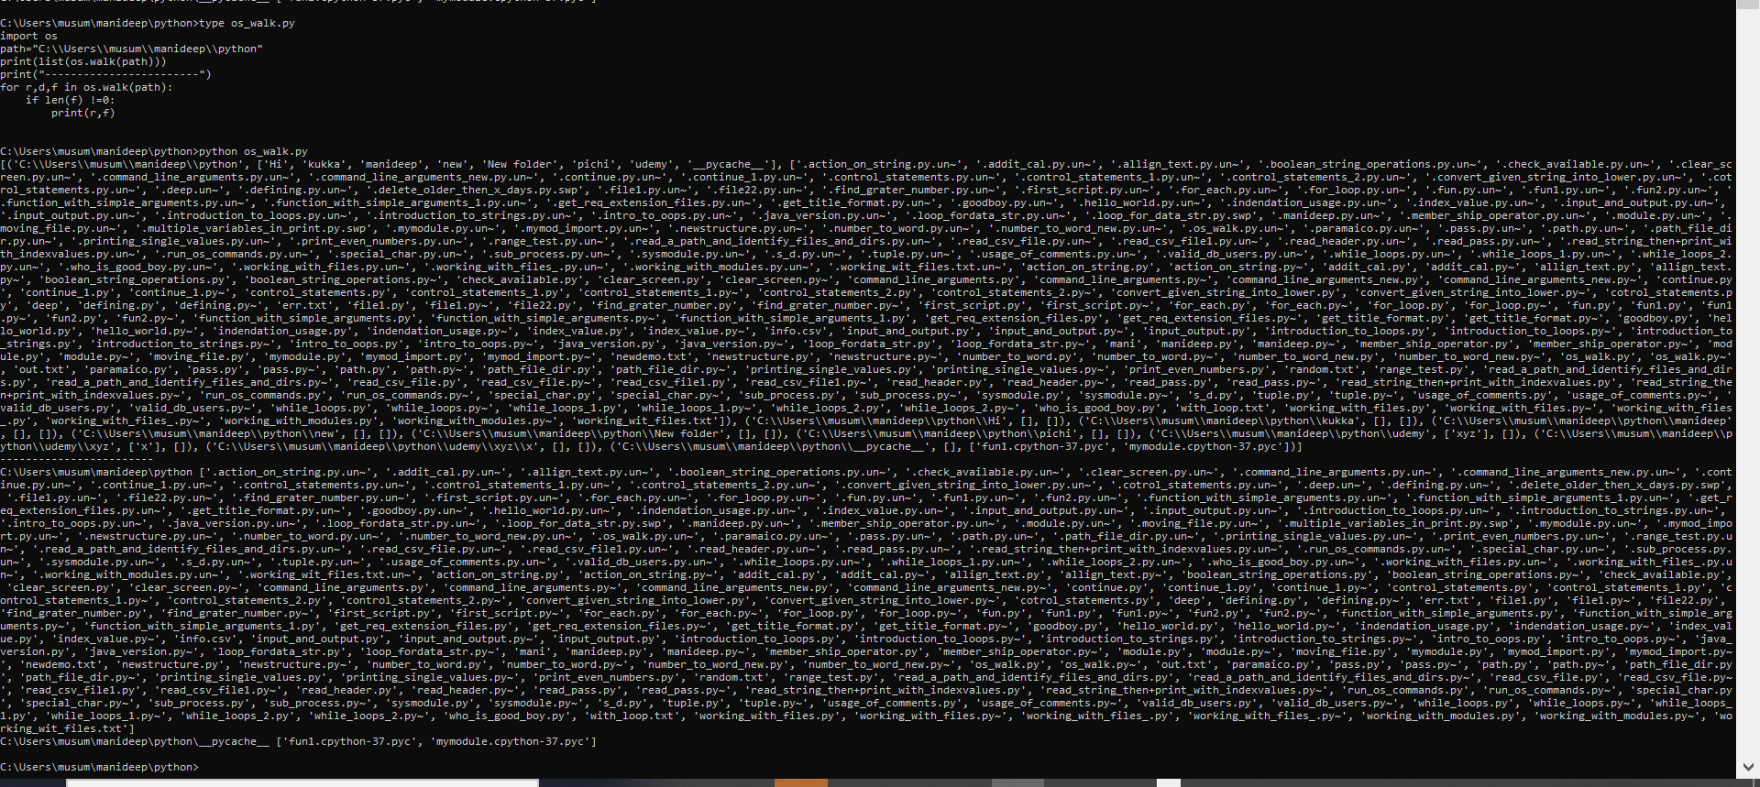

If len(f) !=0---🡪 then it will eliminate all the empty strings.

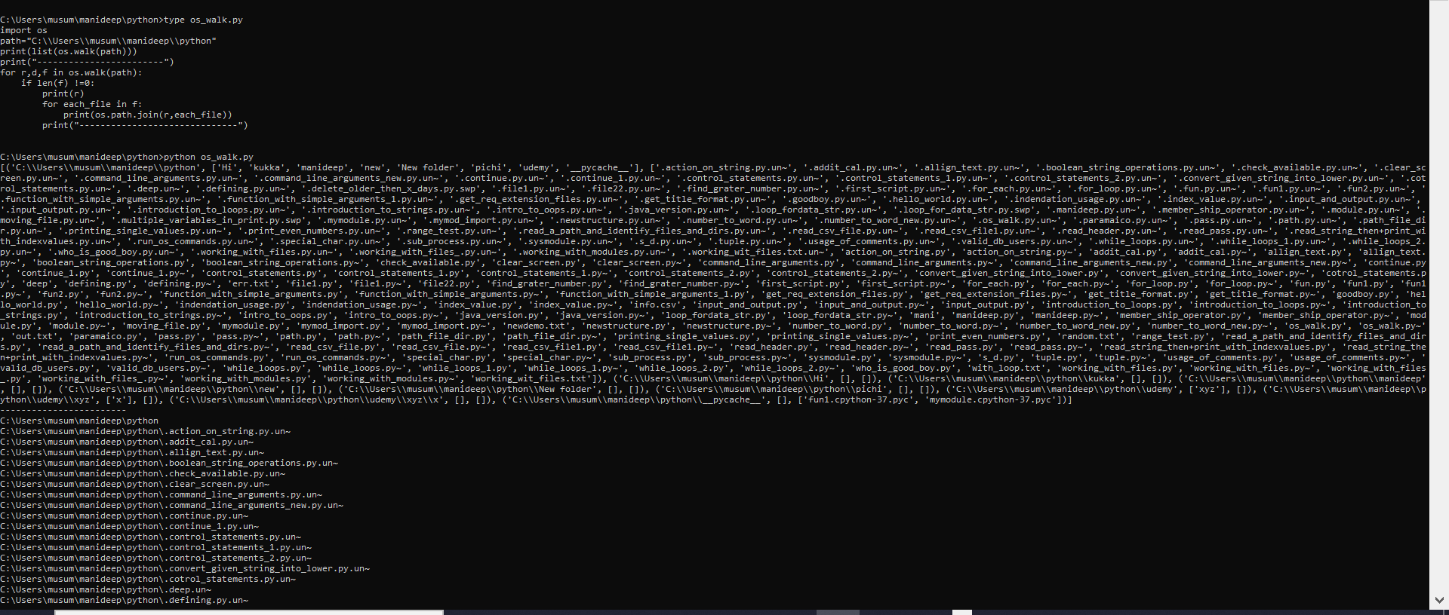

The above will print each file one by one. Including its root location.

Practice with os.walk(path):

How to do a system wide search for a file:

import os

import string

import platform

req_file=input("Enter your file name to search: ")

for r,d,f in os.walk("/"):

for each_file in f:

if each_file==req_file:

print(os.path.join(r,each_file))

this above program will give the file which we are trying the search:

op:

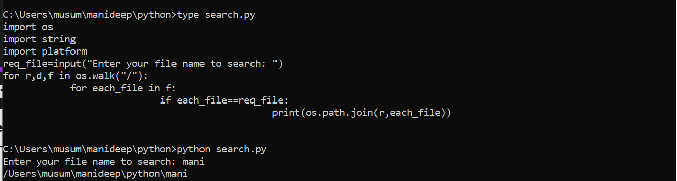

import os

import string

import platform

req_file=input("Enter your file name to search: ")

if platform.system()=="Windows":

pd_names=string.ascii_uppercase

vd_names=[]

for each_drive in pd_names:

if os.path.exists(each_drive+":\\"):

#print(each_drive)

vd_names.append(each_drive+":\\")

print(vd_names)

for each_drive in vd_names:

for r,d,f in os.walk(each_drive):

for each_f in f:

if each_f==req_file:

print(os.path.join(r,each_f))

else:

for r,d,f in os.walk("/"):

for each_file in f:

if each_file==req_file:

print(os.path.join(r,each_file))